Measurement of speed of sound in solids, liquids and gases
National 4 Physics Course: Waves and Radiation
Course Key Area: Sound
Suggested learning activities: Measurement of speed of sound in solids, liquids and gases
In this report three different methods for measuring the speed of sound will be described:
one using an Oscilloscope, one Audacity software and one using a Picoscope.

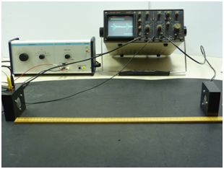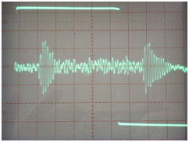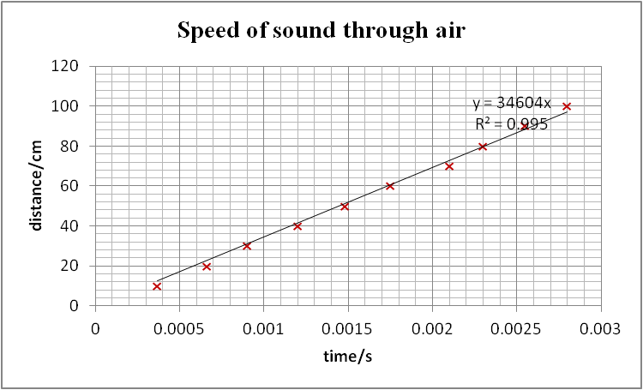
Electrical square signals of frequency 40Hz, in the form of repetitive waveforms, are produced by the signal generator and applied to microphone 1(which in this case is used as a speaker). These signals are displayed on channel 1 of the oscilloscope for reference. The sound received by microphone 2 is converted back to an electrical signal which is displayed on channel 2.

Oscilloscope Method: Sound through air

microphone 1/speaker 1
microphone 2

CH1
CH2
CRO
signal
generator
The top trace of the CRO screen opposite shows the horizontal portion of the applied square wave (the verticals are too faint to show up well). The lower trace shows the output picked up from microphone 2. The time taken for the sound to travel between the two microphones can be found from the difference between the initiation of the transmitted pulse and the first indications of a detected pulse. The distance between the two microphones is now varied and the corresponding time for the sound to transmit is measured. The timebase of the
oscilloscope is varied between 0.1 ms/div and 0.5 ms/div as necessary throughout the experiment, with the trigger set
on CH1.

A graph of the results is shown opposite.

The speed of sound through the air was calculated out at
approximately 346 ms⁻¹.
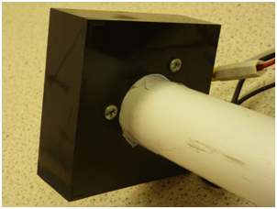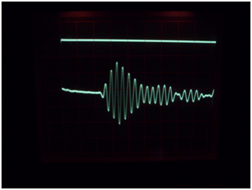
In this experiment the microphones are pressed firmly up against the ends of a PVC pipe and square waves applied from the signal generator as before. The pipe is placed on soft foam to minimise sound transmission through the bench top.

The following results were obtained:-
Length of P.V.C. tube = 156 cm
Diameter of tube = 3.6 cm.
Time for sound to pass = 1.2 ms
Speed of sound through tube = 1300 ms⁻¹
Approximately the same value was obtained when the microphones were taped against
the outside of the pipe.

Oscilloscope Method: Sound through liquid
The microphones were too bulky to be used in any experiment to determine the speed of sound through water. Smaller microphones can be used for this (see ahead).

Oscilloscope Method: Sound through solid

microphone 1/speaker 1
microphone 2

CH1
CH2
CRO
soft foam
support
PVC pipe
sig gen
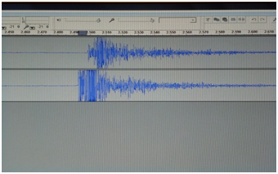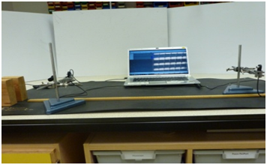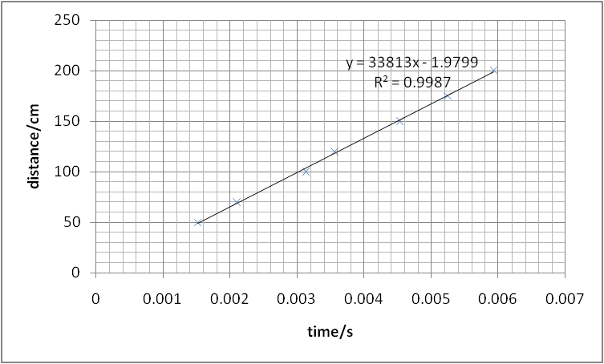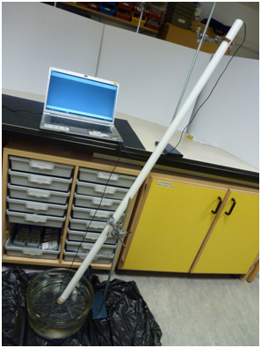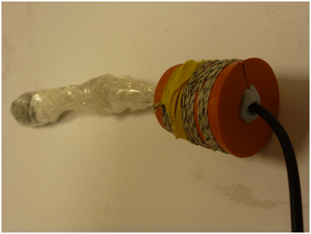
Audacity Method: Sound through air
In this method small microphones, connected to a laptop running Audacity software are used. The laptop has a stereo input which allows the sound detected from each microphone to be recorded on a separate channel. The difference in time between the start of each signal shown on the screen can be measured. The distance between the small microphones is varied and measurements tabulated.

A graph of the results is shown
opposite.

The speed of sound through the air
was calculated as 338 ms⁻¹
Audacity Method: Sound through liquid

For this experiment a rubber bung is split along a radius and the lead from one of the small microphones slid into place. The bung is bound tightly and the microphone covered with a polythene bag. The bung is then pushed into one end of a PVC pipe which is itself clamped upright and filled with water. The other microphone, also covered with a polythene bag, is then placed into the top end of the pipe. The top bung is struck to produce a sound vibration which can be picked up by each microphone and analysed with the audacity software.
The speed of sound was calculated in this case to be around 1500 ms⁻¹.
The diameter of the tube
used was 160 cm with a diameter of 3.6 cm.

It held about 1 litre of water.
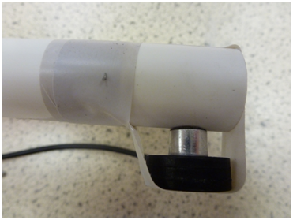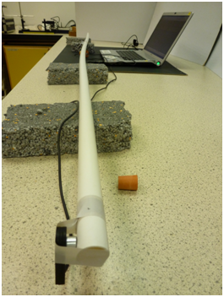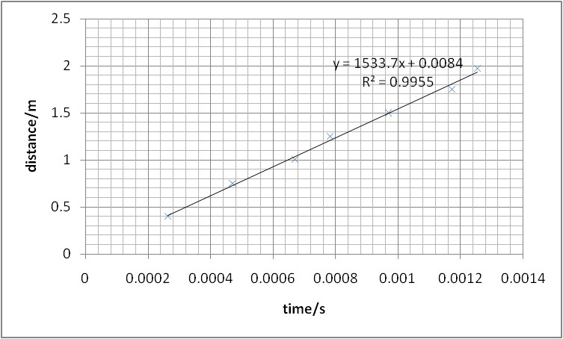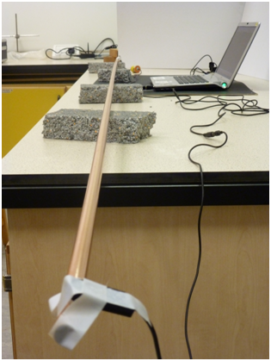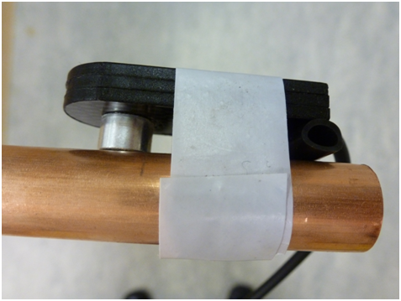
Sound vibrations are made
by tapping the end of the pipe
and recording the time
difference using the Audacity
software.
The distance between the
microphones is varied and the
corresponding time differences noted.
The graph of the results is shown.
The speed of sound through the pipe was calculated as
1534 ms⁻¹.

Audacity Method: Sound through solid

For this experiment the microphones are taped to the sides of a 2 metre length of PVC pipe of diameter 22 mm.
When the experiment is repeated using a copper pipe the signals are more easily discernible on the screen.

This time the speed of sound through the copper was calculated as 1700 ms⁻¹.

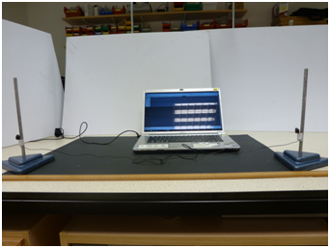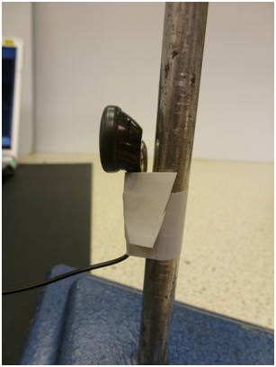
An interesting, cheaper alternative is to use earphones in place of standard microphones. In effect the earphones are being used in reverse to their normal function – in this case converting sound to electricity. They are very easy to work with but the signals recorded inevitable are of smaller amplitude. The values for the speed of sound through the air and PVC tubing were similar to before. However they didn’t perform as well when covered with a polythene bag and inserted into water held in a tube. It is probably better to use the ‘conventional’ smaller microphones for this.
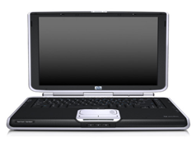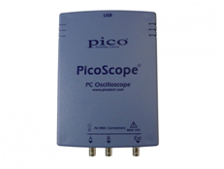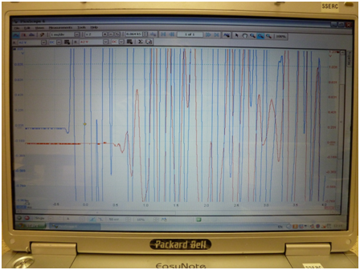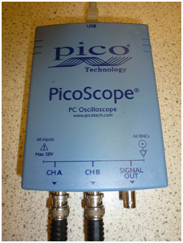
microphone 1
microphone 2

Picoscope Method: Sound through air
The Picoscope is a PC based USB oscilloscope. It enables you to display voltage waveforms on your PC. It can be a powerful tool for recording, processing and displaying a wide range of measurements.

Settings at top of screen
1 ms/div
Timebase
± 2 V
DC
A
B
± 2 V

DC

Settings at bottom of screen
single
A
50 mV
10%
Trigger
Mode
Channel as source of trigger – whichever microphone first detects sound
Trigger
Edge, in this case the leading edge
Threshold of trigger
Pretrigger -amount of data captured before trigger
When a fairly loud sound is produced (e.g. by striking two bits of wood together) the signals picked up are clearly visible on the screen as a fixed image. The scales/tools on screen can be used to magnify the picture and read off the time delay.
Values around 320 ms⁻¹ for the speed of sound through air are readily obtained.
This set-up can be adapted in line with previous experiments to determine the speed of sound through solids and liquids.

Then double click on
at the top left of the screen.
In this experiment Microphone 1 is connected to Channel A and microphone 2 to Channel B. The Picoscope is set so that the two signals from the microphones appear together on the screen as soon as a sound is detected. This is achieved by using the trigger adjustment on the Picoscope. The following settings worked well:

Settings on the picoscope:
A ±2V B ±2V timebase: 1ms/div
Trigger mode: single trigger channel B trigger edge: leading edge
Threshold for trigger: 50mV
How much trace shown before start: 10%
To start again: click on at top twice.
Use cursor to read off values from graph.

Settings for Audacity

Generate Tone
Length 1 second
Frequency 440Hz (you could experiment with this)
Edit Preferences √ Play other tracks while recording new one
Connect microphone 1 to headphone input on laptop
Connect microphone 2 to microphone input on laptop

Click on Record.

