Relationship between temperature and resistance of a conductor
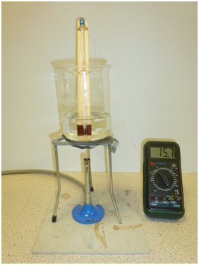
copper
coil of wire
thermometer
water
ohmmeter
strip of wood
15.7
National 5 Physics Course: Electricity and Energy
Mandatory Course Key Area:
Ohm’s Law – The relationship between temperature and resistance of a conductor
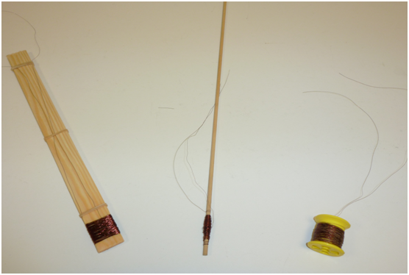
Various gauges of copper wire were trialled in this experiment to determine which gave acceptable results. Firstly different thicknesses of wire were heated between 20ºC and 95ºC and their resistance measured. The results are summarised below:
SWG 44 copper enamelled wire produced a good variation in resistance [from 50 Ω to 64 Ω] but was found to be too thin to work with effectively without snapping when winding it around shapes.
SWG 28 copper enamelled wire was very easy to work with but only produced a small change in resistance [1.4 Ω to 1.9 Ω].
SWG 38 copper enamelled wire seemed to provide the best compromise, being easy to wind round plastic reels/ wooden strips without breaking and displaying reasonable resistance variation [18 Ω to
22 Ω].

Different types of frame were then trialled for winding the wire around.
All were easy to use, however the reel tended to rise upwards when the
water temperature reached around 70ºC due to convection currents.
The wire wound round the dowelling stick didn’t produce as large a
resistance range as that around the strip of wood. So we concentrated on
using the strip of wood, as a greater length of wire could be used.
The strip of wood had the following dimensions: 30 cm x 2.5 cm x 4 mm.
Approximately 200 turns of the SWG 38 copper wire (~12.5 m) were wound round this wooden strip. The enamel was burnt off the ends of the wire which were then connected to an ohmmeter and the coil immersed in cold water (~ 400 ml) in a litre flask. The water was heated using a bunsen burner and the temperature recorded using an alcohol thermometer (-10ºC to 110ºC), stirring occasionally. The resistance of the wire was measured every 5ºC. The whole experiment took about 55 minutes to complete.

The strip of wood, dowelling and reel used
in the experiment
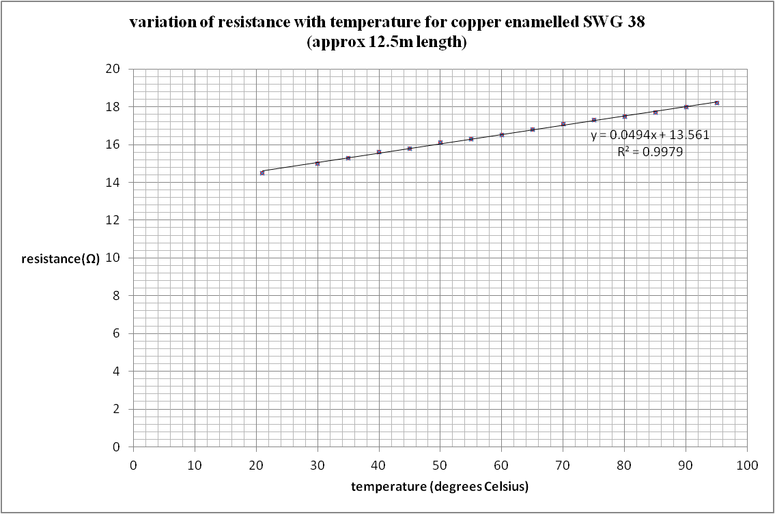
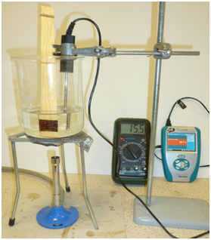
Results: The graph shows the variation of the resistance of the copper wire during the experiment.
The graph gives a value of 3.5 x 10⁻³ ºC⁻¹ for α, the temperature coefficient of resistance for the copper, (accepted value is ~ 4.0 x10^{-3 o}C⁻¹ ).
Uncertainties:
The length of wire connecting the coil to the ohmmeter is not being heated by
the water, so it will not be displaying an increase in resistance. This should
make the value for α a little smaller than it should be.
The bulb of the thermometer should be placed near the coil to record its temperature.
The water should be stirred regularly throughout the experiment.

Note:
A temperature sensor connected to a data logger could easily
be used as a substitute for the alcohol thermometer, as shown
opposite. This allows measurements to be read off very easily.

A Vernier Labquest temperature sesor is used with this set-up

