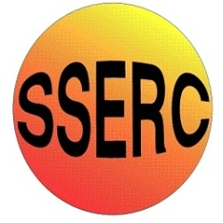
Chemical Demonstrations
Northern Lights
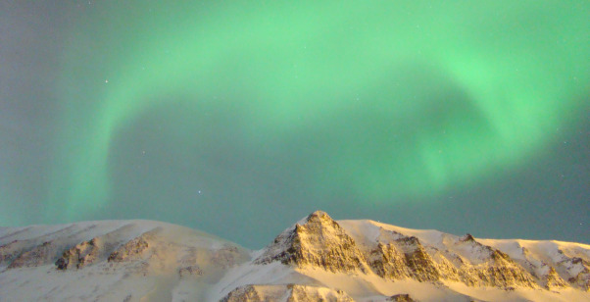
This reaction can be applied to curriculum for excellence.
Through experimentation, I can identify indicators of chemical reactions having occurred… SCN 3-19a

National 4 - Chemical Changes and Structure
Metals

Northern Lights

This demonstration shows the displacement of copper from copper chloride by aluminium (which is higher in the reactivity series). The copper can be seen to form around the aluminium. The acid used which removes the aluminium oxide layer so the reaction can take place, will also in reaction with the aluminium produce hydrogen gas. This can be ignited to produce green/blue flames
Apparatus you will need
1 x large flask
Splints or another way to light the gas evolved
Chemicals you will use
200 cm³ Water
20 cm³ Hydrochloric acid (conc) (corrosive)
5 – 6 g Copper chloride (skin/eye/respiratory irritant, harmful (Cat 4) if ingested)
Aluminium foil (approximately 20 x 20 cm)

What you will do
- Place conical flask on heat proof mat, surrounded by safety screen
- Add water and then HCl (must do it this way round)
- Add the copper chloride
- Add aluminium foil
- Turn the lights down (or off if safe to do so)
- Let reaction happen for a minute then using a lit splint ignite the hydrogen gas that’s built up (this should be at arm’s length and from behind the screen)
- This can be done a few times (remember to show the copper produced at the end, once the reaction has cooled down)
It is the responsibility of teachers doing this demonstration to carry out an appropriate risk assessment.

