
How good is the colorimeter?

Background

Colorimeters and spectrophotometers are important pieces of laboratory equipment and are used in many experiments in schools and colleges. A quick look through the Course Specifications for the Revised and CfE Highers and Advanced Highers flags up a number of opportunities for the use of colorimeters and spectrophotometers. It is not that common for the reliability of colorimeters to be tested and we offer this short practical as a way of testing their accuracy, reliability and precision.

Method

- Set the filter wheel to 440 nm  - Switch on the colorimeter  - Place an empty cuvette into the sample holder and press the ‘R’ button to zero the colorimeter. Note the direction of the light beam - ensure cuvette is in the correct orientation. | 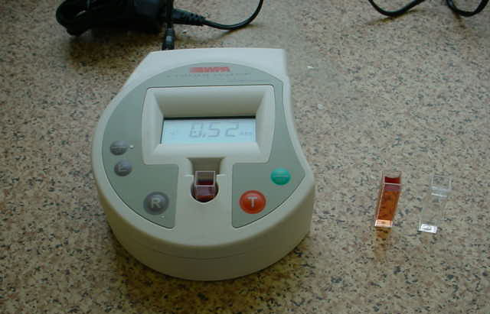 | Direction of beam

- Press the ‘T’ button and record the absorbance.

- Cut 5 pieces of neutral density filter each with dimensions 3 cm x 0.8 cm.

- Place (tweezers may help) a piece of neutral density filter into the cuvette and make sure it is vertical.

- Press the ‘T’ button and record the absorbance. Add another piece of neutral density filter and measure the absorbance. Repeat until you have a total of 6 data points.

- Repeat steps 3-7 with the filter wheel at 520 nm.

- Plot your results

Equipment Needed

- Colorimeter (in the experiment today we will use a WPA CO7500 colorimeter but in principle this experiment could be repeated with any colorimeter).
- Scissors, ruler, tweezers.
- Cuvette (clean, empty).
- Sheet of neutral density filter. This filter is manufactured such that a single thickness allows 50% of light to be transmitted.
- Graph paper.

