This is a metaphase spread of Klinefelter syndrome

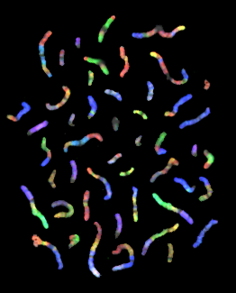

This photograph is taken from The Gene Issues Website
http://www.genecrc.org/
http://www.genecrc.org/site/ko/ko5c.htm#
(Source material no longer available online)

Match the chromosomes by colour!
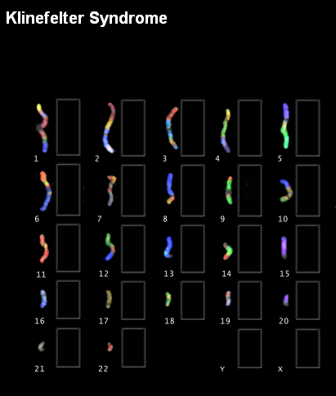
This is taken from The Gene Issues Website
http://www.genecrc.org/
http://www.genecrc.org/site/ko/ko5c.htm#
(Source material no longer available online)

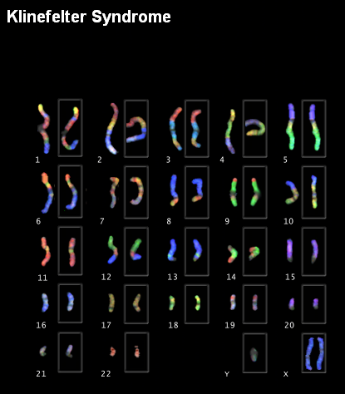
This is taken from The Gene Issues Website

http://www.genecrc.org/
http://www.genecrc.org/site/ko/ko5c.htm#
(Source material no longer available online)

This is taken from The Gene Issues Website
http://www.genecrc.org/
http://www.genecrc.org/site/ko/ko5c.htm#
(Source material no longer available online)

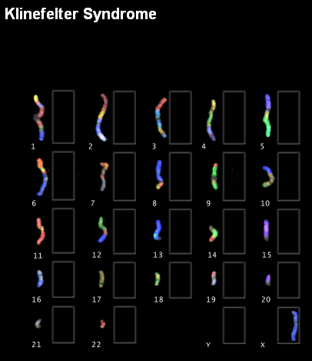

This is taken from The Gene Issues Website
http://www.genecrc.org/
http://www.genecrc.org/site/ko/ko5c.htm#
(Source material no longer available online)

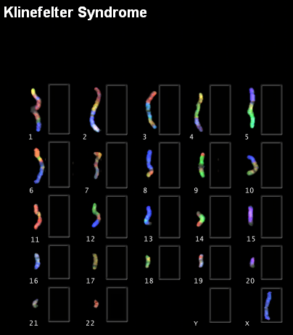
This is taken from The Gene Issues Website
http://www.genecrc.org/
http://www.genecrc.org/site/ko/ko5c.htm#
(Source material no longer available online)

