Novel Materials
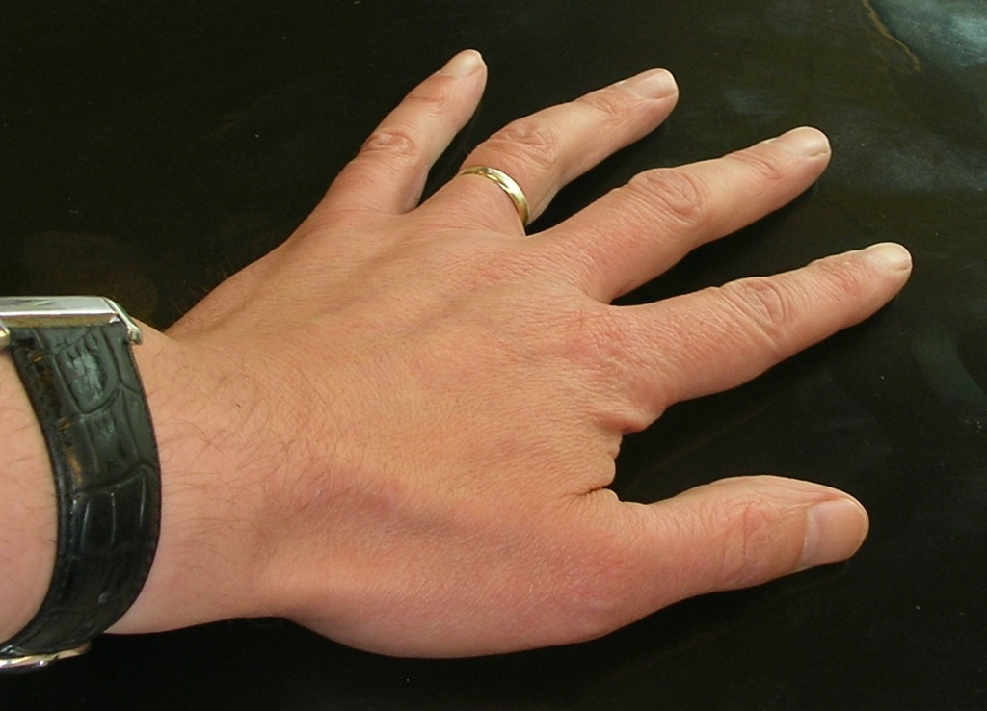

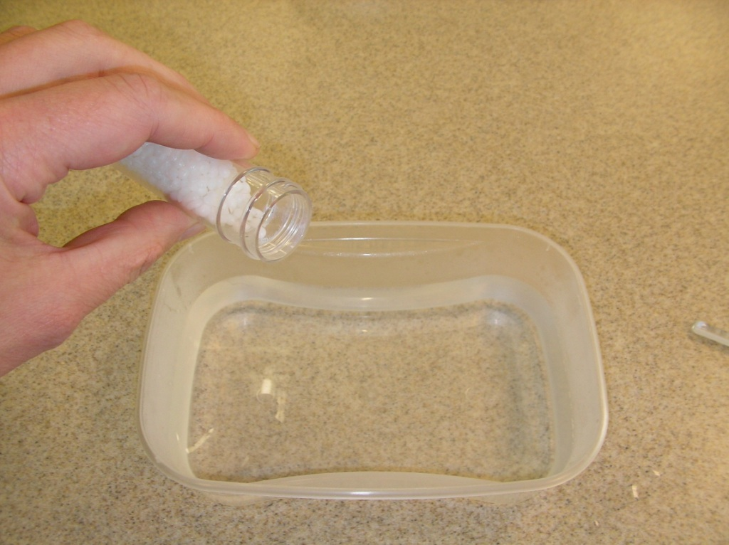
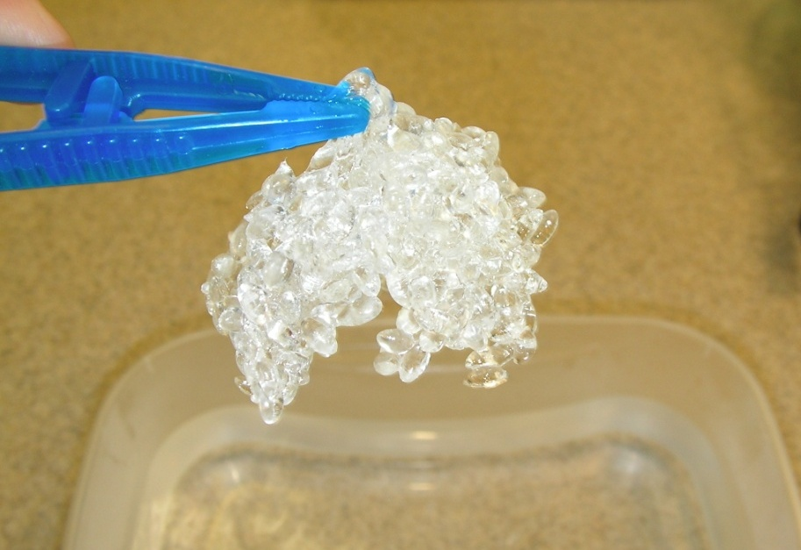
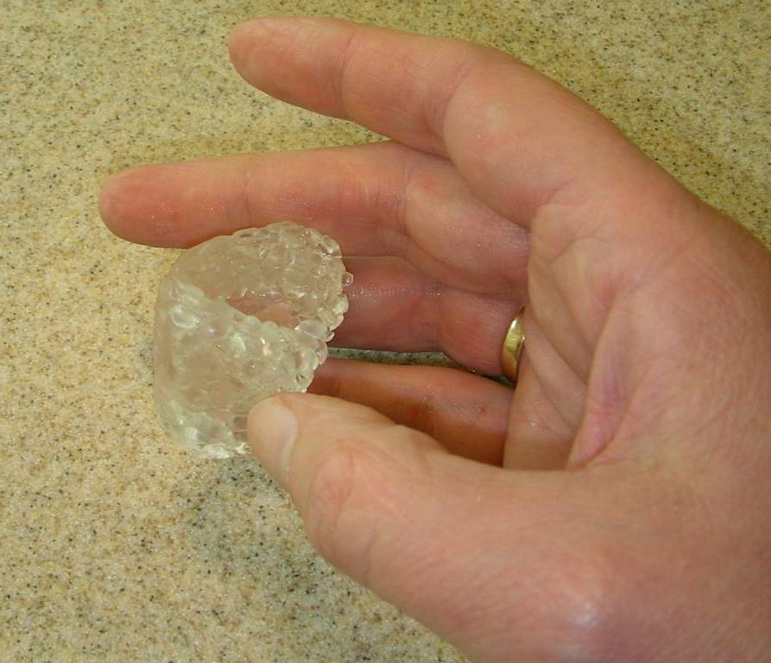

Polymorph

Polymorph is a plastic than can be moulded at low temperatures.

What you need:

Polymorph granules, tweezers, tub of hot water, thermometer to check temperature (optional)

What to do:

- The hot water should not be much above 60°.
- Pour the granules into the hot water.
- Leave the granules in the water until they have turned clear.
- Fish the granules out with the tongs.

- Carefully begin moulding the polymer. It may contain pockets of hot water. Let it drip for a bit.

- Polymorph turns white when set. It can be remoulded as often as you wish.

Safety:
- Do not use boiling water.
- Be careful when beginning to mould the polymer. It tends to be a bit sponge-like when fished out the tub and may contain pockets of hot water.
- Do not mould the polymer around body parts.

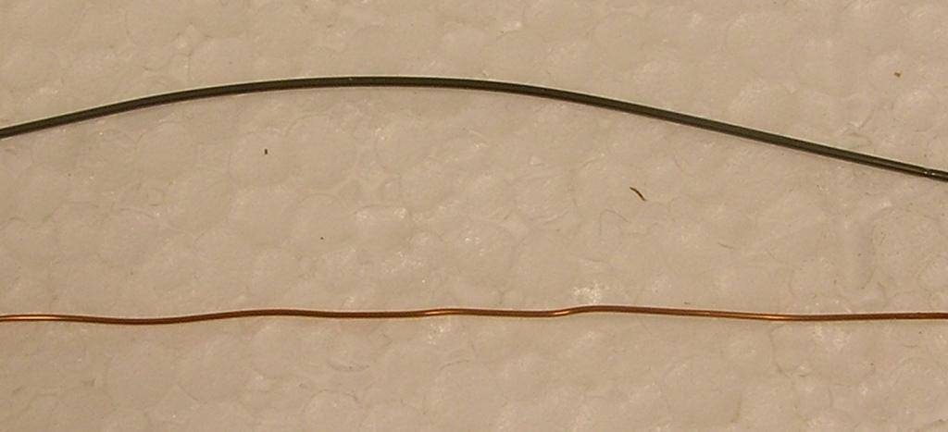

Properties of Metals

Here we are going to look at a metal with an unusual property.

The metal is called nickel-titanium or NiTi for short. It is sometimes called shape memory alloy.

What you need:

10 cm length of copper wire, 10 cm NiTi wire, tub, kettle of water, tongs, safety glasses

What to do:

- Boil the water in the kettle. While the water is heating up, bend the copper and NiTi into shapes.
- Make sure everyone around you is wearing safety glasses.
- Fill the beaker about two thirds full of recently boiled water.
- Use the tongs to drop the bent wire into the hot water.
- Watch carefully what happens.
- If you would like to try again, fish the wire out of the beaker with the tongs. It should be cool enough to touch in 30 seconds.

Safety:

- Wear safety glasses.
- Use tongs for lifting wire in and out of the tub.
- The outside of the beaker will get hot.

NiTi and copper wire
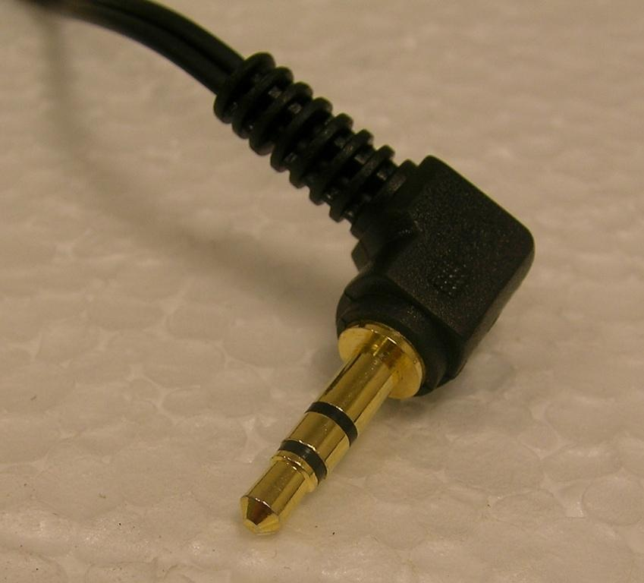

“Headphone jack plugs are made of steel because steel is a metal and all metals conduct electricity.” This “properties” approach is one we might use to introduce shape memory alloys to pupils.
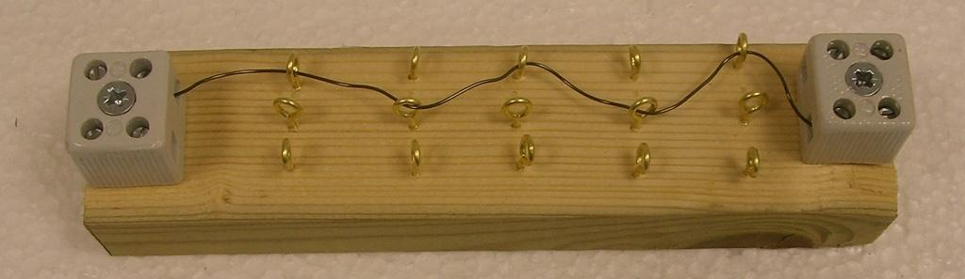

Shape Memory Alloys:

NiTi (nickel-titanium) is an example of a shape memory alloy.

It can be bent into different shapes but will return to its original state if it is heated to a certain temperature.

In this activity we are going to “train” the NiTi to the shape we want it to return to. To do this, we are going to use an electric current to heat the wire to a high temperature.

What you need:

20 cm length of NiTi wire, power supply, stopclock, ammeter, 3 leads, 2 crocodile clips, kettle, large beaker, training jig, screwdriver, safety glasses, tongs.

What to do:

- Pass the NiTi wire through the hoops in the training jig to make a shape. There is a separate sheet with ideas and with warnings of what not to do.
- Set up the circuit shown in the picture above. Set your ammeter to 10 A and use the 10 A and COM sockets.
- Turn the output of the power supply right down. Switch it on and slowly increase the output until the ammeter reads 6 A.
The wire will become very hot. Do not touch it.
- Keep the wire heating in the jig for 2 minutes.
- Switch off the power supply.
Do not touch the NiTi or the croc clips for 2 minutes.
- Remove the NiTi. Straighten it and then drop it into a beaker of water filled from the kettle.
- Did the wire return to the shape you made?

Safety:
- Do not let the current go above 6 Amps.
- Do not touch the wire or crocodile clips while heating or for 2 minutes after the current has been switched off. It gets very hot.
- Wear safety glasses when pouring hot water or when dropping NiTi into it.

The training jig.
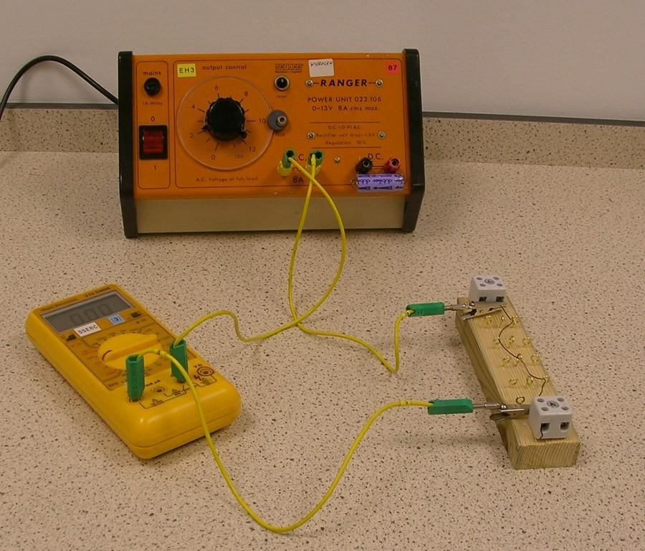
The circuit used to train NiTi.

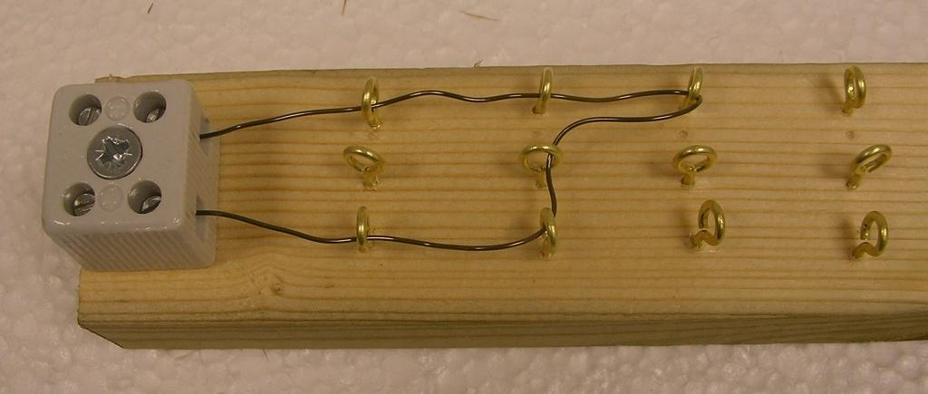
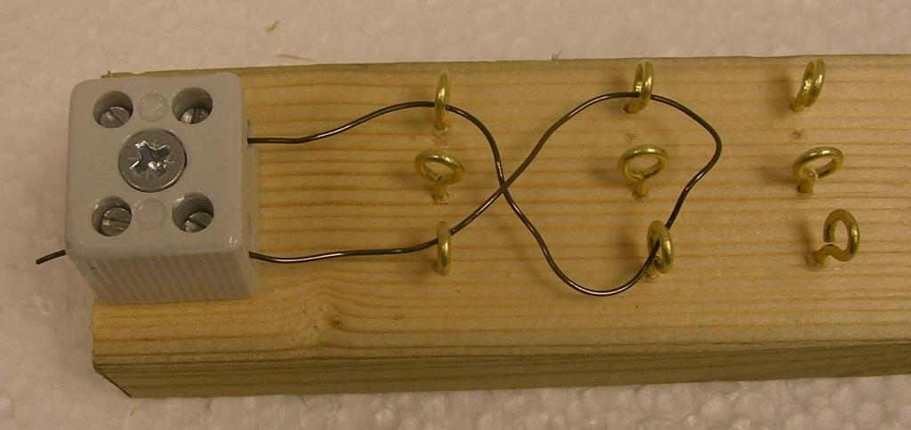
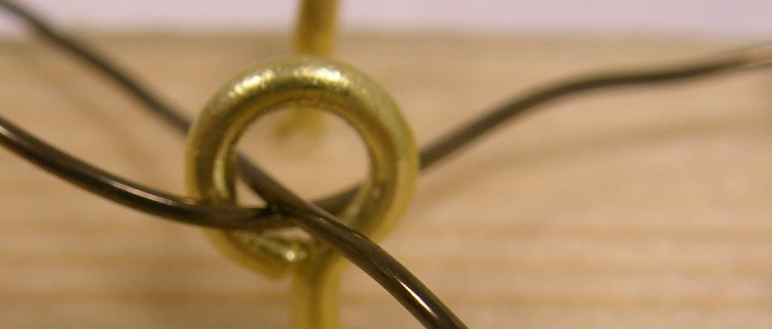
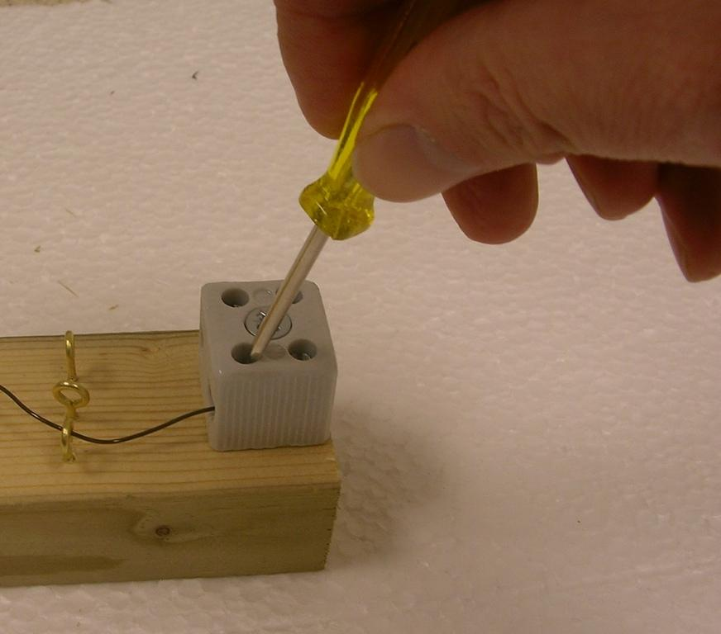
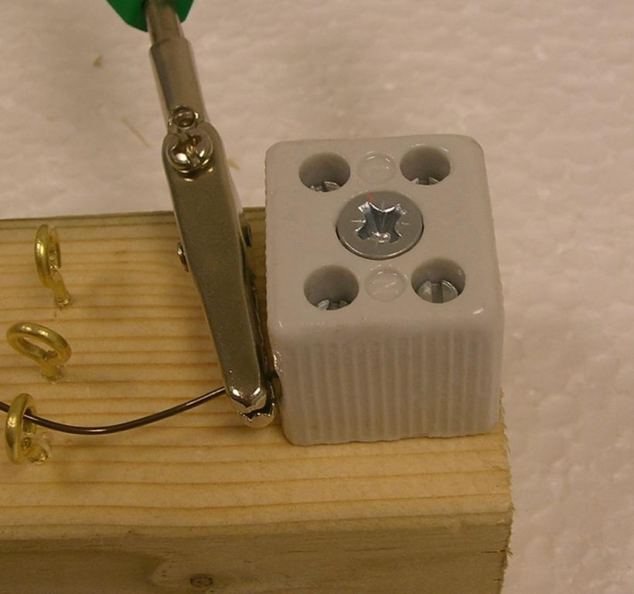
Ideas for using the jig
Using the jig
Tighten the wire firmly in place using a screwdriver.
Connect the crocodile clips here.
Don’t do these things…
Don’t let the NiTi wire cross like this.
A wire can’t pass through a hoop more than once.
X
X

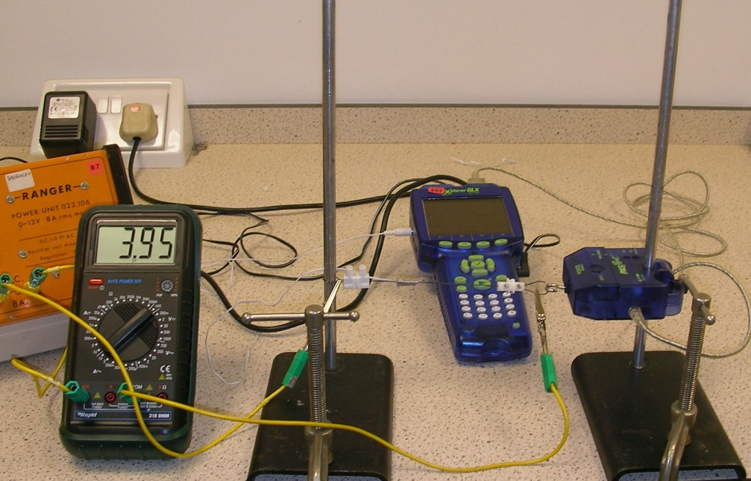

Shape memory alloy used as muscle wire.

You will investigate other effects of shape memory alloy. This investigation concerns the wire’s behaviour when heated. It should expand as it gets hotter, but…

What you need:

2 clamp stands, 2 G-clamps, length of shape memory alloy wire with hoop at either end, temperature probe, force meter (here we connect these to a datalogger), ammeter, power supply.

What to do:

- Set the equipment up as shown.
- Note that one loop of the wire is around one clamp stand, the other hooks on to the force sensor. The force sensor is attached to the other clamp stand.
- Move the clamp stand bases until the wire is tight. Clamp the bases to the bench.
- Tape the temperature probe to the wire.
- Connect the wire and ammeter in series.
- Set the ammeter to its 10 A a.c. setting.
- Connect the ammeter and wire to a variable a.c. power supply. This power supply should be capable of delivering 6 – 8 A. Turn its output down as low as possible.
- Begin recording data. You will be shown how to operate the datalogger.
- Gradually increase the current through the wire. Do not exceed 4 A. Monitor the temperature of the wire. Do not let it exceed 80°C.
- Do not touch the wire.
- Not what happens to the reading on the force metre as temperature increases. What would you expect to happen to the reading as the wire expands?
- Suggest an explanation for what you observe.

Safety:

- The wire will become hot during this experiment. Do not touch it when the current is on.
- Do not exceed 6 A or 80°C

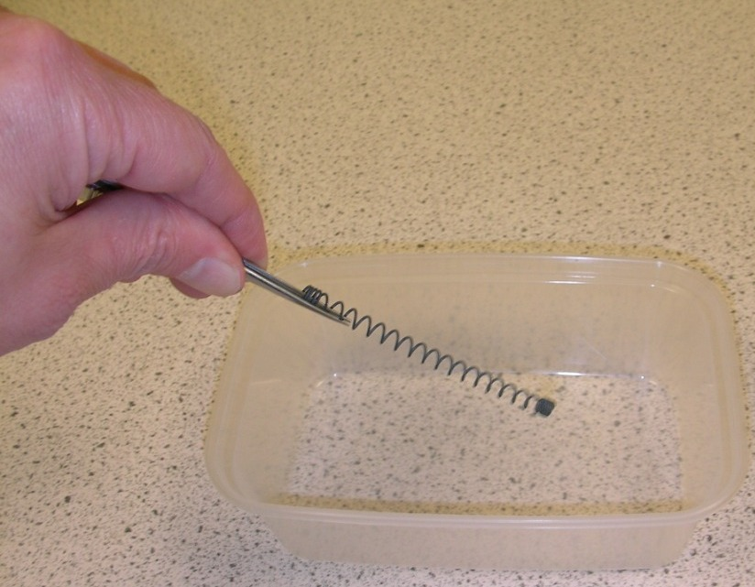

Two state shape memory alloy spring

The spring stretches when heated but returns to its original length when cooled.

What you need:

Shape memory alloy spring, tub of very hot water, tub of cold water, tweezers.

What to do:

- The water in the tub should be freshly boiled.

- Drop the spring into the hot water.

- Fish the spring out using tongs.

- Place the spring in the cold water.

Safety:
- Take care to avoid splashes or spills when using boiling water.

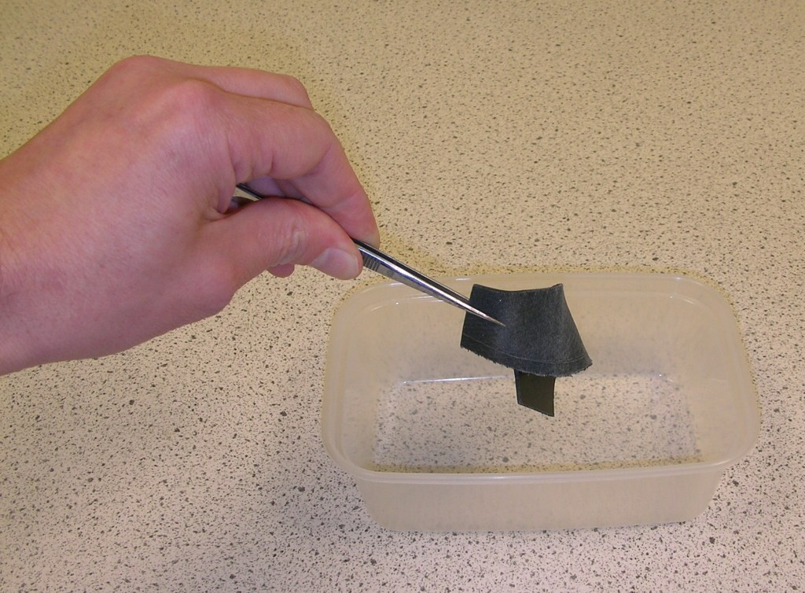

Shape memory polymer

This plastic can be easily shaped when warmed. When placed in very hot water, it returns to its original shape.

What you need:

Strip of shape memory polymer, tub of very hot water, tweezers.

What to do:

- The water in the tub should be freshly boiled.
- Place the strip of polymer into the tub and leave it for several seconds.
- Remove the polymer using tongs.
- Reshape the polymer.
- It is probably best to replace the water with freshly boiled water again. Place the reshaped polymer into the very hot water and observe the results.

Safety
- Take care to avoid splashes or spills when using boiling water.

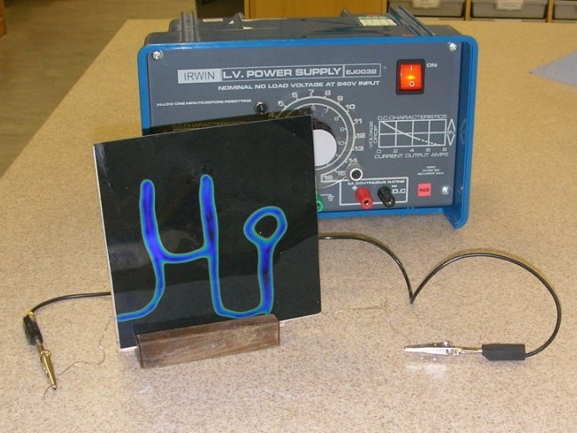

Thermochromic film

This film changes colour according to temperature.

What you need:

Sheet of thermochromic film, power supply, sheet with film and resistance wire.

What to do (1):

- Place your hand on the thermochromic film for a short time.
- Remove your hand and look at the film.

What to do (2):

- Connect the resistance wire (it is attached behind the thermochromic film) to the power supply.
- Place the thermochromic panel in its stand.
- Turn the power supply down.
- Switch on the power supply.
- Gradually increase the output of the power supply.
- Observe the thermochromic panel.

Safety:

- The resistance wire will become hot.

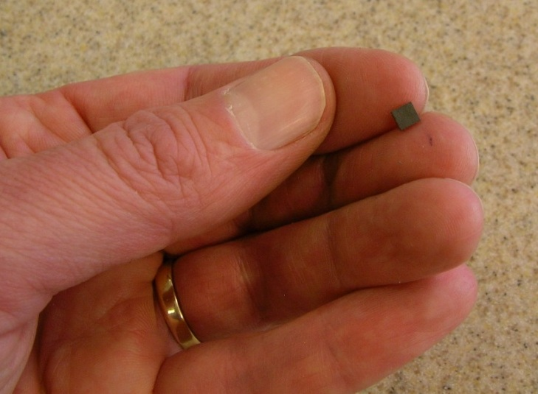
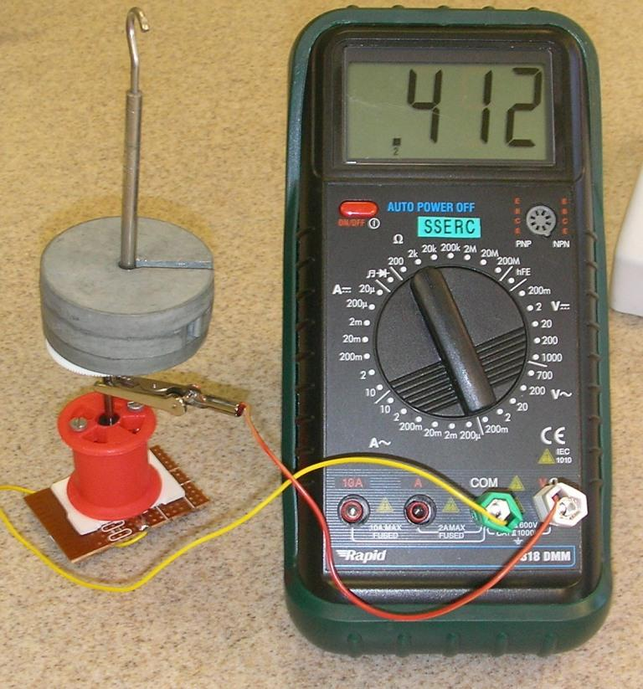
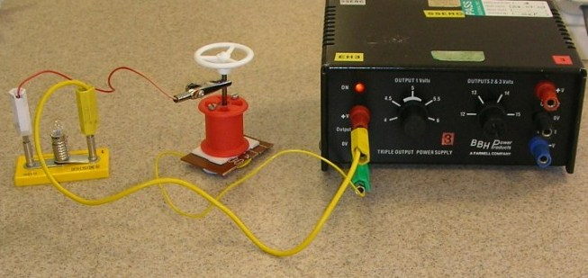

QTC (quantum tunnelling composite)

QTC, discovered by accident, is a composite whose resistance varies dramatically with applied pressure.

What you need:

QTC pellet in test rig, multimeter set to measure resistance, masses, power supply, bulb.

What to do (1):

- Connect the lead with the croc clip to the shaft of the test rig.
- Connect the other ends of the test rig leads to the ohmmeter.
- Change the resistance scale on the meter until the reading is neither zero nor infinite (infinity is shown by a “1” at the left of the display).
- Put a 100 g mass on the test rig.
- Record the new resistance. You may need to alter the meter’s scale.
- Repeat for a range of masses.

What to do (2):

- Connect the bulb and test rig in series to the 6 V terminals of the power supply.
- Press on the top of the test rig, or add masses to it.
- Note the effect on the bulb.

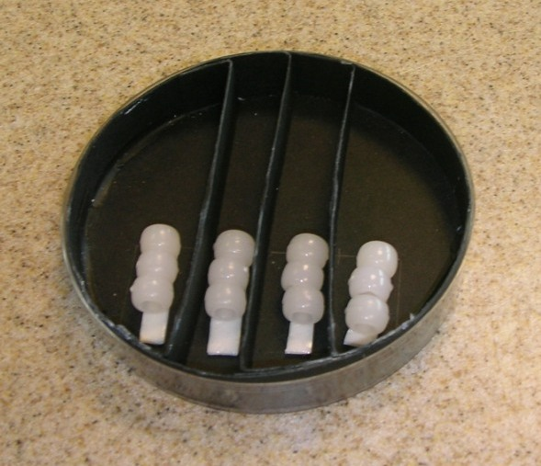
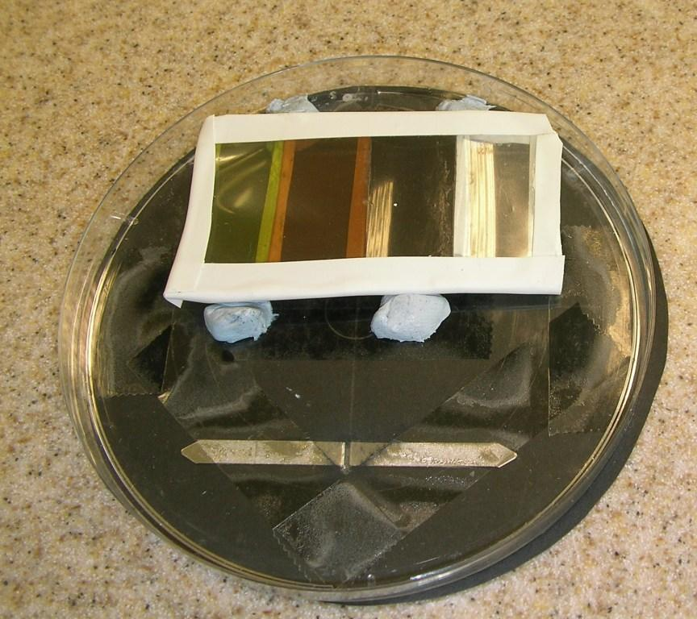
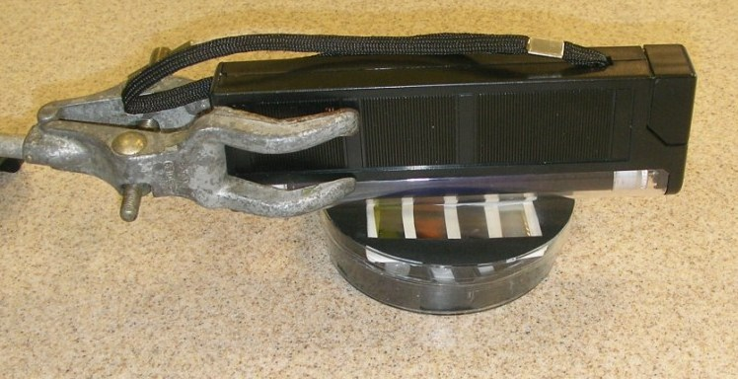

Ultraviolet (UV) sensitive beads.

These beads are sensitive to ultraviolet light and turn vivid colours when exposed to sunlight or artificial sources of ultraviolet radiation. When removed from UV, they revert to white. Here, we use them to test which colour of plastic would be most suitable for a bottle containing medicine that was unstable in UV light.

What you need:

UV bead kit, strip of different-coloured plastics, UV lamp, clamp stand.

What to do:

- Stick the strip of coloured plastic to the inside of the UV kit lid, over the “window” cut into the card.
- Put the lid on the kit.
- Open the card window to check that there is a row of beads under each strip of coloured plastic.
- Close the window. Wait a couple of minutes if the beads had any remaining colour.
- If using sunlight, go outside. Open the card window and expose the beads to sunlight through the different plastics.

- If using a lamp, clamp the lamp above the open card window. Switch the light on. Note the safety advice. Expose the beads to UV through the coloured plastics.
- After a couple of minutes, have a look at the beads. Which plastic blocked the UV most effectively?

You may have to experiment with the exposure time to be able to compare the plastics effectively.

Safety:

- Avoid looking directly at the UV light.
- Avoid unnecessarily irradiating your skin with UV.

Electrolycra

Electrolycra is a fabric that has been sprayed with a conducting material. It therefore conducts electricity, but its resistance varies with stretch.

What you need:

Strip of electrolycra, ruler, multimeter, leads, croc clips.

What to do:

- Set the multimeter to measure resistance. The 200 Ω scale is probably most suitable.
- Connect the strip of electrolycra to the meter using leads and croc clips.
- Lay the strip alongside the ruler. Record its length and the resistance.
- Stretch the strip by 0.5 cm. Record the new length and resistance.
- Repeat for several readings.
- Comment on your findings.

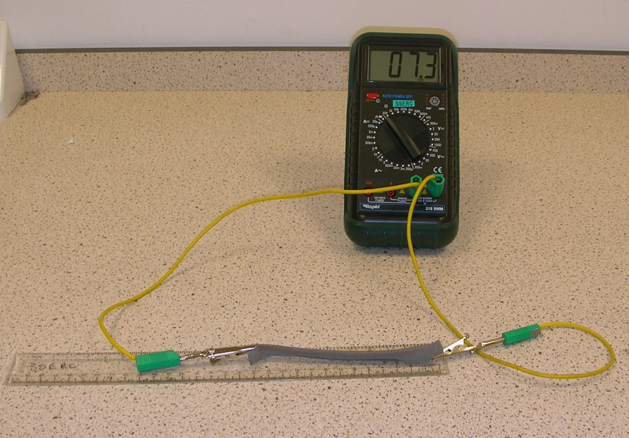
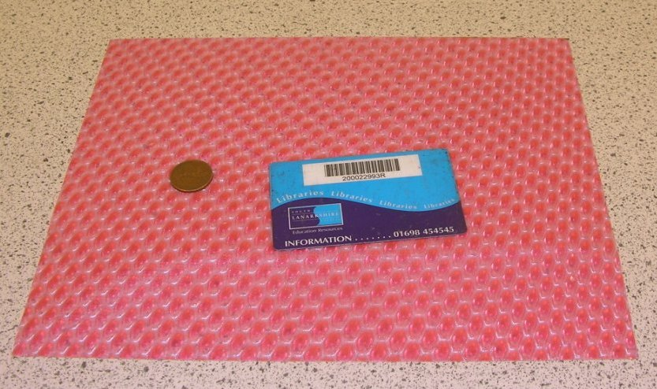

Lenticular polypropylene

This material has a surface pattern that creates an interesting optical effect.

What you need:

Lenticular polypropylene sheet, coin, credit card or similar

What to do:

- Place the coin and car on the sheet of lenticular polypropylene.
- View from above.
- Repeat, having turned the sheet over.

Note:

We have heard that using this material as a picture frame adds an apparent 3-D effect to a photograph.

Note:

A commercial product, D3O®, has similar properties. It is built into some brands of motorcycle and ski clothing to give impact protection whilst till remaining flexible.

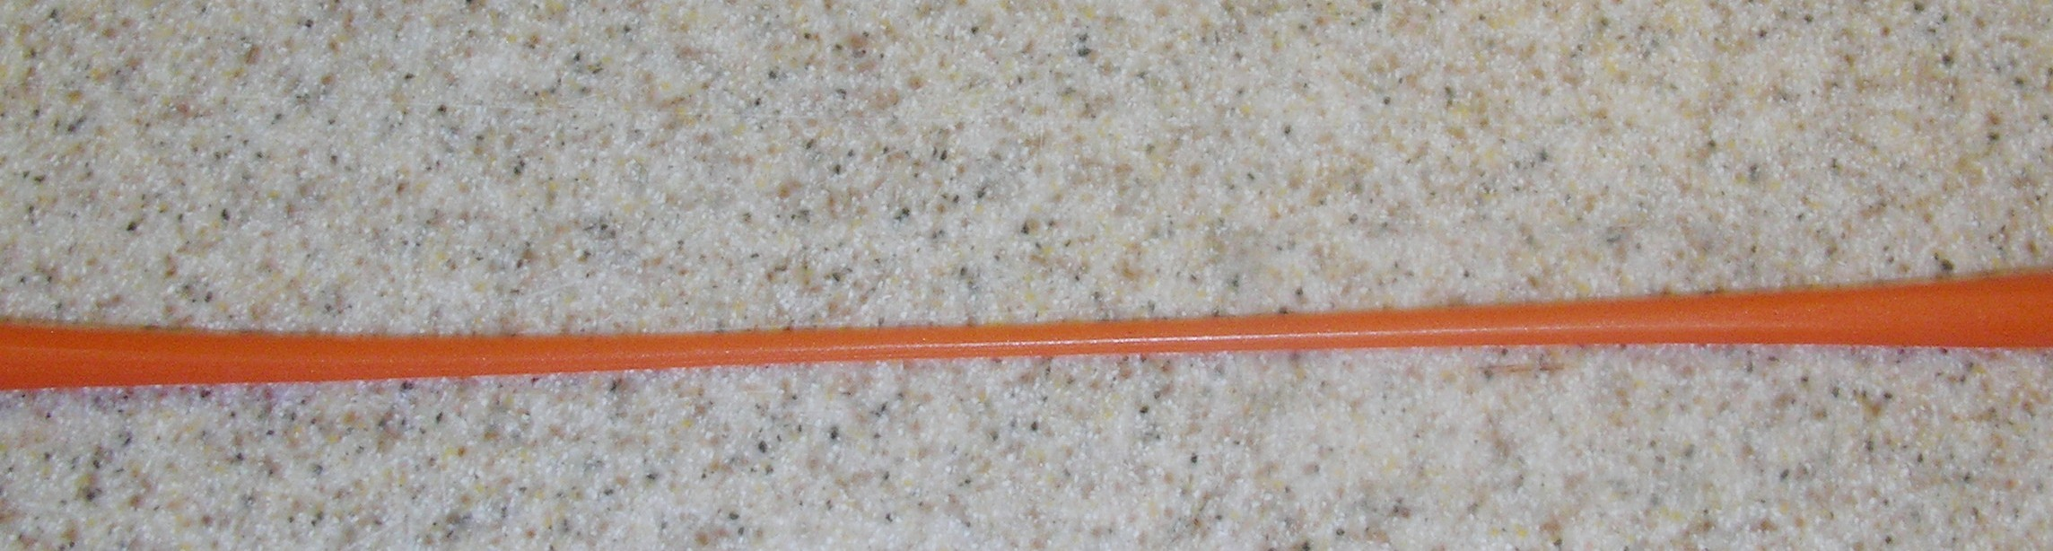
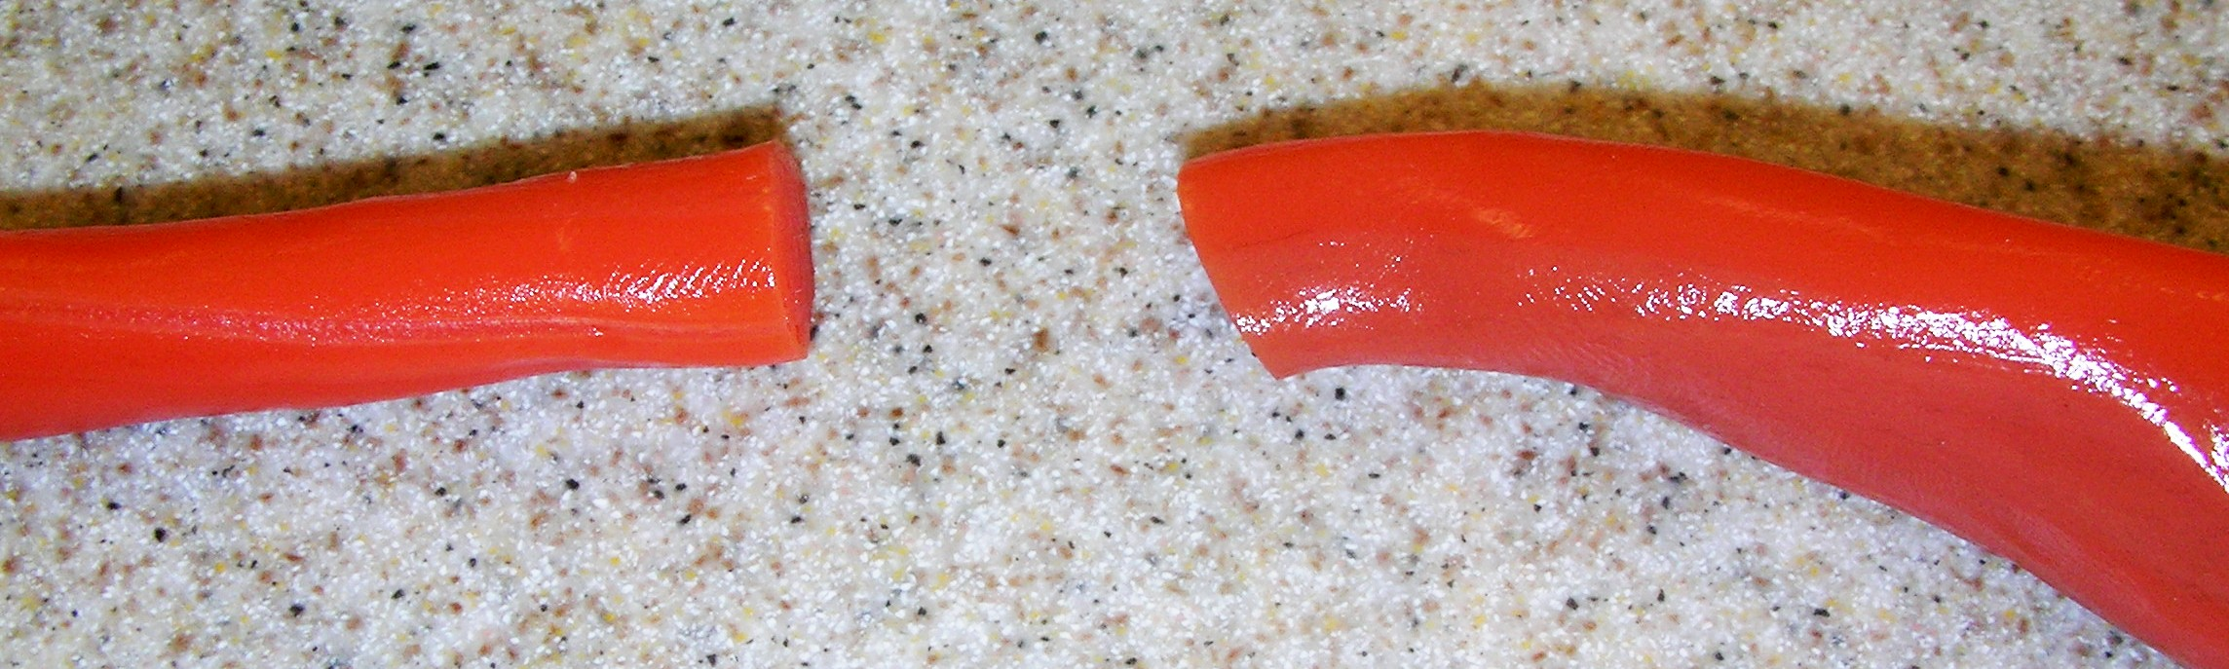

Smart putty

Smart putty is thermochromic and shear thickening.

What you need:

Piece of smart putty

What to do:

- Roll out the smart putty into a snake shape.
- Hold an end in each hand.
- Slowly pull the ends of the smart putty.
- Repeat, but give the ends a sharp tug.
- Now roll the smart putty into a ball.
- With due consideration to those around, throw the ball at the floor or wall.

About the Materials

All materials come from Mindsets (www.mindsetsonline.co.uk)

Polymorph is similar to the glue used in glue guns. It melts at around 62°C, turning transparent when it does. It remains workable at temperatures well below this, but is set at room temperature.

Shape Memory Alloy is an alloy of nickel and titanium. It has two crystal structures and transforms from one to the other at a certain temperature. When it returns to its high temperature state, it also takes the form it had when last in that phase. The transition temperature depends on the blend of the alloy. Ours changes at about 90°C, but there are forms that will do so at body temperature. These are used for stents, for example. By constraining the material in a jig and heating it to several hundred degrees Celsius, then cooling it rapidly, the material can be trained to “remember” a new shape. Interestingly, the material contracts as it approaches its transition temperature, making it useful for “muscle wire” in robotics when heated electrically.

Shape Memory Polymer can be heated and reshaped, but returns to its original shape when reheated.

Thermochromic Film changes colour according to temperature. It is a liquid crystal-based material. The quantities of chemicals used to make the liquid crystal can be varied, thus changing the colours at particular temperatures.

Quantum Tunnelling Composite was discovered by accident by David Lussey. He was trying to make an electrically conductive glue by incorporating metal granules in a polymer. The resistance of QTC drops dramatically when pressure is applied, effectively turning it from an insulator to a good conductor. This makes it useful as a non-sparking switch. It is also useful for touch-screen technology, where the amount of pressure exerted affects the action, for example, a harder press can give faster scrolling on a smart phone. In QTC, the metal granules do not actually touch, even when the material is squeezed. Classical physics cannot explain how it therefore conducts electricity, but quantum mechanics can. As the granules are squeezed closer together, there is an increased probability that electrons can move from one granule to another.

UV Sensitive Beads change colour in the presence of ultraviolet light. The colour change reverses in the absence of UV.

Electrolycra is conventional Lycra®, sprayed with silver to make it conductive. Its resistance increases when it is stretched, up to a point beyond which it decreases.

Lenticular Polypropylene has a surface that is shaped to reflect light in such a way as to give the illusion of depth.

Smart Putty

Smart putty is also thermochromic – it changes colour from red to yellow when heated. It is also shear thickening (also known as dilatant). When a force is applied, it becomes more viscous. Thus, if this putty is stretched gently, it forms a long, thin strand, but if it is pulled apart abruptly, it snaps. If it is formed into a ball that is then thrown, it will bounce.

Smart Materials

This is a term for materials that appear to respond intelligently to their environment. Many of the novel materials here are also smart, such as UV beads, thermochromic film and shape memory alloys, but others, such as polymorph, are not.

Health and Safety

Where there is a significant hazard associated with any of the activities described in this booklet, a customisable risk assessment has been supplied on your pen drive.

Please contact Gregor Steele at SSERC for further information or support.

gregor.steele@sserc.org.uk

