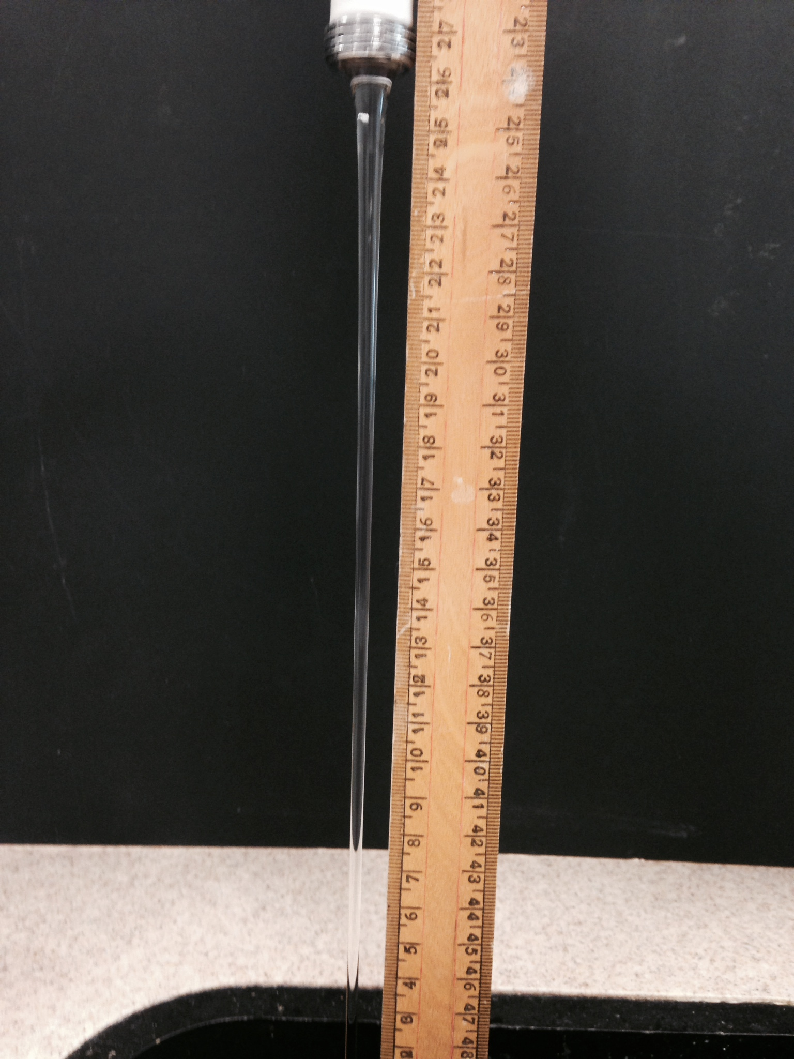
Measuring g by flow rate.
The following theory is consistent with Bernoulli’s theorem, but has been recast in terms more accessible to an Advanced Higher student.
Note that we will use non-standard units of cm³ and cm s¯¹ for convenience.
Imagine water emerging from a tap at a rate of X cm³ s¯¹
Suppose the water has a velocity of u cm s¯¹
Suppose the stream has a radius of r₁ at this point
The cross sectional area A₁ of the stream is therefore π r₁²
It follows that the volume of water per second X = A₁u.
Rearranging: u = X/A₁
As the water streams downwards, it will speed up. The volume per second X will not change – if X cm³ leaves the tap per second, X cm³ enters the sink every second.
Suppose that at some point, the velocity of the water has increased to v.
v = X/A₂ where A₂ is the cross sectional area of the stream at this point.
Since v is greater than u and X has not changed, A₂ must be smaller than A₁. We can see this in the above picture – the stream narrows as the water travels downwards.
X can be measured by finding the time to collect a particular volume of water.
A₁ and A₂ can be found by finding the diameters of the stream at two points, then halving them to get r₁ and r₂.
u and v can then be calculated.
The vertical separation s will need to be measured too.
Using the equation v² = u² + 2 a s, the acceleration due to gravity can be found.
Making measurements
We have seen advice stating that a travelling microscope should be used to find the diameter of the stream. We have two alternative methods. Both involve photographing the stream with a ruler alongside it. The ruler must be in the same plane as the stream.
The photograph can then be projected and measurements made. These measurements are then scaled, the scale being determined by the ruler.
Alternatively, the photograph can be loaded into the free Tracker application.
With Tracker open, go to Video and choose Import.
Navigate to your photograph.
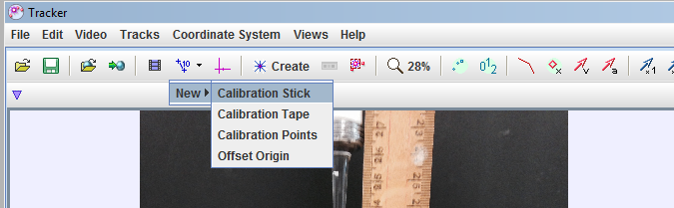
Go to the calibration tools.
Choose New… Calibration Stick
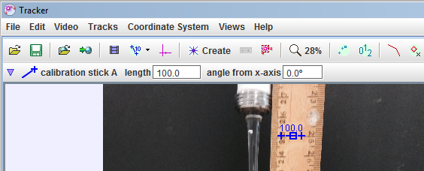
Move your mouse to the middle of the blue line that appears. Drag one end of it to a prominent marking on the ruler in the picture.
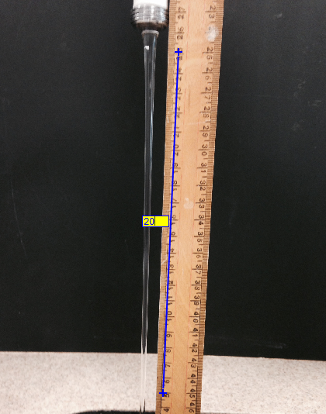
Move your mouse to the other end of the blue line.
Drag the end of the line down to another prominent marking, the further away from your first marking the better (to reduce percentage uncertainties).
Click the “100” beside the blue line and replace it with the number of centimetres between the start and end of your line. We chose to stick with centimetres.

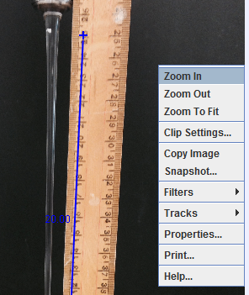
Now right-click on your image in Tracker and choose Zoom In.
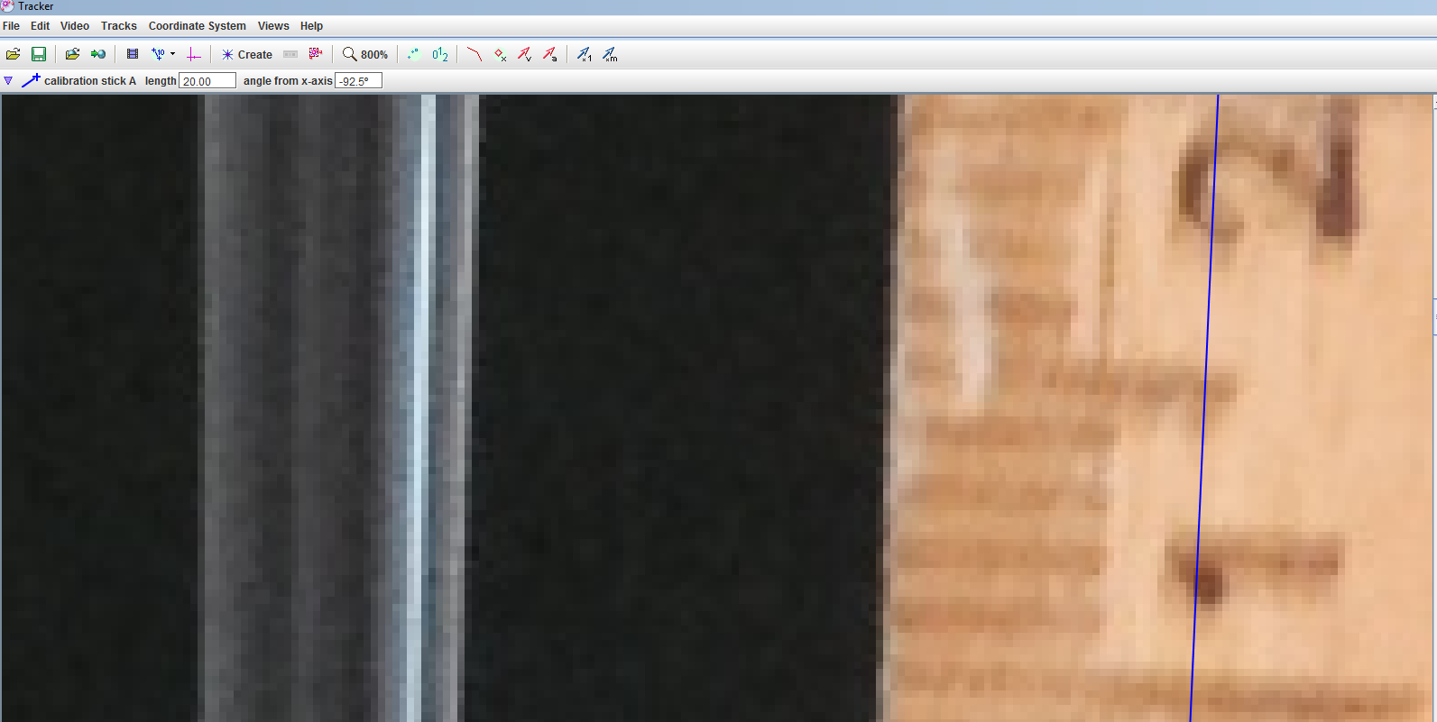
Keep zooming until your image is as large as possible consistent with being able to see the full width of the water column and the markings on the ruler. (It’s actually not necessary to see both as you can use the scroll bars to go from ruler to stream, but it will be much easier if you can.)
Go to the calibration tools button where you got the calibration Stick, but this time choose Calibration Tape.
A blue double-ended arrow should appear. If you can’t see it, you may have to use the scroll bars.
Move the arrow to a point near the top of the stream, opposite a prominent ruler marking.
Drag the ends of the arrow until the tape is measuring the stream diameter as shown below.
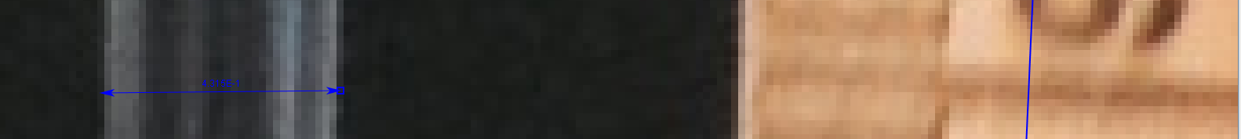
Record the diameter. It will be in cm, and note that Tracker uses a scientific notation format.
This will be your zero displacement reading.
Move down the column using the scroll bars and measure the diameter say 0.5 cm or 1 cm further down from your zero reading. Record the reading.
Repeat for several readings.
We recommend entering the data into a spreadsheet. Use the spreadsheet to calculate the stream velocity from the diameter and flow rate as described earlier.
Plot velocity squared versus displacement. The graph should be a straight line of gradient 2g (in cm s¯²). The y-intercept will be the velocity squared at displacement zero.
Here’s one we made earlier:
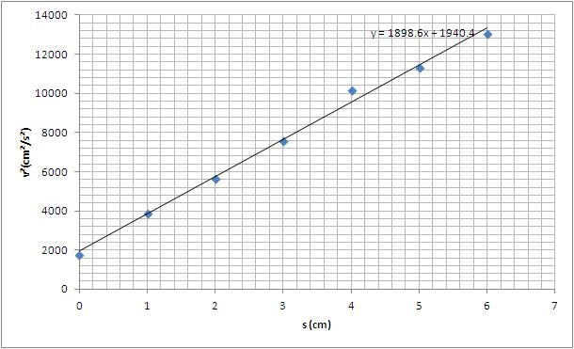
Sometimes we noticed that at larger values of s, linearity broke down. We concluded that the stream was becoming unstable at this point, hence the theory would not apply. We used only the linear section of the graph to find g.

