The Wonderful Wizardry of Finding a Gene

Introduction
Pupils have a great interest in all things forensic, particularly as a result of watching such TV programmes as CSI. Many pupils are therefore likely to have heard of DNA profiling, and may be curious to find out more. Besides its use in solving crimes, it can also be used to: track the evolution of living organisms and movements of species; study genetic diversity; carry out gene profiling; and establish human relationships (e.g. in paternity or immigration issues).

DNA profiling makes use of the technique of gel electrophoresis, whereby large molecules of the same type within a mixture (in this case DNA) can be separated by size on the application of an electrical voltage. The gel is porous and so small molecules can move faster through the gel than large ones. Small molecules therefore travel further in a given time. Molecules of the same size travel the same distance and form a band on the gel. These bands of DNA can be stained to make them visible, so that the pattern of the bands can be assessed. In the case of DNA, the familiar ‘DNA fingerprint’ so often seen in the media, is characteristic of a particular individual. Hence its usefulness in the areas outlined above.

The aim of this activity is to allow pupils to carry out simple gel electrophoresis in order to simulate DNA Profiling. The protocol uses mixtures of food colouring instead of DNA. On application of a voltage across the gel, the mixtures separate into bands of their individual colours. Each colour represents a gene for a ‘magic power’ so that this fun protocol allows pupils to identify the ‘magic power genes’ possessed by each of the wizards.

Setting up the Activity
For this activity, you need electrophoresis tanks, four-well combs, leads, carbon fibre electrodes, batteries or transformer, agar, water, mixtures of food colourings and micropipettes. Agar, water and mixtures of food colourings are used instead of the more expensive agarose, buffers and DNA required for DNA fingerprinting. Four-well combs are used in preference to six-well combs as this allows for inexpert technique to be more successful.

The gel electrophoresis equipment necessary for this practical work formed part of the ‘Protein Power’ kit produced by the National Centre for Biotechnology Education. and distibuted free to all schools in Session 2002/3. However, additional equipment may be purchased from the National Centre for Biotechnology Education (NCBE). For a full price list see: www.ncbe.reading.ac.uk. (at the time of going to press the ‘Electrophoresis Base Unit’ containing eight tanks plus supporting equipment costs £50).

Preparation of gels

These can be made up in advance for the pupils. For ten tanks you will require approximately160 cm³ of molten agar (i.e. 16 cm³ per tank).

1. Make up a 3% w/v solution of agar (i.e. 6 g agar in 200 cm³ water) in a stoppered flask and heat on a hotplate stirrer or boiling waterbath until the agar melts and the solution goes clear.
- Cool agar to 60ºC in a water bath.
3. While agar is cooling, slot the combs into electrophoresis tanks and place on a level surface.
- Pour the molten agar into the centre of each tank so that it flows between the teeth of the comb. The agar should be about 5 mm thick so that its surface is level with the plastic ridges which form the end channels.
- Leave the gels to set (approximately 10 minutes) and then remove the combs gently.
- Cover the gels with water to prevent them drying out, topping up as required.

Preparation of ‘Wizard DNA’ samples

The ‘Wizard DNA’ is made by mixing liquid food colourings. Colours may vary depending on brand or shade of food colouring. We have used green, blue, yellow and black colouring of several brands and found them all to undergo satisfactory separation as a result of gel electrophoresis. Sucrose is added to make the mixture more dense. This helps the samples sink into the wells.

Method
- Add 3 g sucrose to every 5 cm³ of dye and dissolve.
Note: for ten groups, each with four mixtures, a total of 12.5 cm³ green, 5 cm³ blue, 2.5 cm³ yellow and 1 cm³ black food dye is required).
- Make up the required volumes in labelled tubes with food colouring mixed in the proportions shown:

Tube label | Food colourings
1 | Green
2 | 1 blue: 1 yellow
3 | 1 green: 1 black
4 | 1 blue: 1green
NB See article on Food dyes and electrophoresis

- Aliquot 0.5 cm³ of each mixture into small, labelled tubes for the pupils. The labels can be numbers or letters which may relate to the names of the wizards (e.g. ‘H’ for Harry, ‘D’ for Dumbledore, etc).

Pupil procedures

- The four types of ‘Wizard DNA’ are loaded into separate wells using a micropipette from NCBE with a different tip for each sample (Fig 1 & 2). It may be worth spending a little time on the use of such pipettes beforehand. 20 µl of each sample is loaded and should sink to the bottom due to the presence of sucrose in the mixture. Pupils must ensure that the tip of the pipette lies below the surface of the water (Fig 3), but does not pierce the gel at the bottom of the well. Should this happen, the ‘DNA’ will disappear under the gel.
- The carbon fibre electrodes are then placed at either end of the tank (Fig 4) and connected by wires and crocodile clips to the batteries .The black (-ve terminal) clips go at the end nearest the wells, with the red clip at the vacant +ve terminal of the battery (Fig 5).
- The apparatus can be left to run for as little as 10 minutes to see that the ‘Wizard DNA’ separates into different coloured bands (Fig 5). The wires should then be removed from the battery and tank and the water poured off. The bands of colour can then be examined and the magic power genes possessed by each wizard can be identified.

The table below shows the allocation of powers to particular genes in the story developed by SSERC.
Colour | Power | Ability Conferred
Yellow | Psychokinesis | Can move objects from place to place through thought
Pink | Transfiguration | Can change one object into another
Blue | Vanish | Can disappear in a puff of smoke
Red | Evil | Cannot block out evil
Orange | Creation | Can create objects from nothing

Applications

The Wizard Gene scenario provides a non-contentious lead-in to discussion of potentially difficult ethical dilemmas. It can be used to raise the question of whether possession of genes for a particular characteristic necessarily leads to an individual displaying that characteristic. This in turn may provoke discussion of the ethical issues involved in gene testing.
The activity was originally developed to reflect interest in the Harry Potter and Lord of the Rings books and films. Teachers may wish to adapt the protocol for a variety of different scenarios in which different properties are allocated to the coloured ‘genes’.

This practical is one of a suite of resources developed by SAPS and SSERC to support the ‘Inheritance’ content of 5 – 14 Environmental Studies: Science. It was produced for the Improving Science Education through CPD project and is included in SAPS/SSERC 5 – 14 Biotechnology workshops.

Figures
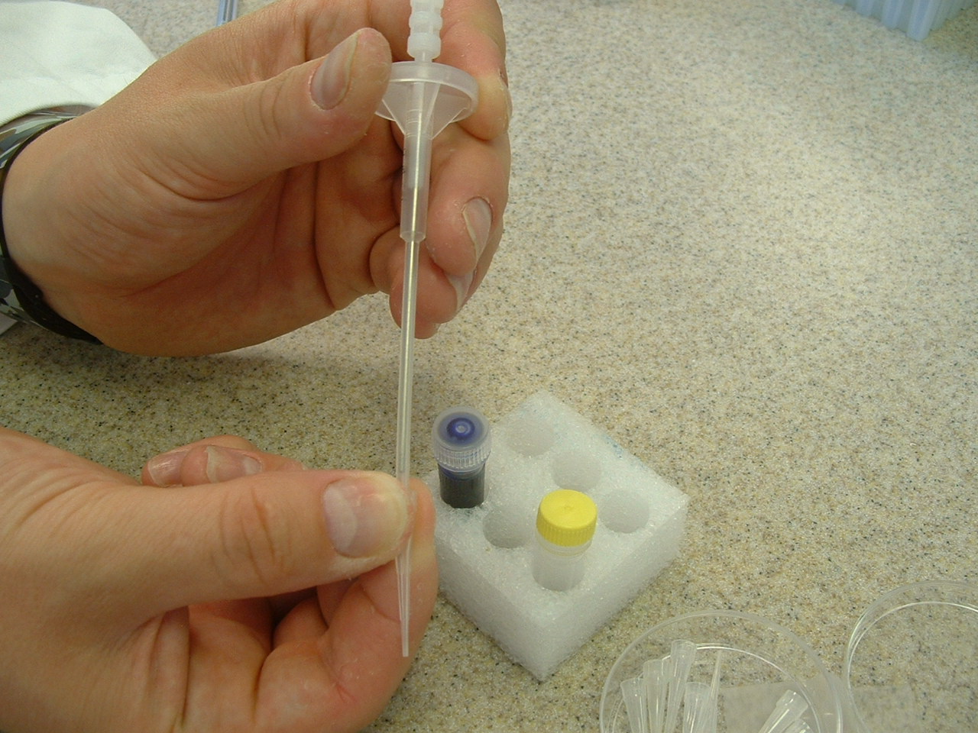
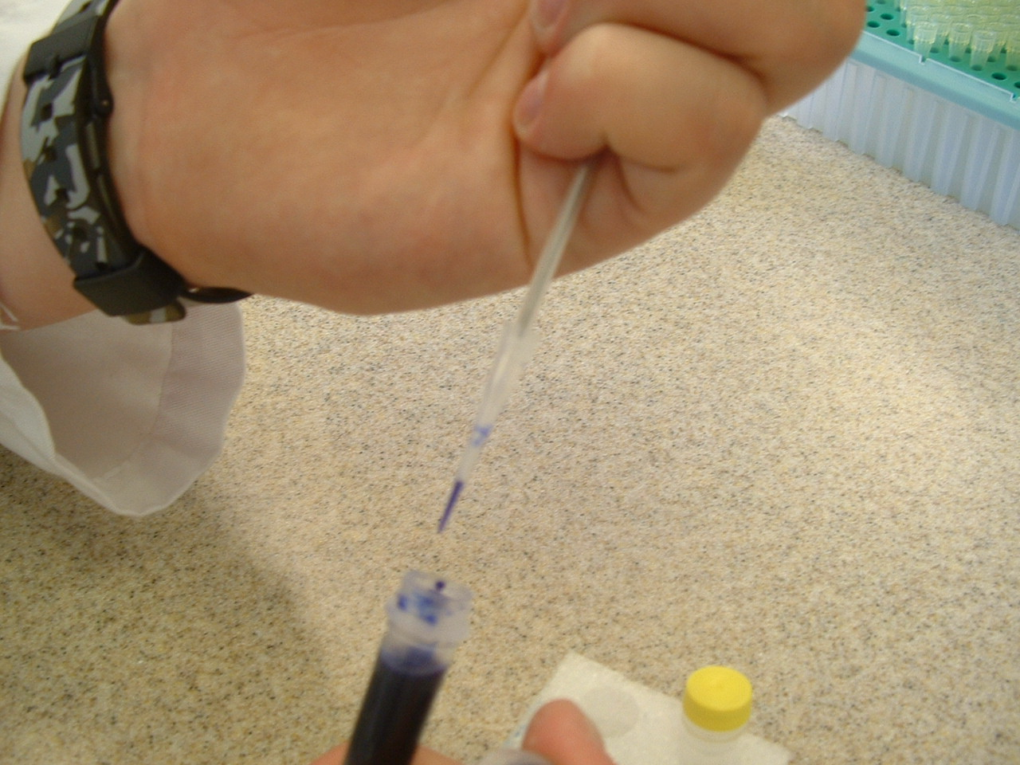

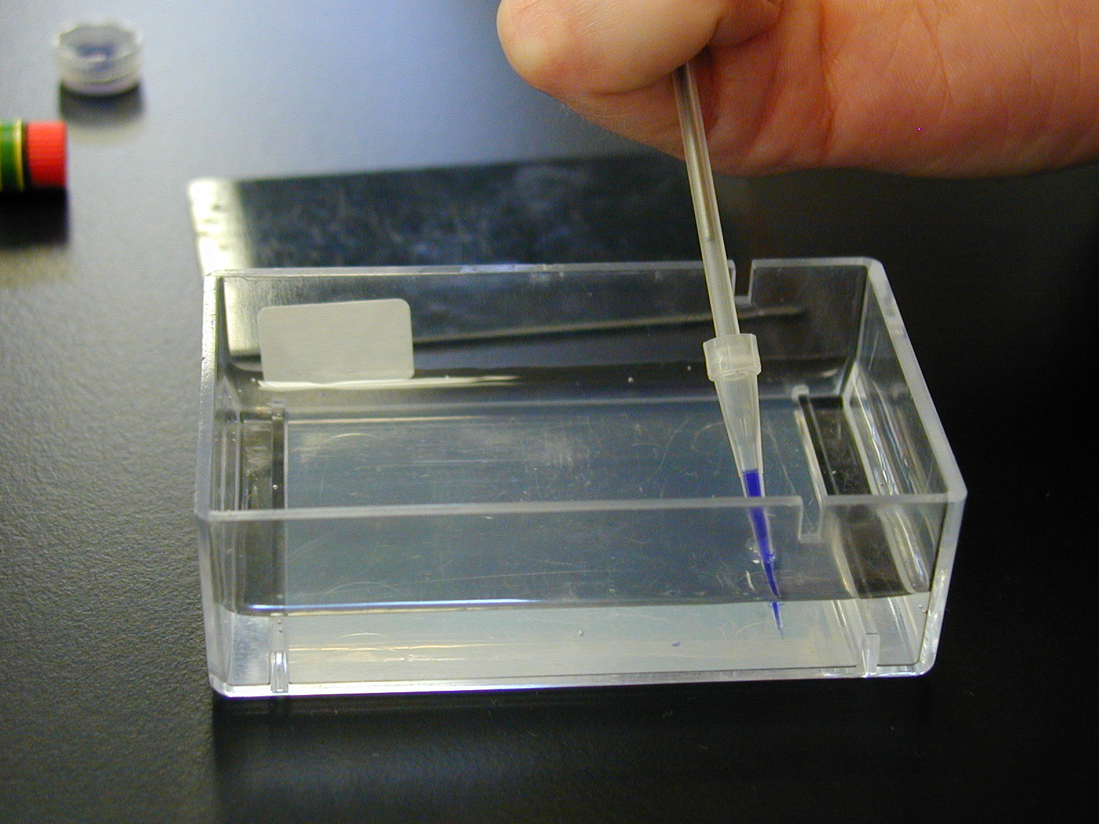
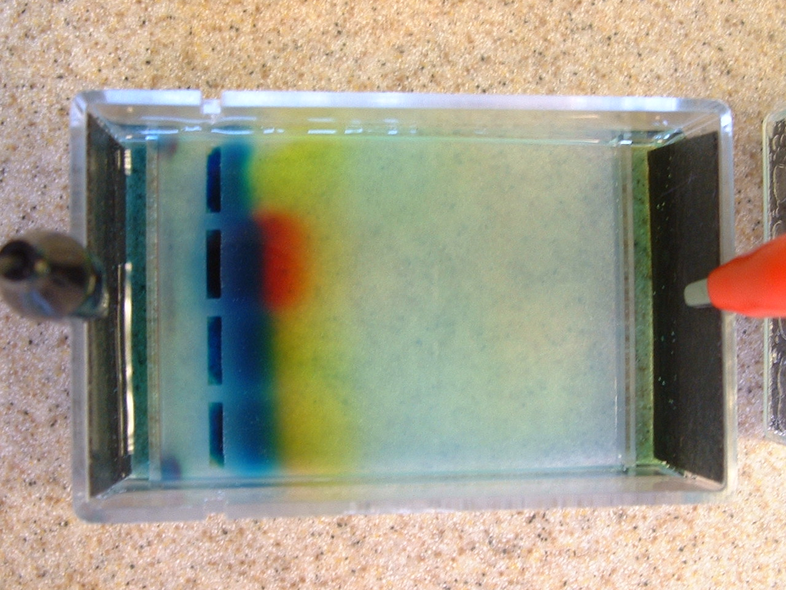
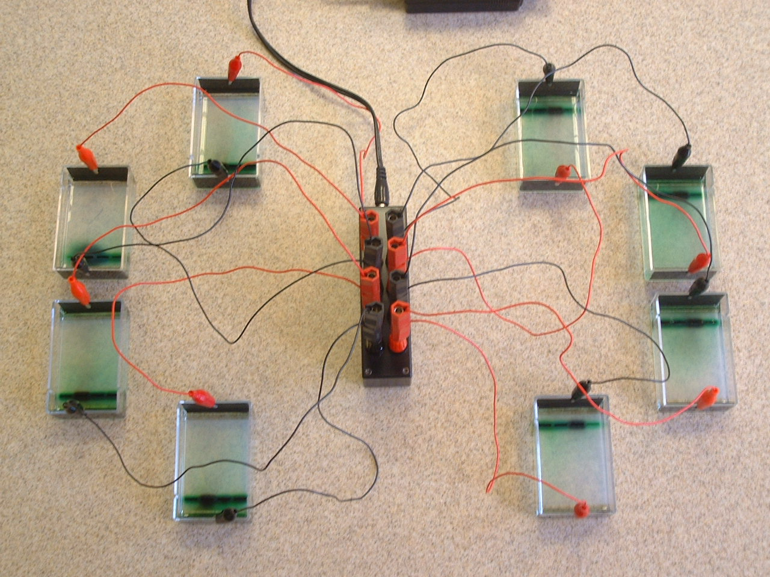
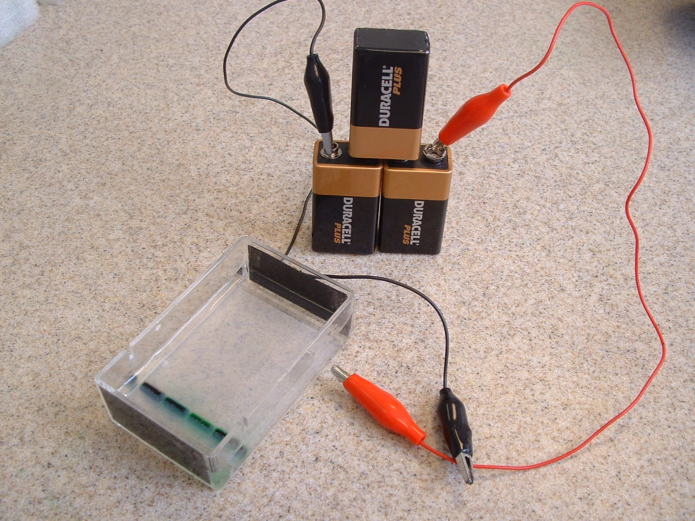
Fig 1&2: NCBE micropipette used to load the ‘DNA’into the gels
Fig 3: Loading the ‘DNA’ into the gel tank. Note that the tip of the micropipette is under the water
Fig 4: Loaded gel tank ready to be connected to three 9V batteries
Fig 5: Voltage applied to the gel tank causes the ‘DNA’ mixtures to separate, resulting in characteristic banding patterns
Fig 6: No need for 9V batteries! (see next issue)

Detailed instructions for use of gel tanks were included in the original kits. Call SSERC if more instructions are required.
Using 9V batteries for a whole class can be cumbersome and somewhat expensive. The next issue of the bulletin will outline a battery-free method which can be used for up to eight tanks at a time (Fig 6).
This practical should run within the timescale of one teaching period, allowing the results to be observed and discussed. However, the results cannot be held over to the next lesson; food colouring molecules are of low molecular weight, and so they dissipate quickly through the gel.

