
Use of UV-sensitive yeasts at Higher
and Advanced Higher

Practical work involving the use of a mutated strain of Saccharomyces cerevisiae which is sensitive to UV light is suggested as a learning activity to support learning and teaching of aspects of the content of the CfE Highers in Biology [1] and Human Biology [2]. We believe that such practical work could also serve to help learners develop their understanding of Investigative Biology and associated skills at Advanced Higher and as a foundation on which students could base an Advanced Higher Investigation [3].
The experimental work referred to in this document was initially adapted by Alison Rutherford from practical protocols produced by the Carolina Biological Supply Company (www.carolina.com). An article entitled ‘How much sun is too much?’ was published in SSERC Bulletin 228 and provides background to and description of the practical work [4]. The article describes 2 practicals:
- The effect of UV radiation on the survival of UV-sensitive yeasts
- Investigation into the protection conferred by sunscreens on UV-sensitive yeasts exposed to UV radiation
In today’s session, we shall carry out an investigation into the effectiveness of sunscreens of different strengths at conferring protection on UV-sensitive yeasts from exposure to sunlight for one hour.
The UV-sensitive yeasts are sourced from Blades Biological (www.blades-bio.co.uk/), Product ID LZB106, cost £11.12 (£13.34 inc. VAT). The yeasts are grown on Yeast Glucose Agar (YGA).
Prior to the practical being carried out, YGA plates should be streak-inoculated with UV-sensitive yeast and incubated at room temperature 2-3 days to allow distinct colonies of a reasonable size to grow. Plates can then be kept in the fridge until required.

To carry out the practical, a single colony from one of these stock plates is suspended in 10 cm³ Ringer’s solution. This suspension is then serially diluted tenfold until a solution of 10⁻³ is achieved. 5 YGA plates are then inoculated with 100 µl of the 10⁻³ suspension using the spread or lawn technique. Each of these plates is then subjected to a different treatment (see table below), radiated with UV for one hour, covered with aluminium foil and incubated for 2-3 days at room temperature. The number of colonies that have grown can then be counted and conclusions drawn about the effectiveness of the treatments.

Plate 1 | Plate 2 | Plate 3 | Plate 4 | Plate 4
Covered with aluminium foil | No cover | E45 | SPF x | SPF y

Note:

1. Guidance on microbiological practical work and techniques can be found in Safety in Microbiology: A Code of Practice for Scottish Schools and Colleges (available on the SSERC website [5, 6]).
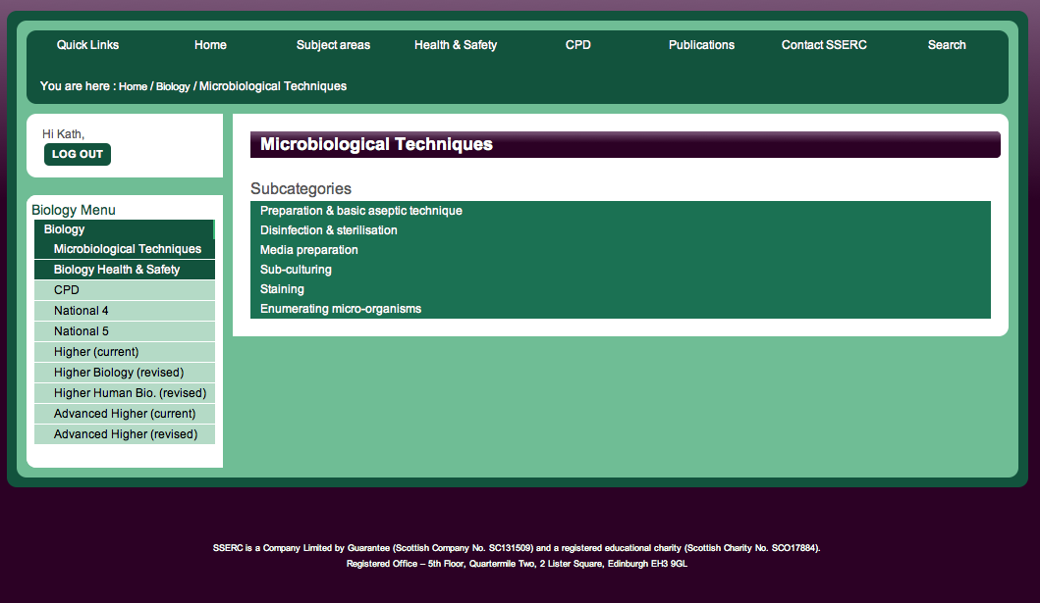
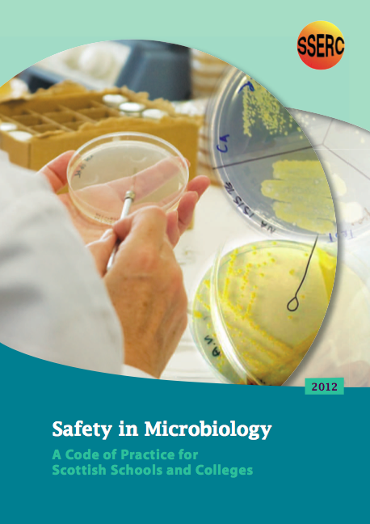

2. Use eye protection when carrying out the serial dilution.
Materials
Bunsen burner, lighter and mat Paper towels
Disinfectant (1% bleach) Pen for labelling
Discard jar with 1% VirkonTM Aluminium foil
Stock plate of UV-sensitive yeast SellotapeTM
Wire loop or sterile, disposable plastic loops Spatula
Sterile Universal with 10 cm³ Ringer’s sol^{n} Sunscreens, or filters
3 x sterile Universals with 9 cm³ Ringer’s sol^{n} Stopwatch
Disposable sterile 1 cm³ pipettes
5 YGA plates
Plastic spreader and 3 plastic discs

Method

(1) To prepare a serial dilution

- Wash your hands, and clean your work area with 1% bleach.
- Label the bottles with the appropriate dilution:
Bottle containing 10 cm³ Ringer’s solution – starter; Universal bottles containing 9 cm³ Ringer’s solution - 10⁻¹, 10⁻², 10⁻³. At this stage it is useful to loosen the bottle lids slightly – they are often very tight after autoclaving and hard to remove.
- Using aseptic technique, transfer one small, isolated colony of UV-sensitive from the stock plate to the bottle containing 10 cm³ Ringer’s solution and labelled ‘starter’. Tilt the bottle and swirl the loop in the media (as demonstrated) to transfer as many as possible of the yeast cells into the solution before replacing the lid. Discard the loop into discard jar.
- Flick the Universal bottle to separate the clumps and ensure the cells are distributed throughout the liquid.
- Using aseptic technique and a disposable sterile pipette, transfer exactly 1 cm³ of the fluid from the starter bottle into the bottle marked 10⁻¹. Mix well.
- Repeat step 5 until you have a 10⁻³ solution.
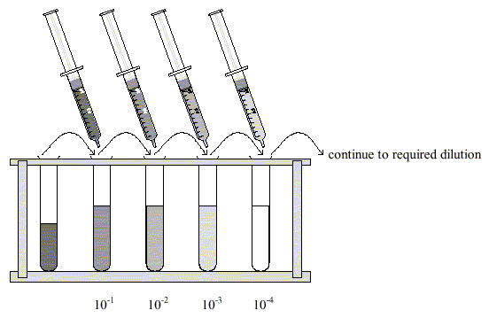
7. Wrap bottles in foil to prevent exposure to UV light.

(2) To test the effectiveness of sunscreens with different SP factors
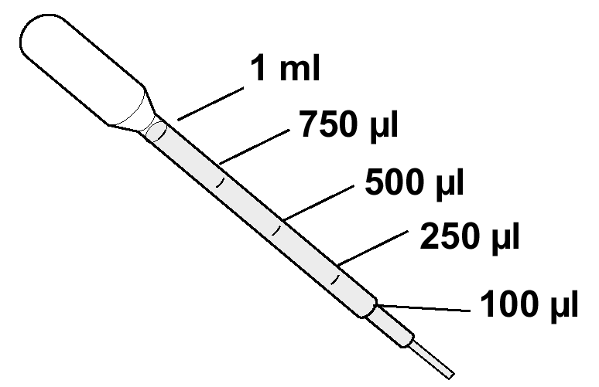
- Label all plates on the underside with date, your initials, UV-sensitive yeast dilution factor, and treatment (e.g. SP 6, SP 30)
- Using aseptic technique and a disposable sterile pipette, transfer 100 µl yeast culture into a Petri dish.
- Using aseptic technique, spread the culture evenly over the surface using a loop.
- SellotapeTM the Petri dish closed with two small pieces of tape.
- Repeat this for the other four plates.
- Wrap plate 1 in aluminium foil.
- Apply sunscreen, or E45, to plates 3, 4 and 5 by placing a ‘petit pois-sized’ piece of sunscreen to a plastic disc, spreading it with the plastic spreader and placing the disc over the lid of the Petri dish. Make sure the appropriate disc is put on to its correspondingly labelled plate!
- Cover each plate with foil until you are ready to irradiate.
- Irradiate all 5 plates for one hour by placing in sunshine or using a UV lamp.
- Remove the plastic discs.
- Wrap the plates in aluminium foil again.
- Incubate all five plates for 2-3 days at 30ºC
- Count the number of distinct colonies on each plate.

References
- Higher Biology Course Support Notes, Page 30 Unit 2, Genetic Control of Metabolism http://www.sqa.org.uk/files_ccc/CfE_CourseUnitSupportNotes_Higher_Sciences_Biology.pdf (accessed 18.06.2013)
- Higher Human Biology Course Support Notes, Page 14 Unit 1, Genes and proteins in health and disease http://www.sqa.org.uk/files_ccc/CfE_CourseUnitSupportNotes_Higher_Sciences_HumanBiology.pdf (accessed 18.06.2013)
- Advanced Higher Biology Course/Unit Support Notes, Page 55 onwards, Unit 3 Investigative Biology http://www.sqa.org.uk/files_ccc/AHCUSNBiology.pdf (accessed 18.06.2013)
- SSERC Bulletin 228, How much sun is too much? http://www.sserc.org.uk/index.php/bulletins226/2009/228-summer-2009/1184-how-much-sun-is-too-much (accessed 18.06.2013)
- Safety in Microbiology: A Code of Practice for Scottish Schools and Colleges http://www.science3-18.org/sserc/images/Publications/Biology/SSERC-Safety_in_Microbiology_Code_of_Practice.pdf (accessed 18.06.2013)
- Microbiology Techniques http://www.sserc.org.uk/index.php/biology/health-a-safety-home151/microbiological-techniques265 (accessed 18.06.2013)

Appendix 1

Preparation of Yeast Glucose Agar
Materials (for 1 litre)
20 g glucose
10 g yeast Extract
2 0 g agar
0.1 M sulfuric acid or 0.1 M sodium hydroxide
Distilled water
Instructions

1. Wear lab coat.
2. Weigh glucose and yeast extract into a beaker.
3. Add distilled water to 1 litre mark.
4. Stir thoroughly and adjust to pH 6.
5. Add agar.
6. Autoclave @ 121°C for 15 min.
7. Pour plates as described in Microbiology Techniques section of SSERC website . If the plates are going to be used immediately, 15 cm³ agar per plate will be adequate.

Note: Some recipes use 20 g Bactopeptone, in our experience when culturing yeasts and moulds this is not required

