The Problem with Lactose....

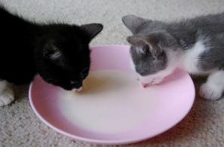

Most people believe that cats are fond of milk. It may be surprising to learn that many cats cannot tolerate cow’s milk; it upsets their digestive system making them sick. The problem is that lactose (sometimes called milk sugar) cannot be digested in large amounts by cats. This is because the enzyme lactase is not produced by their digestive system in large enough amounts to digest lactose properly. This condition is known as lactose intolerance.

Manufacturers of pet food have addressed the problem of
lactose intolerance in cats by producing ‘cat-safe’ milk.

This may seem like a trivial problem, however lactose intolerance is also a problem for humans. Around 75% of the world’s population are intolerant of lactose when they reach adulthood.

Lactase is an enzyme which speeds up the breakdown of lactose molecules to smaller molecules of glucose and galactose.
lactase
lactose → glucose + galactose


Lactase is used in the production of lactose-reduced milk for people and cats who have problems digesting lactose.

How might we demonstrate that lactase breaks down the lactose in milk to glucose and galactose.

The Breakdown of Lactose by Lactase.
This can be done by manufacturers of reduced-lactose milk in two ways:
- Lactase can be injected into the cartons as UHT milk is being packaged.
- Milk can be treated by enzymes which have been ‘immobilised’.
An enzyme is immobilised when it is trapped on pellets of gel so that it cannot move freely in a solution. The enzyme is, therefore, easily separated from the products of a reaction and can be used over and over again.
In this activity you will immobilise lactase on beads of gel and then use the beads to treat milk.
Step 1 Immobilise the Enzyme
Materials

- Lactase enzyme
- Sodium alginate solution
- Calcium chloride solution
- Small measuring cylinder
- Plastic dropping pipette
- Stirring rod
- Two small beakers labelled 1 and 2
- Tea strainer

Method
- Put 100 cm³ of calcium chloride solution into beaker 1.
- Into beaker 2 put 8 cm³ of sodium alginate solution.
- Using the dropping pipette add 2 cm³ of lactase solution to the sodium alginate solution in beaker 2. Stir well using a stirring rod.
- Draw the mixture of lactase and sodium alginate solution from beaker 2 into the syringe.
- Using the syringe carefully add the enzyme / alginate mixture one drop at a time to the calcium chloride in beaker 1. This has to be done slowly and gently because each drop will form a bead. Swirling the beaker gently, continue until you have added all of the enzyme / alginate mixture a drop at a time.
- The beads will be very fragile, so allow them a few minutes to settle.
- Using a tea strainer, separate the beads from the calcium chloride solution.
- Gently rinse the beads with distilled water.
You have now immobilised the lactase enzyme on the beads. The beads can now be used to treat milk.
Step 2 Treatment of Milk by Immobilised Lactase
Materials

- Beads from part 1
- Treatment column
- 100 cm³ Milk
- Glucose test strips
- Glucose test strip colour scale
- Small beaker
- Stop watch
- Distilled water

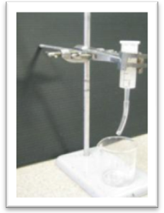
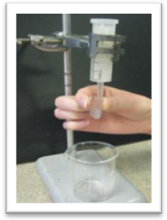
Method

Fig 1 Fig 2
- Put 10 cm³ of milk into a beaker.
- Test the milk with a glucose test strip. Give the strip 30 seconds to develop before comparing it to the colour scale. Decide whether or not glucose is present in the milk.
- Record the colour of the strip and the presence or absence of glucose in a suitable table.
- Carefully transfer the beads you made in part 1 into the treatment column (Fig 1). Four milk samples will be placed in the column, each for a different length of time and then each will be tested for the presence of glucose.
- Sample 1. Place an empty beaker under the column.
- Flush the column by allowing some distilled water to flow through the column and collect in the beaker. Discard the water. Replace the beaker under the column.
- Collect 10 cm³ of milk. Bend the soft plastic tube back on itself at the syringe nozzle thereby sealing the column (Fig 2). Pour the milk sample into the column then immediately release the plastic tube allowing the sample to run into the beaker.
- Test for glucose and record your result. Discard the testing strip. Discard the milk and wash the beaker.
- Repeat step 3 for 3 further milk samples. Allow sample 2 to remain in the column for two minutes before releasing the plastic tube and testing for glucose. Sample 3 should remain in the column for 4 minutes and sample 4 should remain in the column for 6 minutes. Make sure that you discard the test strips, flush the column and wash the beaker between tests.
Conclusion
What is the optimum time for the milk to be in contact with enzyme for the breakdown of lactose using this treatment column?

Further discussion

- How could you prove that it is the lactase enzyme, and not the beads on which the enzyme has been immobilised, that is breaking down the lactose in the treatment column?
- In designing a treatment column for the production of lactose-reduced milk, what factors would a manufacturer have to take into consideration?

Some other uses for lactase- treated milk

- Glucose and galactose have a sweeter taste than lactose. How might this be of benefit to manufacturers of flavoured milk drinks made form lactase-treated milk? | 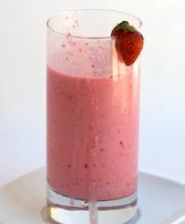
- A problem often encountered in the manufacture of ice cream is the formation of lactose crystals which cause the ice cream texture to be gritty and difficult to scoop. How could lactase solve this problem?  How might you investigate this? | 
- Find out how lactase is used in the manufacture of calorie-  reduced yoghurt. | 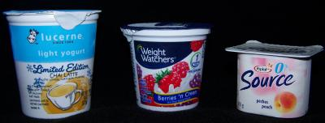
Adapted from an NCBE protocol: Better Milk for Cats, (1995)

