The Art of Induction
Here we look at a method for examining the factors that affect the voltage induced across a coil by a moving magnet. Schools are likely to have most of the necessary equipment for these activities. We see the potential for an Advanced Higher investigation here; indeed a student from an Edinburgh secondary school visited SSERC to carry out the experiments detailed below.
Induced Voltage and Speed
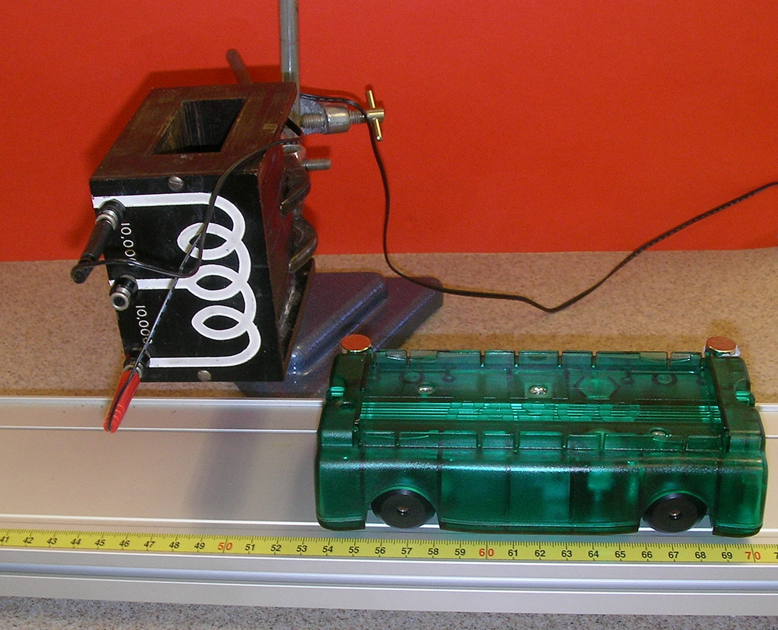
Figure 1: Setup for investigating induced voltage versus speed
This experiment uses neodymium magnets. These are very strong for their size, so much so that they can pinch skin when attracted to a magnetic object. They are particularly dangerous if swallowed and should be kept away from pacemakers, credit cards and magnetic storage media. Two magnets are fitted to a trolley, same pole upwards in each case, at a known distance apart. As shown in Figure 1, the cart is placed on a ramp, above which is suspended a coil that is connected to a datalogger via a voltage probe. There should be as little clearance between the magnets and coil as possible. With the datalogger running, the trolley is released and passes beneath the coil. Figure 2 shows a graph of induced voltage with time for one run of the trolley.
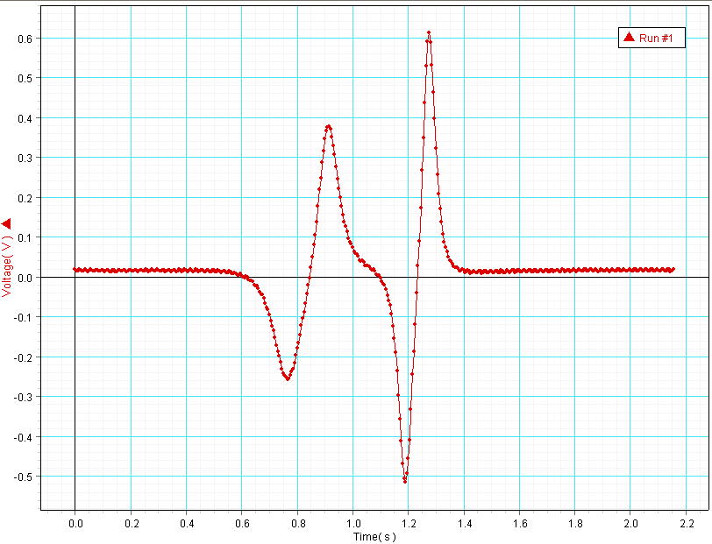
Figure 2: Induced voltage versus time.
As each magnet passes beneath it, a voltage is induced across the coil. This voltage changes polarity as each individual magnet passes. This is explained by Lenz’s Law. An induced voltage opposes the change that brought it into being. Thus, as the magnet moves towards the coil, a voltage is induced across the coil, setting up a magnetic field that opposes the approaching magnet. After the magnet passes under and moves away, a field is created in the opposite direction to try to keep the magnet from moving away.
The first peak is smaller than the second because the trolley is accelerating as it passes under the coil. To find speed, we found the time to get from positive peak 1 to positive peak 2 and divided the separation of the magnets by this time. This gives an average speed. We then found the average induced voltage by adding the two positive peak voltages together and dividing by two. The trolley was released from different positions on the ramp, sometimes with the aid of a push, to give a range of speeds. Results are shown in Figure 3.
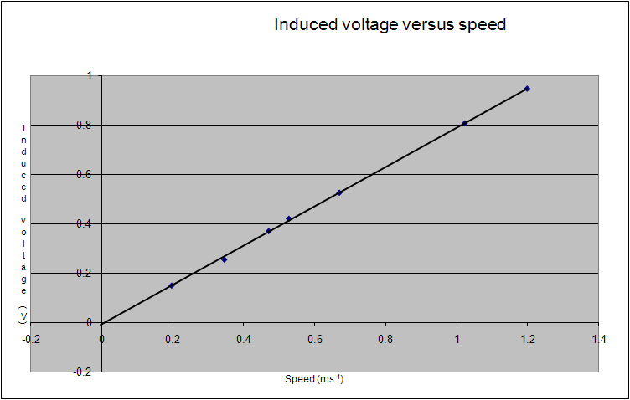
Figure 3: Graph of induced voltage versus speed
We recall seeing a spoof article in a journal that translated common phrases found in scientific papers. The phrase “typical results are shown” translated as “the best results are shown”. Each time we or our visiting student tried this experiment we obtained a straight line with an acceptably small scatter. On occasions it did not go through the origin. This could not always be accounted for by the small systematic uncertainty present in voltage and visible in Figure 2, an offset we were unable to eliminate. The experiment relies on the magnetic field of the two magnets being the same. This may not be the case for two reasons. The magnets themselves may not be identical or they may not be mounted at exactly the same height. There is a way of checking this. Look at Figure 4 below. It shows the relationship between the induced EMF ε and the rate of change of magnetic flux Ф. N is the number of turns on the coil.
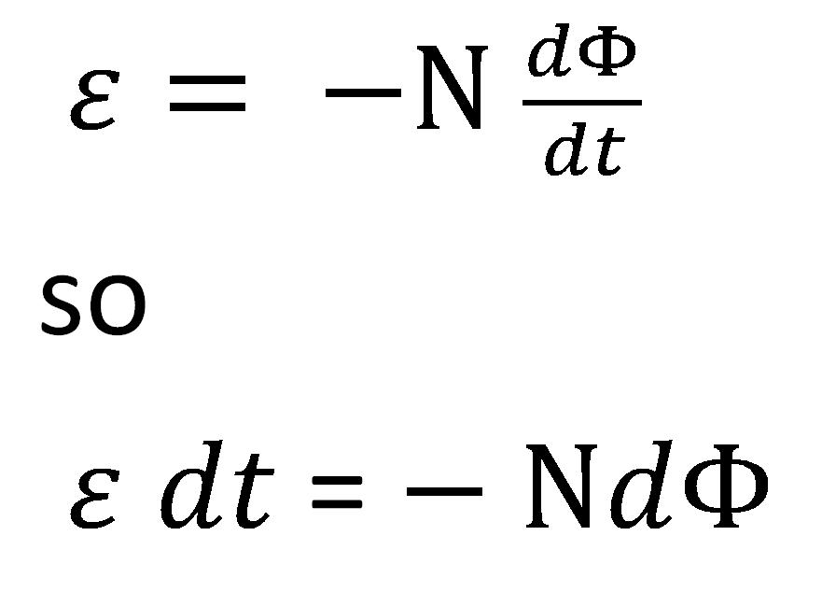
Figure 4: Equation linking induced EMF with rate of change of magnetic flux
If we integrate each side, we see that if the magnetic flux from each magnet is the same, the area under the induced voltage / time graph should also be the same each time a magnet passes under the coil. We were able to check this as we were handling data using Datastudio which has the facility to calculate the area under the graph for a selected region of data.
We had to place the magnets sufficiently far apart such that the first magnet was clear of the coil before the second passed below it. A smaller coil allowed us to place them closer together, meaning that the speed did not change as much from peak to peak. Our method assumes that the mean voltage occurs at the same time as the mean speed. If this is not the case, then the shorter the time interval over which average speed is found, the better. The trade-off is that, since the time interval is found by subtraction, a small time interval will be subject to a large percentage uncertainty. The coil supplied with the SEP Seismometer Modelling Kit [1], which has 7195 turns, allowed us to place the magnets 8 cm apart. This proved to be a good compromise.
Note that it is not necessary to measure the separation between the magnets. This will be constant throughout the experiment, so the inverse of the time between peaks can be used in place of speed when its relationship with induced voltage is studied.
Another potential confounder in this experiment is electromagnetic braking. As the magnet approaches the coil, the induced EMF sets up a magnetic field that will act against its motion. Our coil was connected to a datalogger which has a high impedance. Hence, any induced current in the coil will be small, as will be the resultant braking effect. Note also that some dynamics carts contain built-in magnets. These may result in blips on the graphs.
Induced Voltage and Number of Turns
In this experiment, the speed of the moving magnet will be the same each time so there is no need for a pair of magnets. To get the maximum induced voltage, we used a stack of four 24 mm diameter neodymium magnets, as shown in Figure 5.
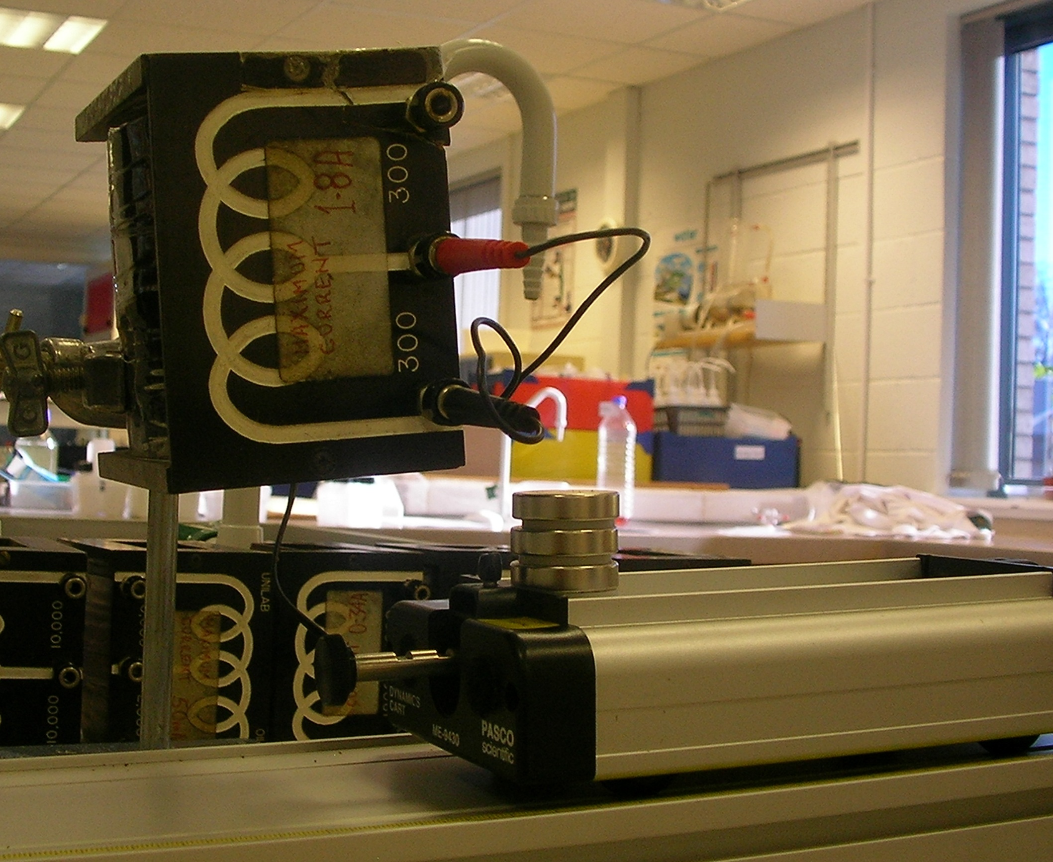
Figure 5: Number of turns experiment
The setup presented us with two problems. Firstly, great care had to be taken to clamp the coil in the same position each time. Secondly, taking the coil in Figure 5 as an example, there are two sets of coils, each of 300 turns. They can be used individually, or together to give a coil of 600 turns. Using the top set of coils gives a different induced voltage to the bottom set and neither is half the value of that obtained when all 600 turns are used. Each set of coils behaved if it was a different distance from the magnets. We solved this by taking the average of the voltages obtained from the top and bottom sets. Some of the coils were not symmetrical, for example one set had 2000 and 15000 turns. In this case we took readings when the 2000 turn coil was at the bottom, then inverted the coil and took readings when it was at the top. We then averaged both sets of readings. When the experiment was repeated, the trolley was released from the same point on the slope so that the speed was the same each time it passed below the coil. This gave a straight line graph (Figure 6), though the scatter was greater than that in the first experiment. This may be due to the difficulties encountered in keeping the coils in the same place each time a new set is used.
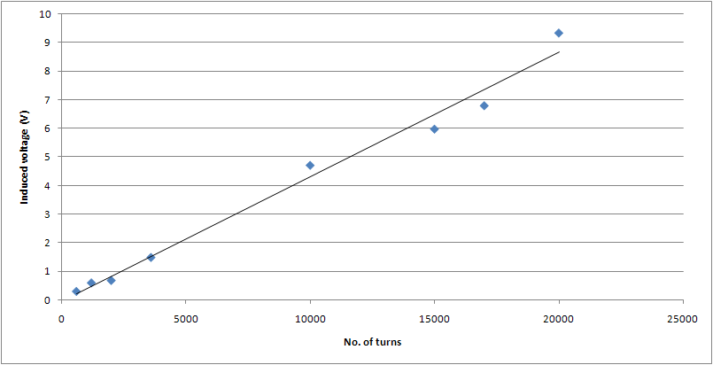
Figure 6: Induced voltage versus number of turns
Induced Voltage and Distance
In this set up, the variation of the induced voltage with the distance from the moving magnet was explored. We had never heard of this experiment being attempted using school equipment before and were thus unsure of what to expect. Figure 7 shows a magnet with one of its poles uppermost. In theory, magnetic field strength varies as the inverse cube of x, the distance from the pole measured axially as shown.
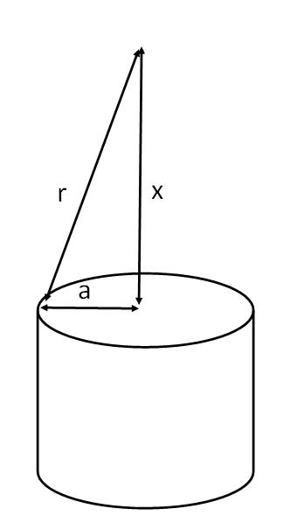
Figure 7
This relationship breaks down if x is not large in comparison with a, the radius of the pole-face. Under these circumstances, the magnetic field strength varies with the inverse cube of r where r = √(x²+a²). Our hypothesis was that induced voltage would follow the same relationship if we kept the speed of the magnet and the number of turns of the coil constant. When we plotted induced voltage versus r ⁻³, we got a straight line through the origin. This was with the small SEP coil (Figure 8). We felt that its dimensions were more suitable for an investigation involving distance.
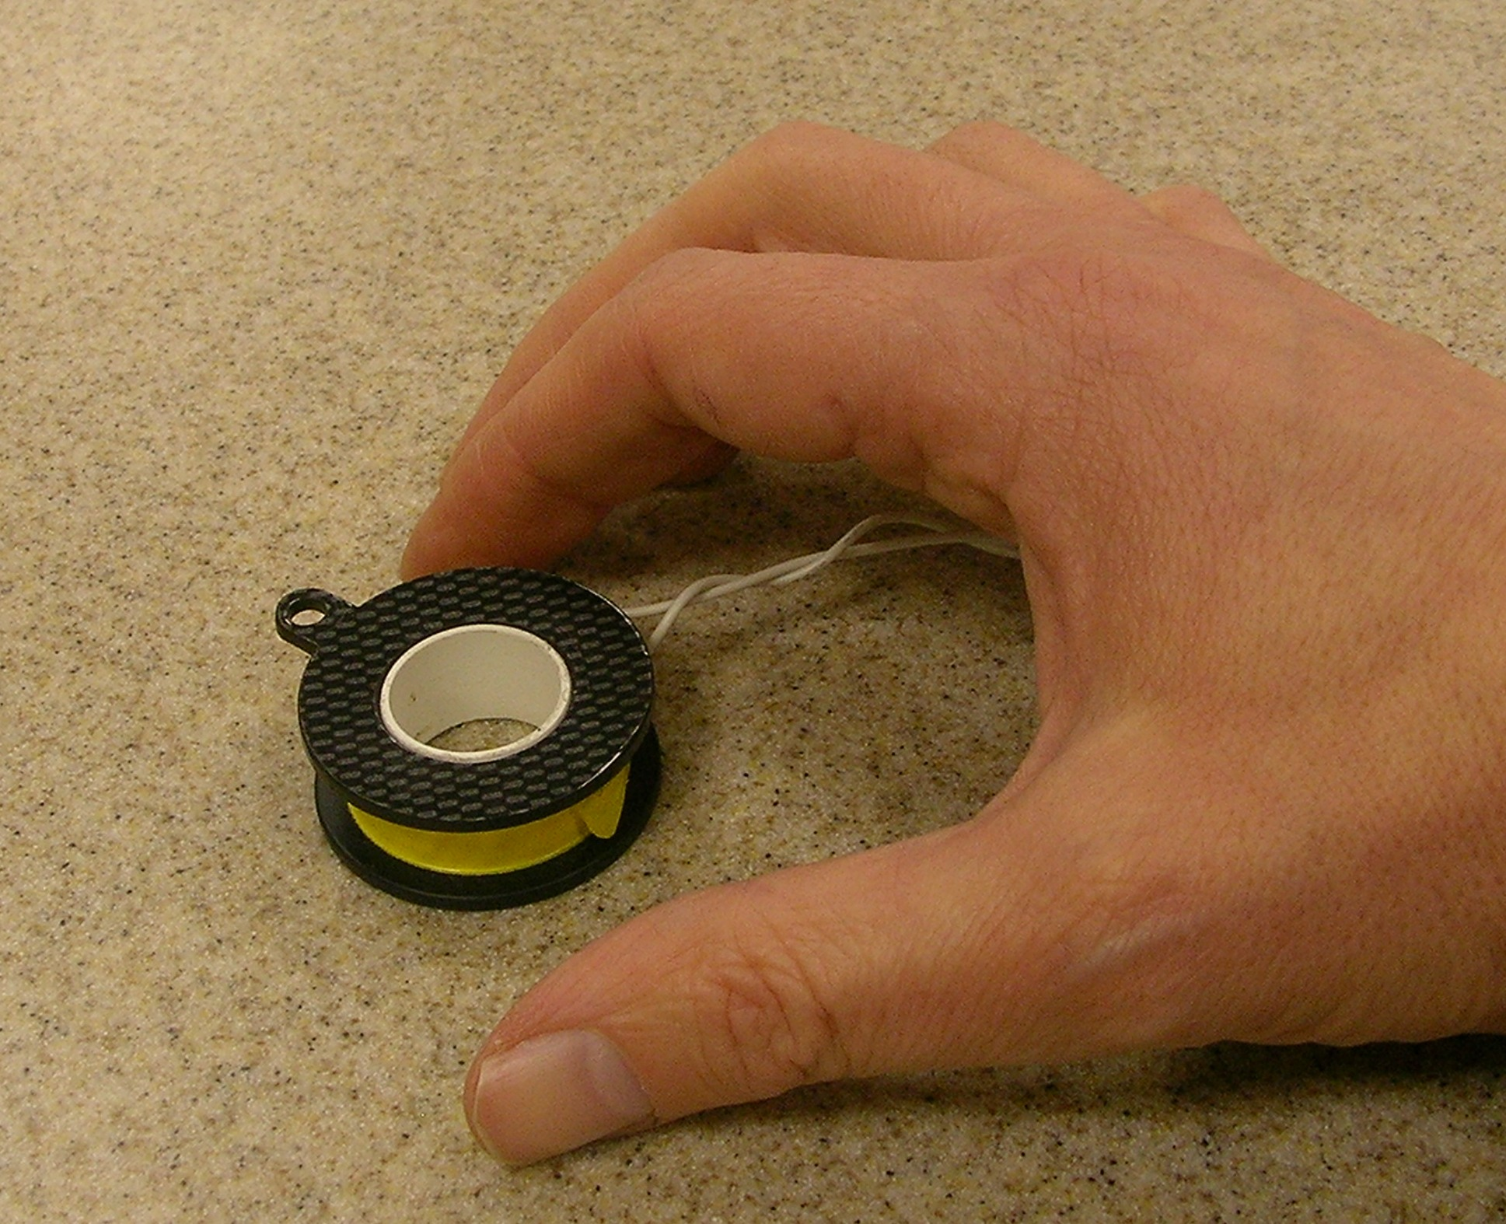
Figure 8: SEP coil
Taken as a group, we feel that these experiments could form the core of an Advanced Higher investigation. They go beyond the current curriculum but do not require exotic resources. The experiments work well and provide opportunities for data analysis and discussion.
[1] www.mutr.co.uk, part number SEP 172

