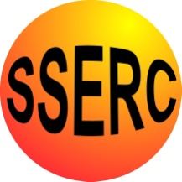
The Brine shrimp bottle ecosystem
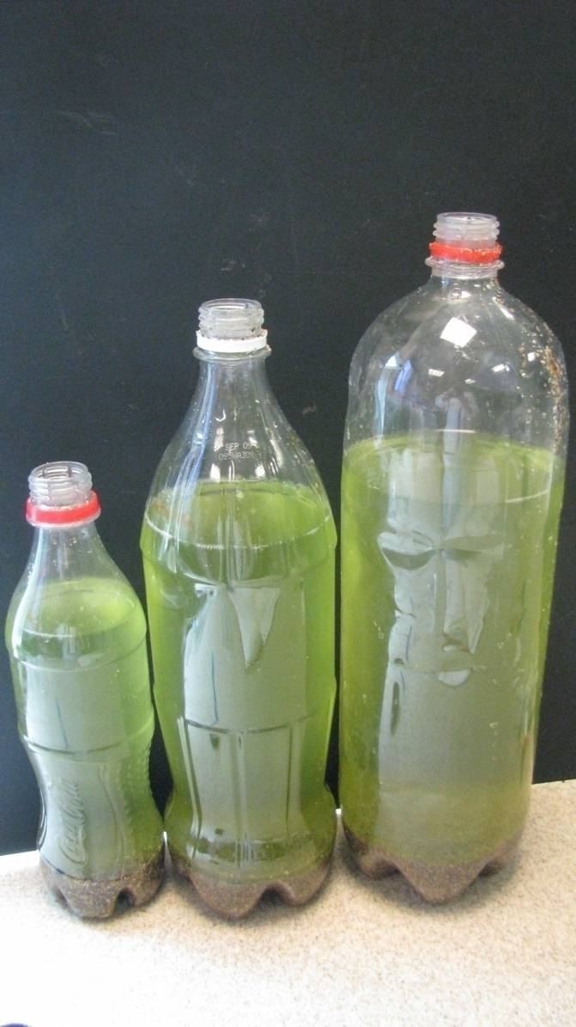
The bottle ecosystem activity is adapted from ‘Brine Shrimp Ecology’ by Michael Dockery and Stephen Tomkins. This publication was developed jointly by the British Ecological Society and Homerton College Cambridge and contains many excellent ideas for practical activities using Brine shrimps to teach ecology. There is a copy of this on the pen drive you will receive at the end of the course.
Here you will create an artificial mini-ecosystem within a single plastic bottle. This can be compared to natural ecosystems in the living world. The bottle ecosystem has sand and shell at the bottom, salt water and an atmosphere of air at the top. You will populate your ecosystem with the motile green algae Dunaliella and some brine shrimps of various stages of development. The algae will get energy from the sun to photosynthesise and will grow and reproduce to form the start of the food chain in your system. The brine shrimps will feed on the algae and will in turn grow and reproduce. When the brine shrimps and algae die, their bodies will decompose and their atoms and molecules will be recycled in the bottle. Over time the populations of algae and brine shrimp will rise and fall as the populations use up all the available resources, which are then replenished by death and decay releasing the nutrients back into the system.
We have had the three bottle ecosystems set up since 27th April 2009 and they have all been through periods where there have been population booms followed by crashes where it looks as though nothing is alive at all in the bottles, simply to recover in a week or so and be teeming with life again.
This is a very simple but effective model of an ecosystem which could easily be set up on a sunny windowsill in a classroom and visited periodically throughout the school year. We feel there is great potential to use the bottle ecosystem in many ways and at many levels in school.

Materials

Clear clean plastic bottle Sand and shell from a beach
Brine shrimps Baby BioTM
Measuring cylinder Dessert spoon
Pen and Label Plastic funnel
Seawater, made from dechlorinated tap water plus sea salt

(Chlorine can be removed from tap water by leaving it in a clean beaker open to the air for 48 hours. Chlorine in the water may harm the microorganisms and brine shrimps)

Please note - The sand and shell must be collected from a clean area where there has been no contamination with any faecal material etc. Hands must be washed thoroughly with soap and water after handling it.
Method

- Ensure the bottle is clean and that any labels have been removed.

- Add sand and shell to the bottle using the funnel, covering the bottom of the bottle to a depth of about 3cm. The sand and shell from the beach will contain a microbial community which is very important in your ecosystem.

- Fill the bottle with seawater using the funnel, until it is about 4/5 full. This leaves 1/5 of the bottle filled with air which is the atmosphere of the ecosystem.

- Carefully add one drop only of liquid Baby BioTM to provide your ecosystem with some minerals to help the algae grow.

- Screw the lid on the bottle and give it a good hard shake for about 30 seconds.

- Leave it to settle before you add the algae and brine shrimps.

- Once it has settled, add 50 cm3 of algae culture to the bottle.

- Catch around 8 shrimps of varying sizes, including a couple of mating pairs and add them to your bottle.

- Keep the cap off the bottle, or screwed on very lightly to allow some air into the system.

- Label your bottle with the date and your name.

- It is recommended that you roll the whole bottle around once a week to help the recycling of the nutrients (after screwing the top on tightly of course!).

- Put your mini ecosystem in a sunny spot and start your ‘Brine shrimp diary’ to record your population growth and fluctuations (see ‘Brine Shrimp Ecology’). Bottles can also be kept under a light bank, with continuous illumination.

- Wash your hands thoroughly with soap and water.

