Satellite Imaging
Investigate the uses of different satellites related to the orbital period or height and their potential impact on society.

This activity uses a webcam that has been converted to see into the near infrared. For details on webcams that can be easily converted, please contact SSERC.
Get a selection of leaves, some picked freshly from plants and some that have begun to wither. Try to get a variety including dark red leaves as well as green ones.
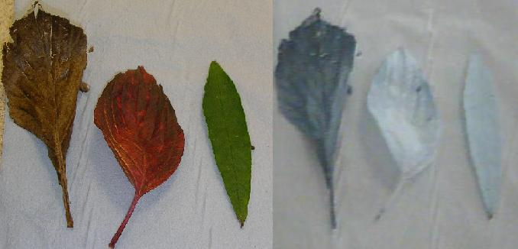
Place a filter that cuts out visible light over the webcam lens. Take an image of the leaves with the webcam.

In the living leaves, the chlorophyll fluoresces, emitting near-infrared radiation. In the dead leaves, the chlorophyll has broken down.

