Physics Demonstrations
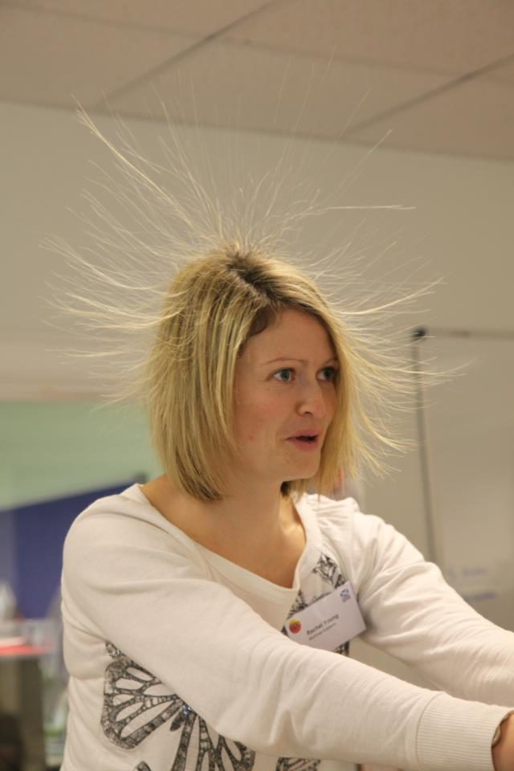
Van De Graaff Generators
These devices seem to break the rules: They can charge up to more than a hundred thousand volts and yet we allow pupils to hold on to them and inevitably some receive shocks. Do not listen to anyone who says that charging pupils up is now banned, but do follow the safety rules shown below, and if your department is looking to buy a new machine, consult the SSERC website or a SSERC physicist first to make sure the one you buy conforms to our current guidelines.
The following rules should be applied:
- Beforehand the teacher should check the appropriate records held at school for any relevant heart condition .
- Before using the equipment, the teacher should warn the class that it should not be used by anyone with such a heart condition.
- The dome should be discharged immediately after every operation ensuring that it never stands idle in a charged condition.
- The dome can be safely discharged by touching it with an earthed, metal conductor. The usual means is by a spark discharge to an earthed metal sphere mounted on a stand, or hand-held with a handle, which need not be insulated. If this is earthed, the experimenter does not receive a shock.
- The dome can also be safely discharged by touching it with a pointed metal wand which is earthed. The resulting corona discharge is accompanied by little or no sparking.
- The dome may be safely discharged through the human body by a corona discharge. With one hand firmly on the workbench, rapidly bring up an outstretched finger of the other hand to touch the charged dome. The shock is mild and not unpleasant. This is a safe way to discharge the dome. In contrast, were you to bring up a raised fist to the dome, the machine discharges all its energy in one burst as a hurtful spark.
- The demonstration with hair standing on end may be done safely by adapting the above procedure. Begin with the generator off and dome uncharged. The pupil should stand on an insulated platform (such as a plastic basin), placing one hand on the dome while ensuring that no part of the body or clothing is in contact with the bench, or another person. Start the generator and run until hairs stand on end. Stop the generator and instruct the pupil to place his or her free hand on the benchtop while still keeping the other hand firmly on the dome. Wait several seconds until completely discharged. Then tell the pupil to remove the hand from dome, step off the platform and walk away from the apparatus. The dome at this stage will not be carrying a charge and will be safe for another person to touch.
- Persons being charged should be limited to volunteers.
- Pupils can be charged in a chain. The number needn’t be limited unless standing on insulated platforms, in which case no more than three.
- The demonstration of lighting a Bunsen flame by discharging through a human body via a pointed fingertip to the Bunsen funnel would seem also to be fairly harmless. Being a corona discharge, the spark energy is low.
- Because a human body has capacitance, do not let someone who has been in contact with a charged dome walk away without discharging. In these circumstances such a person may carry quite a lot of charge and experience a disagreeable and possibly unexpected electric shock on touching earth. Any other person touching such a charged person is also at risk of getting a shock.
- If the capacitance of the system were to be greatly increased, for instance by connecting the dome to a Leyden jar, the stored electric energy can increase dangerously. If it really is necessary to work with a Leyden jar then the person working with the apparatus must be a teacher who is competent to do the demonstration.
- Do bear in mind that any person getting a shock is at risk of harm from jerking or falling over in fright. There is then an indirect risk of a blow to the head, or damage to muscles, bones, or other parts.
- During spark discharges, electromagnetic energy is radiated from the spark gap. This radiated energy will be picked up by any nearby electrical leads across which extra-high voltages can be induced. These voltages can destroy electronic apparatus. Vulnerable equipment includes anything supplied from a plugtop power supply such as a laptop computer, digital balance or digital camera because the long supply lead can act as an effective pick-up aerial. No such equipment should be within 2 m of a spark gap.
- All science staff should be trained in how to work with the Van de Graaff generator, being made aware to avoid a direct path through the human body to a good earth.
As a precaution, whilst we await further advice, we are recommending that people with pacemakers and cochlear implants remain 6 m or more from a Van de Graaff generator when it is operating.

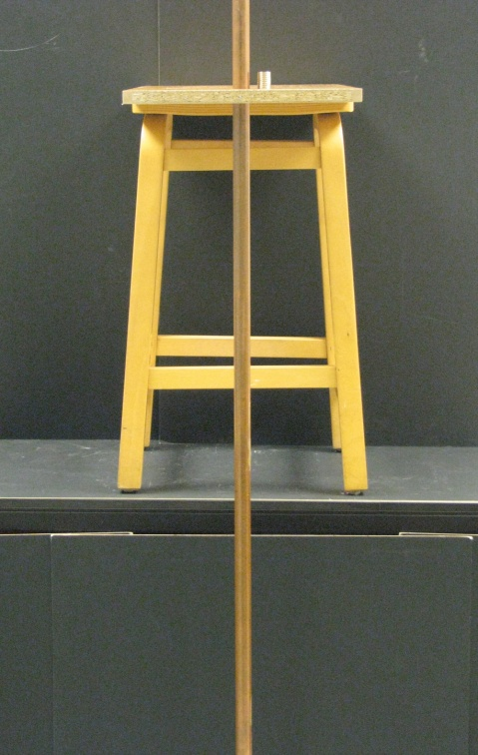
Magnets down a copper tube
Drop a stack of strong (neodymium) magnets down a copper tube. Compare the time they take to hit the ground with the time for a similar non-magnetic mass to do the same.
As the magnets fall, they induce (create) a current in the tube.
A current in a conductor has its own magnetic field. This magnetic field opposes the magnet’s field, causing it to move more slowly.
Safety:
Never give neodymium magnets to children who might put them in their mouths and hence swallow them. Be careful not to pinch your skin by trapping it between two strong magnets.
People with pacemakers should not handle strong magnets.

Hand generator and thermochromic film
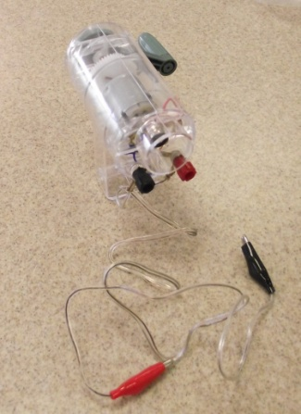
Cut a piece of thermochromic film about the size of a bank card. Peel the backing film back enough to stick a piece of resistance wire along its length.

Demonstrate, using hand heat, the properties of the thermochromic film.

Connect a hand generator to the wire and turn it.

You should observe the heating effect of the current.

Note that it is worth letting the pupils experience how much harder it is to turn the generator when there is some kind of load (such as the resistance wire or a bulb) connected to it. You don’t get electrical energy for nothing!

Pressure Demonstrations

Place a piece of thin, flat wood (metre stick dimensions are about right) on a bench with about 10 cm protruding over the end. Cover the rest with 3 or so sheets of newspaper. Flatten the newspaper down.

Strike the protruding end of the wood.

Take care if using bare hands and keep observers out of any area where the stick might land if something goes wrong.

****
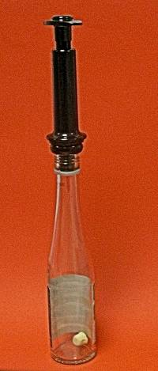
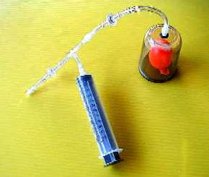
Place a marshmallow in a clear bottle to which you have attached a pump that draws air out a wine bottle to keep the wine fresh, or use the Microscale vacuum Apparatus. Remove air from the bottle or jar. The marshmallow has air pockets that are now at higher pressure than their surroundings, so the air in them expands as the pressure equalises.

Do not use a mechanical or electrical pump with these devices and do not pump air into them.

For the large balloon demonstration, see here:

http://tinyurl.com/air-has-mass

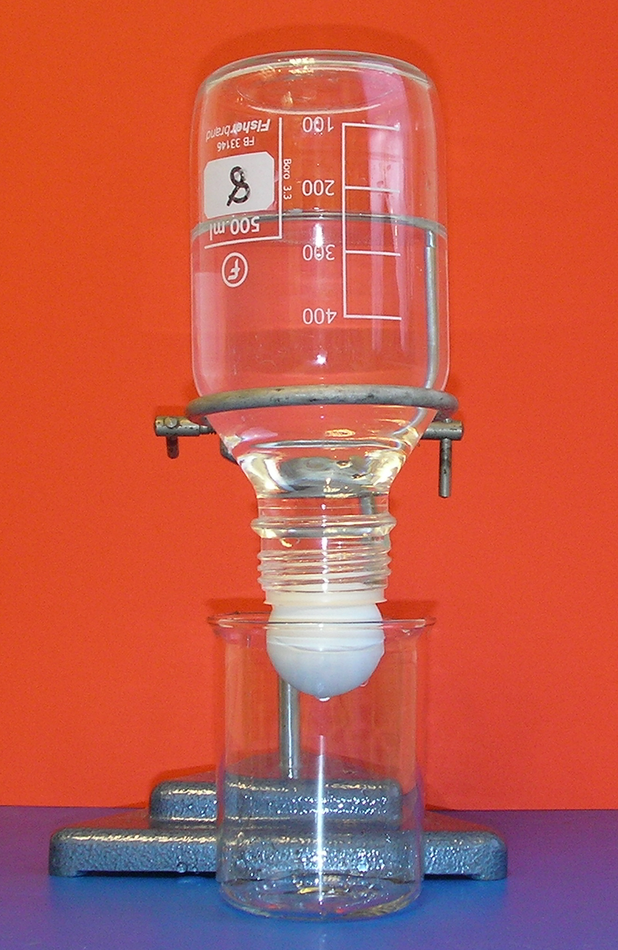
****

Three-quarters fill a bottle with water. Place a ping pong ball over its mouth and invert. This is a variation on the “card over the tumbler full of water” experiment. Whenever you do this, some water always seeps out past the ball. If it didn’t, the ball wouldn’t stay in place. Think about it!

****

Fill a trough with water. Sprinkle some lycopodium powder on to the surface. Take a drop of oil – we used oleic acid in ethanol – and drop it on the surface. A roughly circular pool forms. Assume that the layer of oil is one molecule thick. Pupils could be asked ways of estimating the volume of the drop (e.g. by finding the volume of 100 drops). We assume this volume is now the volume of a cylinder, height h (1 molecule). By measuring the radius r of the pool, we can equate volume with πr²h and hence find h, an approximation for the diameter of a single molecule.

Newton’s First Law of Motion

Place a playing card or drinks mat on top of a tumbler. Place a coin on the mat. Flick the card away. The coin falls into the tumbler. It doesn’t move with the card because there isn’t a force on it to change its speed or direction.

Newton’s Third law with Straws

See here:

http://tinyurl.com/newton-3-straws
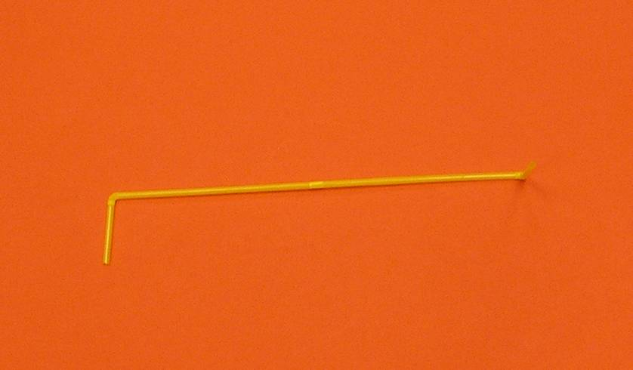
Air is forced out of the straw. This air exerts an equal but opposite force on the straw.

Rice and ball Bearings

See here:
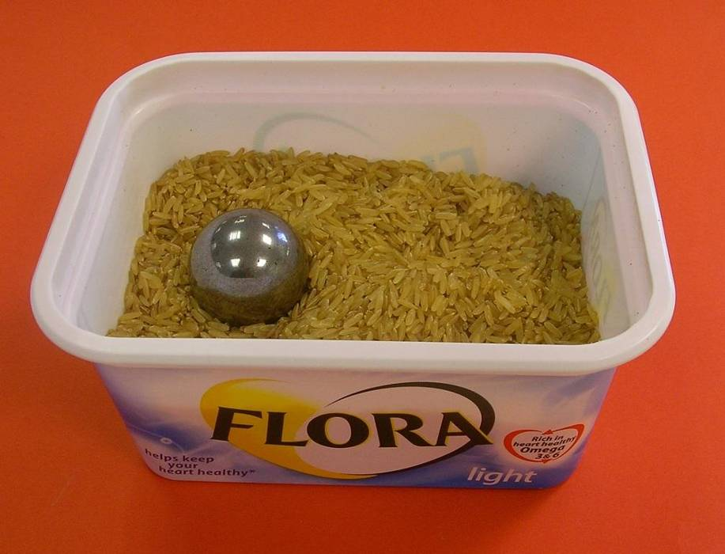
http://tinyurl.com/rice-density

The rice behaves like a liquid when shaken. This sometimes happens with soil during earthquakes, causing buildings to sink.

Cartesian Diver

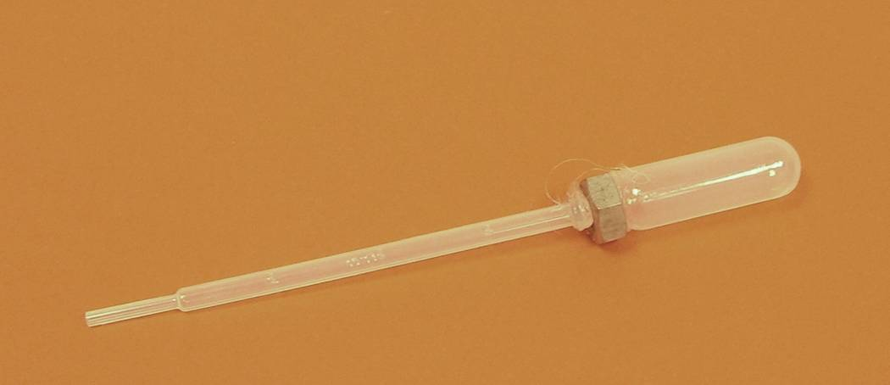
We made ours from a dropper with a nut glued on near the bulb. Placed in a 2 litre bottle (with as little air space as possible) it should float. Put the top on the bottle and squeeze and it sinks. The pupils can see water entering the open end and may assume it sinks because it gets heavier. Ask them if it would still sink if we blocked the end of the dropper and squeezed the bottle. When they try this, they may be surprised.

Blasting Balls

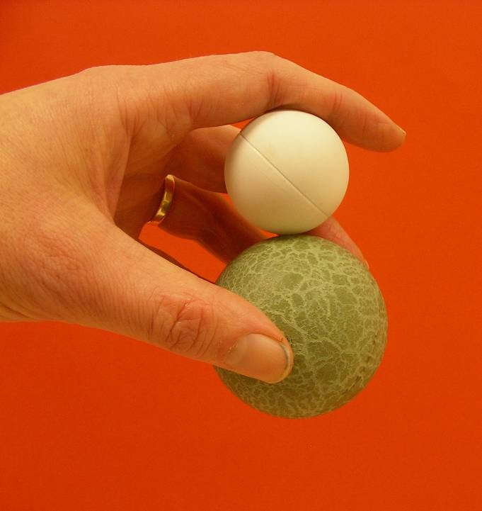
Hold a light ball above a more massive one and drop them together.

See here:

http://tinyurl.com/blasting-ball

The more massive ball hits the ground first and collides with the lighter one, causing it to shoot upwards. Something similar happens in exploding stars.
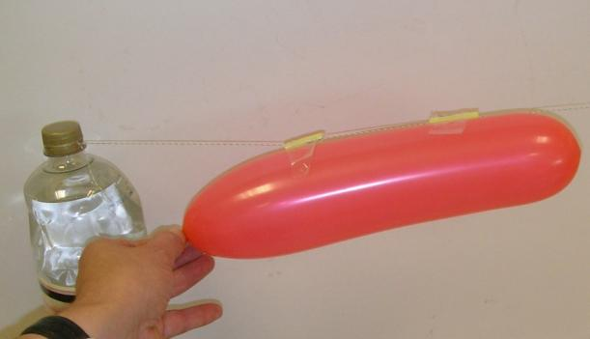
Newton’s Third Law Using Balloon Rockets.

Cut two short sections of drinking straw and pass a thin string or thread through them. Stretch this tight between two clamp stands (or two filled, capped 2 litre bottles)

You can stretch this right along the lab or classroom.

Inflate, but don’t tie, a balloon. Tape it to the straw sections and release it.

The balloon forces the air backwards. There is an equal but opposite force that propels the balloon forward.

Safety: some people are allergic to latex and should not handle balloons. Indeed, some have severe reactions and should not be in the same room as them in case they burst. Balloons contain a powder (to stop them sticking to themselves) that becomes impregnated with latex. If the balloon bursts, this can get into the air and cause respiratory problems in people so afflicted.

Falling Objects

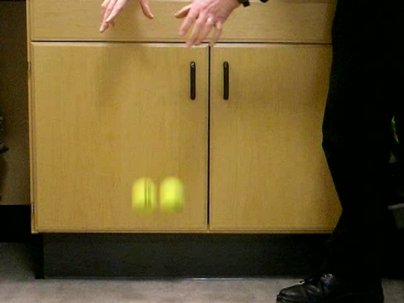
Drop the seemingly-identical tennis balls together. They hit the ground together. When asked why, children will probably say it is because they are the same.

Hand the balls to the children. One is clearly heavier than the other.

It’s important to subvert misconceptions rather than simply tell children to believe something that is counterintuitive to them.

Producing the Ultimate Spectrum

You can create a spectrum by sticking a prism in front of a single ray from a raybox and rotating the prism slowly until a spectrum appears, but a much better one can be made by following the instructions in this Bulletin article:

http://tinyurl.com/ultimate-spectrum

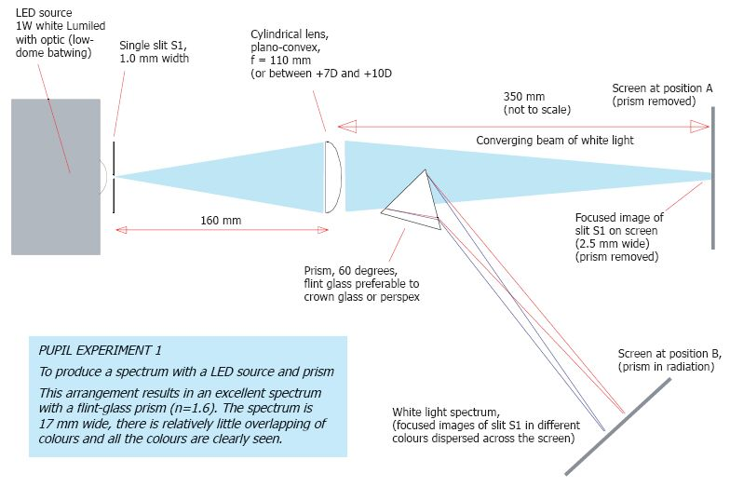
You don’t need to use a Lumiled – any white light source will do.

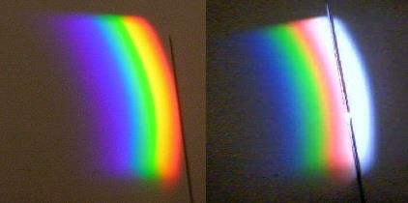

Infrared webcam

It is relatively easy to remove the infrared filter from a webcam so that it can “see” into the near infrared (the infrared that lies just beyond visible red light). Contact SSERC for advice.
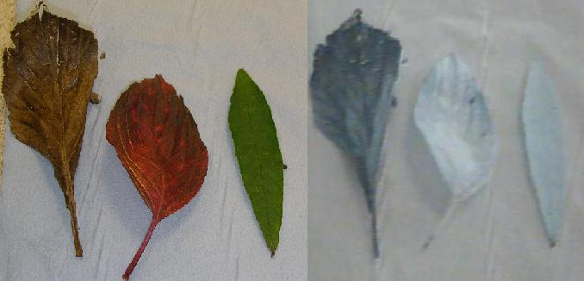
Such a camera can be used for a number of demonstrations including showing that there is light beyond the visible in a spectrum from a filament lamp (see above).

The picture on the right shows an image in visible and near infrared (the latter taken with a filter that blocks visible light over the lens) of some leaves. Fresh leaves look bright because chlorophyll fluoresces and gives out infrared, but chlorophyll breaks down when a leaf dies.

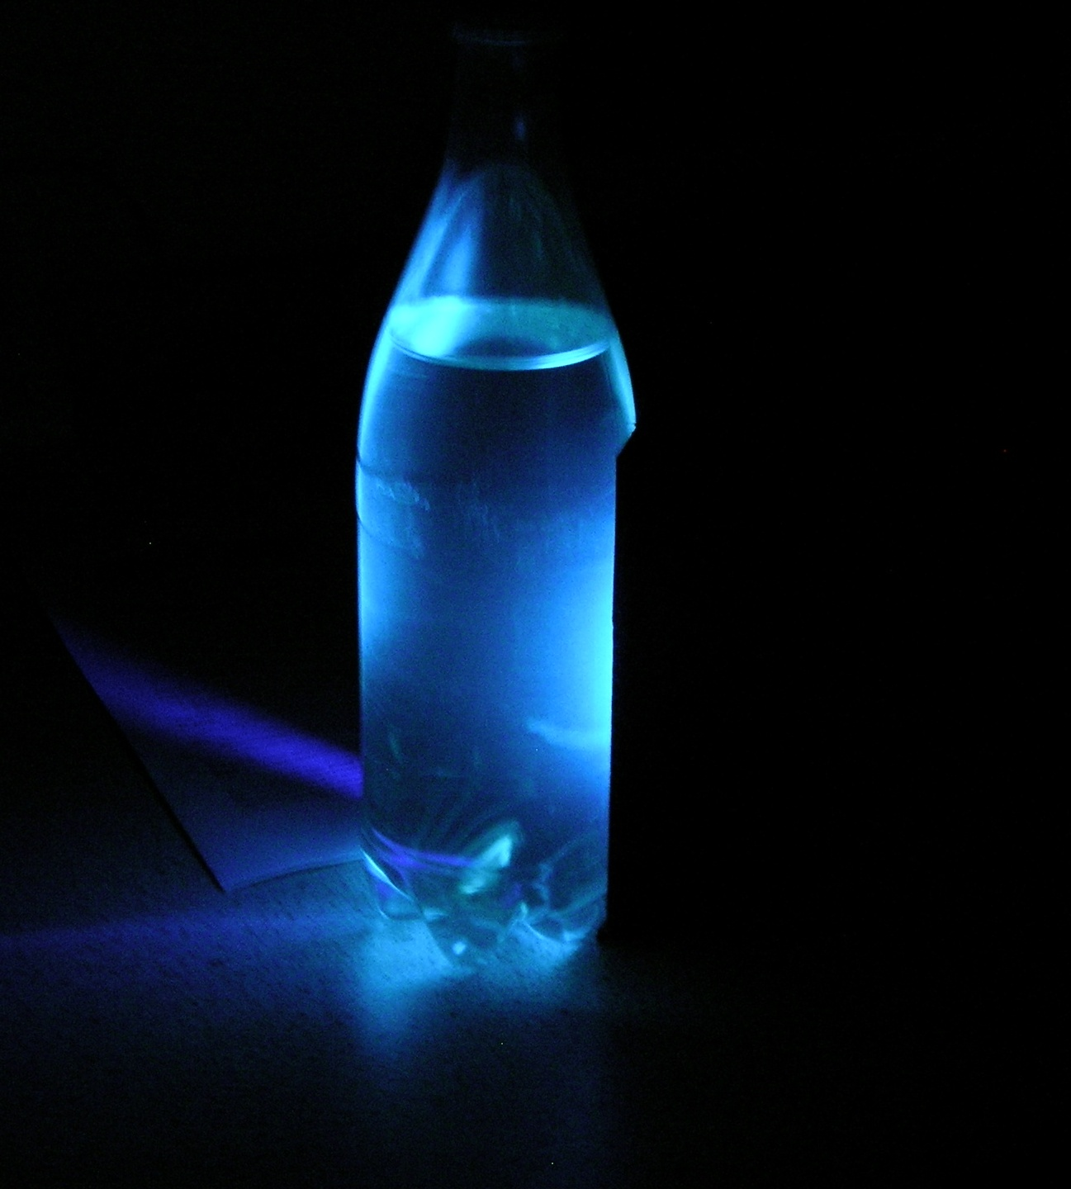
Fluorescence

Fluorescence is when a substance absorbs light at one range of wavelengths and re-emits it at another, longer wavelength. We have seen the example above with chlorophyll and the leaves. Another is tonic water, which absorbs ultraviolet light and radiates in the blue part of the spectrum.

You can read about safe use of ultraviolet light here:

http://tinyurl.com/SSERC-UV

For the “security” type of battery powered UV lamps, the advice is:

Most of the radiation is UVA, hence there are hazards to the eye and skin. We measured the emissions from the lamp and conclude that exposure limits are unlikely to be breached in a school laboratory provided that users:
- avoid looking directly at the lamp;
- do not hold or carry the lamp with their hands or fingers across the tube when the lamp is on (see photograph below);
- avoid irradiating their skin where possible.
This does not apply to “sterilising wands” or UV tubes used for the photoelectric effect in Higher and Advanced Higher sciences. These give out higher frequency (UVC) radiation and need much stronger control measures.

Laser Experiments
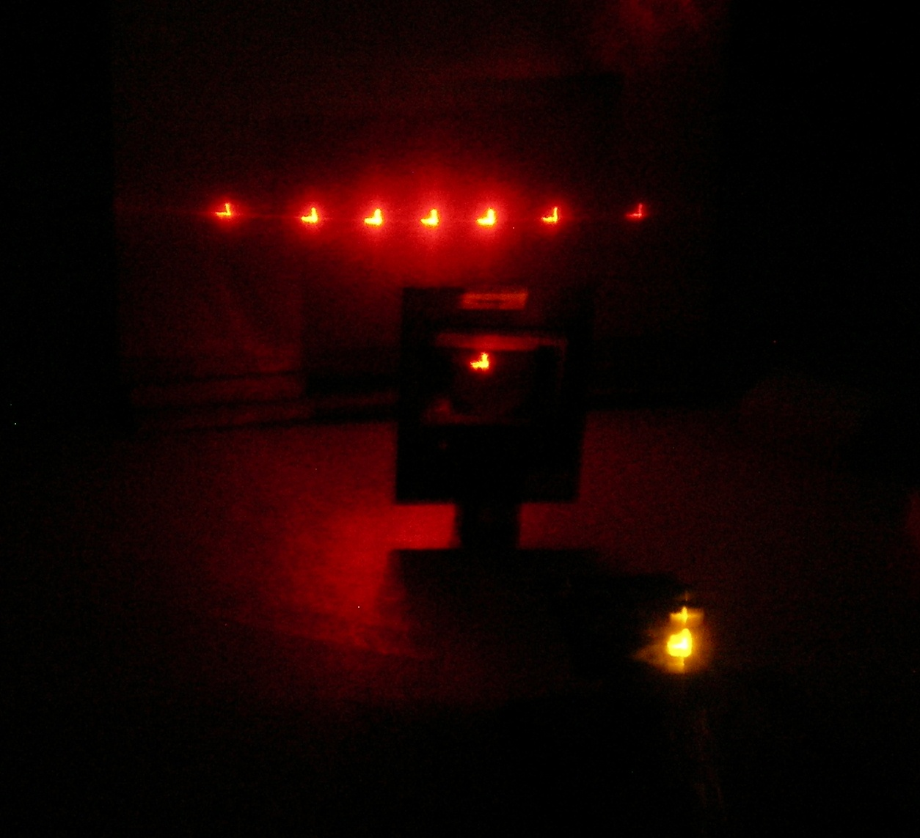
The right type of laser is an excellent light source for pupil experiments and teacher demonstrations. First off, note that we are not using laser pointers for any of our experiments.

SSERC guidance on lasers is here:

http://tinyurl.com/SSERC-laser
Rules for safe laser use
- The laser classification is either Class 1 or Class 2, but not Class 1M, 2M, 3R, 3B or 4.
- Work is supervised at all times.
- Pupils are made aware of the safety precautions they must take:
- They must never stare into the beam;
- The laser must not be pointed at another person.
- The laser is stable or clamped.
- The beam should be terminated by some sort of beam stop.
Why Class 2? Class 2 lasers emit only visible light and are rated at 1 mW or less. Our natural aversion response prevents us from becoming exposed accidentally to a harmful amount of laser radiation. America operated a similar classification system using Roman numerals. Whilst their Class II is equivalent to our IEC Class 2, there is not always a direct correspondence between the other ratings.
Laser pointers
Note that many laser pointers are unclassified. Their power output can vary significantly depending on the batteries fitted. Indeed, we have heard of some that are nine times more powerful than they ought to be. Also, laser pointers may be picked up by pupils and waved around. A Class 2 laser pointer may be used by a teacher to highlight something on a board, but laser pointers should not be used for experiments.
Laser diode modules
Laser diode modules (LDMs) are a safer option than laser pointers. They can be clamped in a boss head. See SSERC Bulletin 229. The LDMs discussed in this article have automatic power control circuitry built in, so they do not exceed the appropriate power output.
Despite what Hollywood films might suggest, laser beams are not visible in clear air. They need to be scattered off something.
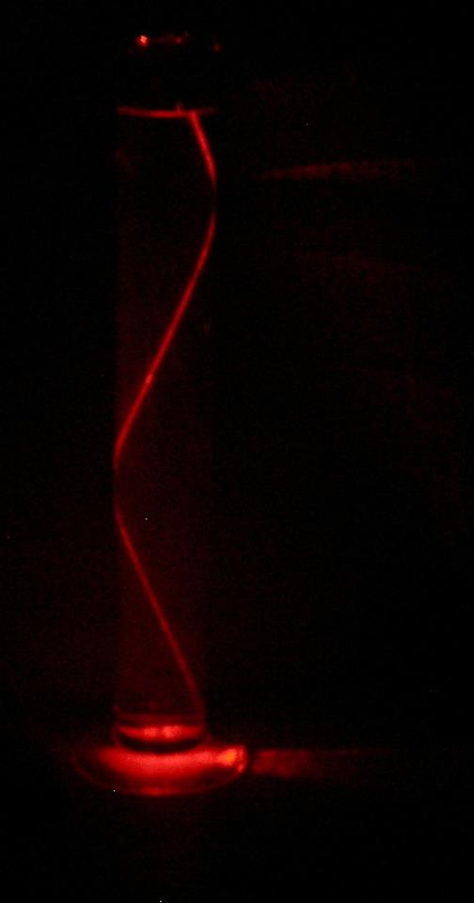
One way is to let the beam travel through water to which a small amount of skimmed milk has been added. In the picture on the right, the beam is in a 500 ml measuring cylinder to which a single drop of milk – about the size of a 5 p piece when spread out on the bowl of a teaspoon – has been added. The milk will go off after a day or two, so it is better to use colloidal silica (Ludox) for set ups that have to remain in place for some time. If using this, wash and rinse glassware thoroughly afterwards as the silica forms tiny particles when the water evaporates. These particles can be inhaled and cause lung damage over time.

Laser Brownian Motion

- Use lowest magnification (x40) (Objective = x4, eyepiece = x10).
- Work in a blacked-out room (can also be seen with room lights on).
- Fill the cell with smoke from a smouldering wooden splint.
- Take the objective down to the cell and slowly wind it up bringing the smoke particles into focus. The lens almost touches the smoke cell.
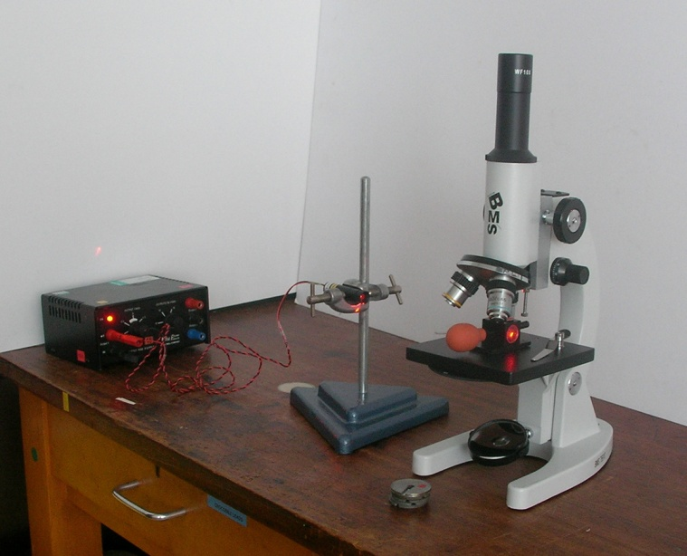
- The hard part is getting the depth of field right such that you focus on the smoke particles. To get this, replace the smoke cell with a stack of coins whose height is that of the centre of the smoke cell. Focus on the top surface of the top coin, setting the depth of focus. Position the laser such that the beam glances over the coin. Replace the smoke cell.
- View at the edge of the laser beam. The main beam is too bright.
- Once filled with smoke, the cell operates fine for 30 min before needing refilled.
- The smoke can drift for the first 5 min.

Safety: Extinguish your source of smoke.

See here: http://tinyurl.com/SSERC-brownian

Laser Shadow Imaging

Take a drop of water from a puddle or fish tank.
Suspend the dropper in front of a laser. Squeeze it to produce a drop.
Let the beam pass through the drop.
Project on to a white surface.

See here: http://preview.tinyurl.com/SSERC-shadow

Laser Colour Mixing
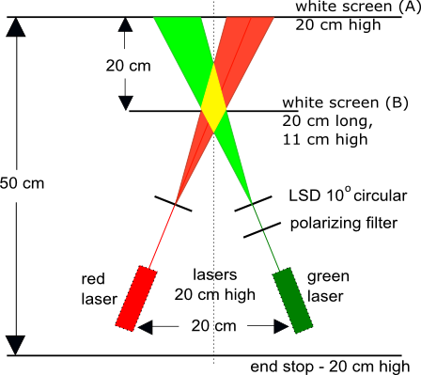
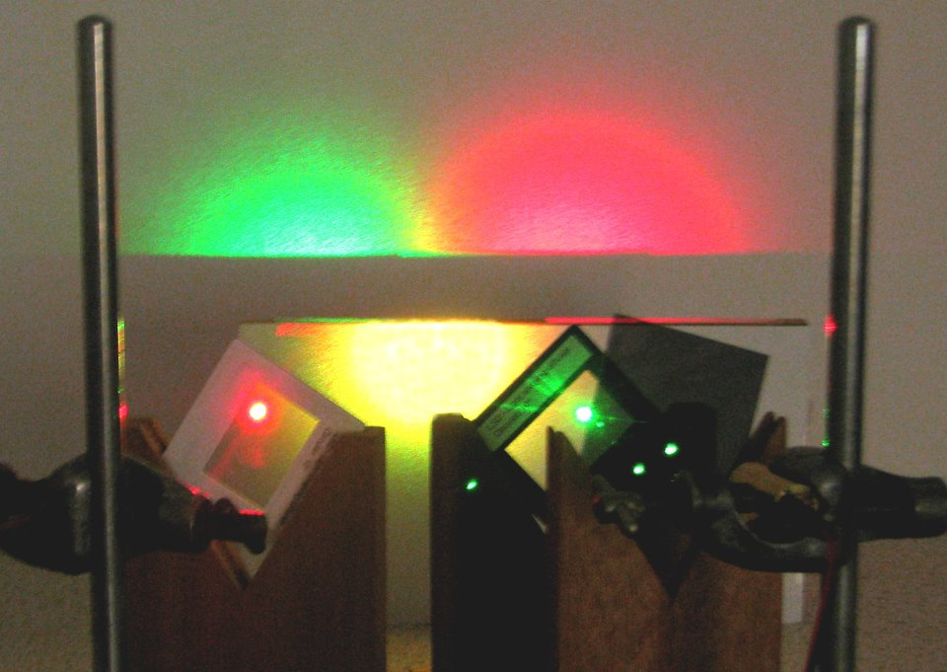
Lasers are highly monochromatic (single coloured) but you can use them for colour mixing.

In this set up, a plastic called LSD (light-shaping diffuser) is used to turn the narrow beam into a cone of light.

Polarisation
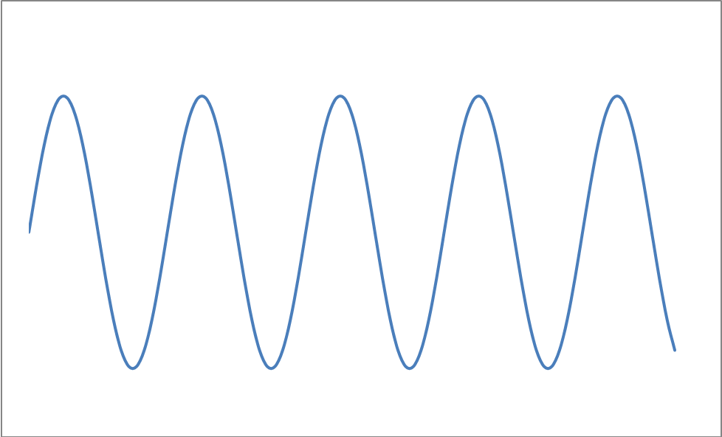
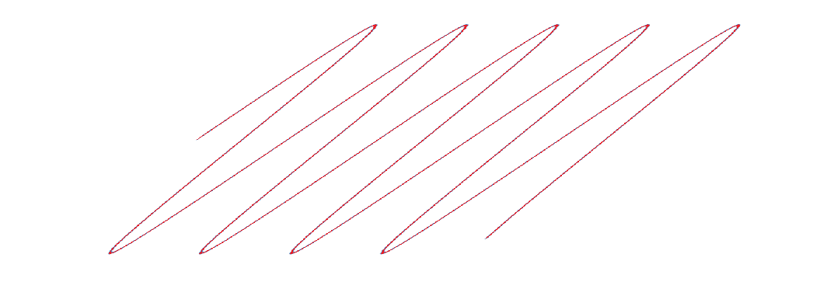
Light behaves like a wave, but unlike water waves, the waves from most light sources do not oscillate in a single plane.

To make light oscillate in a single plane, we use a polariser.

Two polarisers at 90 degrees to one another are said to be “crossed” – no light can pass through.
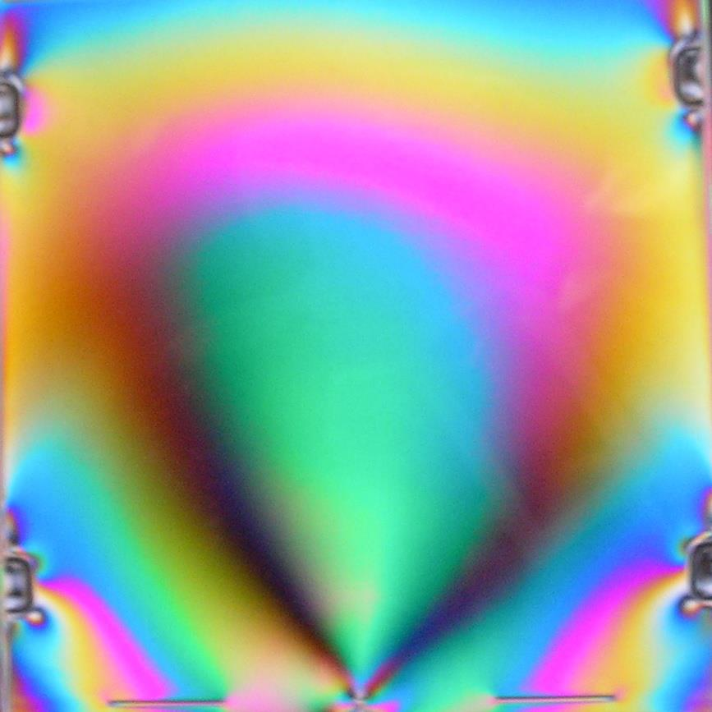
We can show that light from an LCD screen is polarised by holding a polariser in front of the screen, which has been set to display white, and rotating it. The screen should black out at a certain angle. If it doesn’t, but instead changes colour, it’s because the different colours used to make white are polarised in different planes.

Now, some materials are optically active – they rotate the plane of polarisation of the light passing through them. Perspex does this under stress, and the amount of rotation depends on the wavelength (i.e. colour) of the light. Thus, if we put a Perspex CD case in front of a monitor and look at it through a polariser, we can see beautiful colours appear as we rotate the polariser.

gregor.steele@sserc.org.uk

