EM-spectrum

Microwave leakage from electrical devices (eg ovens, TVs, mobile phones, tablet computers
and Wi-Fi hubs)

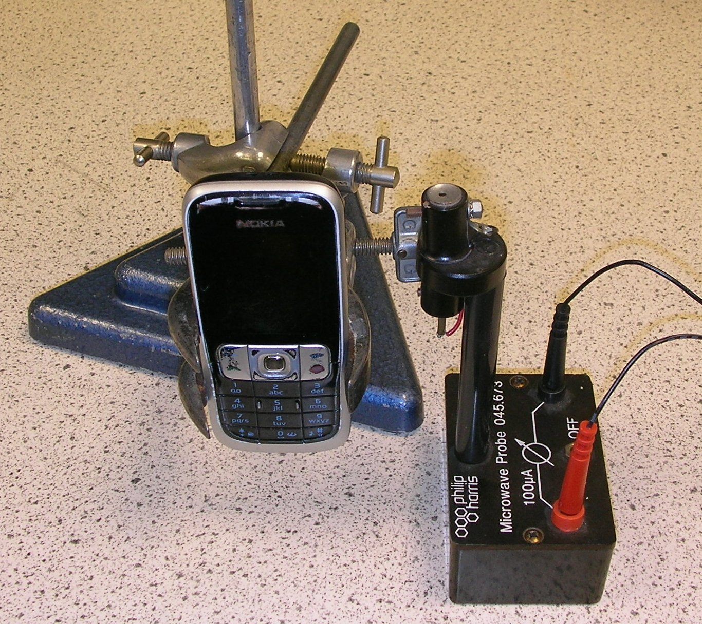
If you have a diode probe for a microwave kit, you can use it to pick up mobile phone signals. The voltage output is proportional to the RF (radio frequency) power incident on the diode.
Our initial experiments had the phone and probe separated by about 5 cm (centre to centre).
Note: we do not know the orientation or position of the antenna inside the phone.

It is best to connect the probe to a datalogger or oscilloscope that can freeze a trace (e.g. a USB Picoscope). You will have limited success with a voltmeter, for reasons that should soon be apparent.
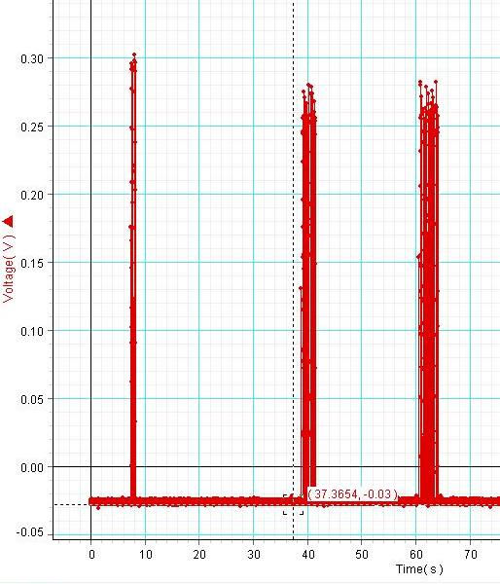
First, switch the phone off. Then switch it on again. When you do this, the phone “handshakes” with the nearest tower to inform the network that it is off line or back on. Since the phone doesn’t “know” when you switch it on how far away the nearest tower is, it broadcasts at maximum power. The image on the right shows some handshake signals.
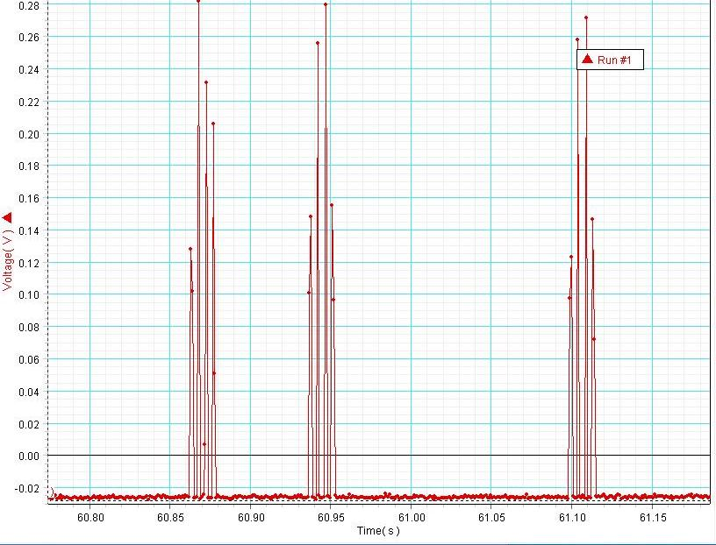
Closer inspection shows that signals are made up of pulses each a few milliseconds long. Mobile phone signals are transmitted at a frequency of hundreds of megahertz, so there is no chance using a school scope or datalogger of resolving individual radio waves.
It’s this pulsed nature, with gaps between, that renders using a voltmeter unsatisfactory.

If you monitor a call made to a phone, you may find that the voltage level drops during the call, perhaps in stages. To conserve battery charge, phones only broadcast with enough power to communicate with the tower. If the signal from the tower is strong, the phone reduces its output power.
We performed a “signal power versus distance” experiment as follows.
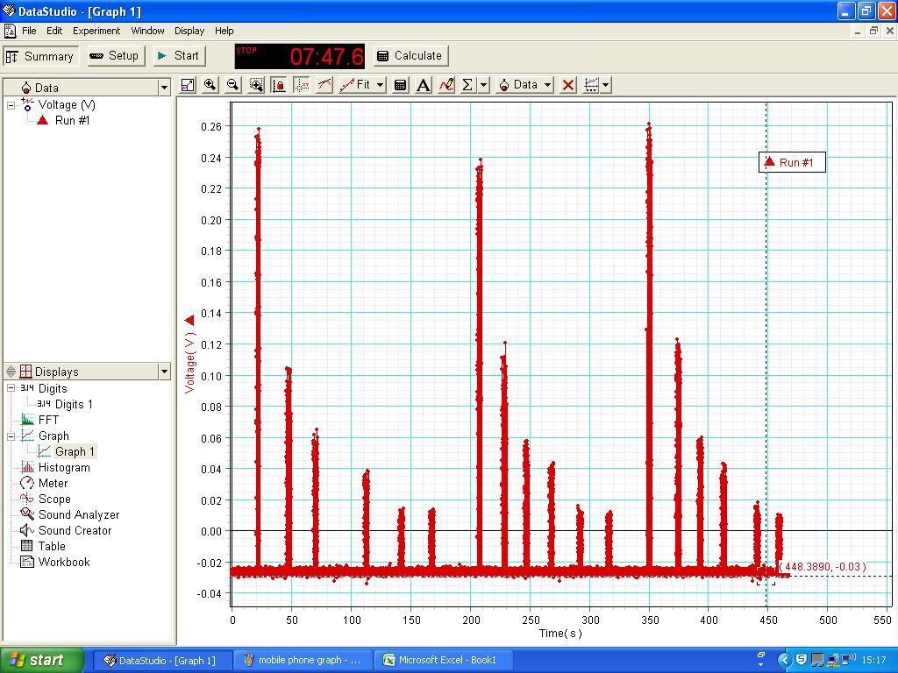
Mobile phone in clamp
Diode probe
To oscilloscope or data logger
Distance d
Clamp the phone as shown. Connect the diode probe to an oscilloscope or data logger. Using a ruler to measure from the centre of the phone to the tip of the diode probe, place them 5 cm apart.
Begin data logging.
Send a text from another phone to the one in the clamp. (We might ask pupils to explain where the other phone should be).
Repeat for a range of distances. There is no need to stop logging between texts.
Repeat the experiment. We suggest 3 times for N4.
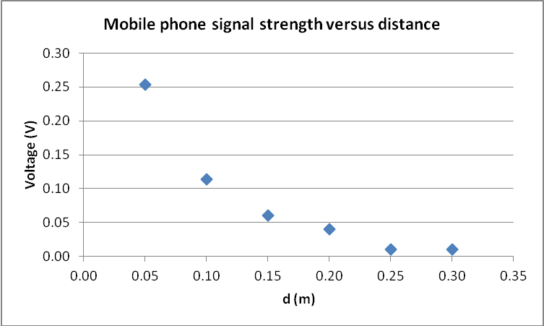
The peak voltage can then be noted for each distance and the three readings averaged.
A graph like the one on the right is probably sufficient for N4. We did investigate this further and found that the relationship was closer to inverse rather than inverse square at small distances. Why might this be so?

We are measuring the signal from the phone that receives the text, rather than the one that sends it. Why does this still work?

