Force on a Current-Carrying Wire
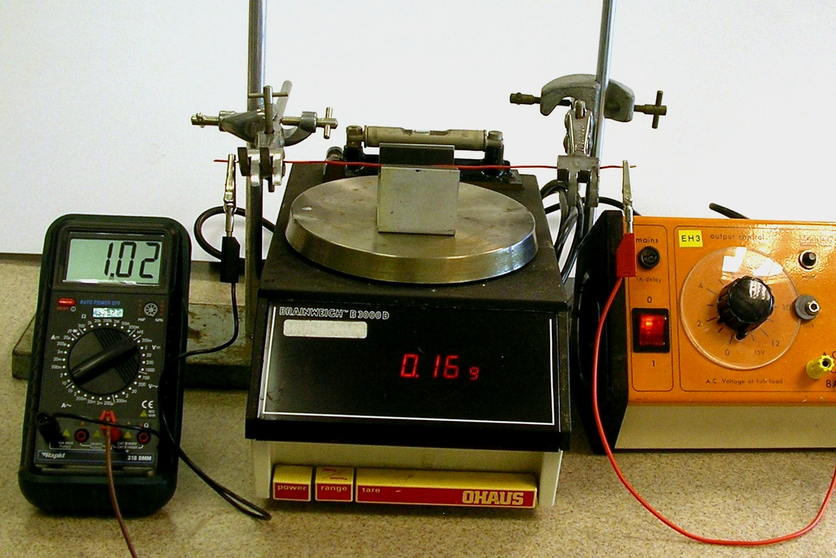
A yoke fitted with opposing pole-faced magnets is placed on top of a digital balance. A power supply is used to pass a direct current, monitored using an ammeter, through a piece of stiff copper wire that is placed between the yokes, at right angles to the magnetic field. The magnetic field around the wire exerts a force on the magnets, altering the reading on the balance.

- Place the yoke bearing the magnets on top of the balance.
- Arrange the yoke so that the faces of the magnets are parallel to the stiff wire.
- Turn the power supply right down.
- Tare the balance.
- Switch on the power supply. Check that the ammeter and balance both read zero.
- Increase the output of the power supply until the ammeter reads 0.50 A. Record the reading on the balance.
- Repeat for currents up to 4.00 A. Reverse the PSU terminals and repeat for negative currents.
- Graph the balance reading (proportional to force) against current.
This experiment tends to give a very good straight line graph through the origin. It can therefore be used as a good teaching point about systematic uncertainties. After taring the balance, place a very small piece of adhesive tack on the yoke. Repeat the experiment and ask students to comment on the new graph.
Note that some balances will be affected by the presence of the magnets. The influence of the magnets on the balance can be reduced by placing a piece of expanded polystyrene on top of the balance.
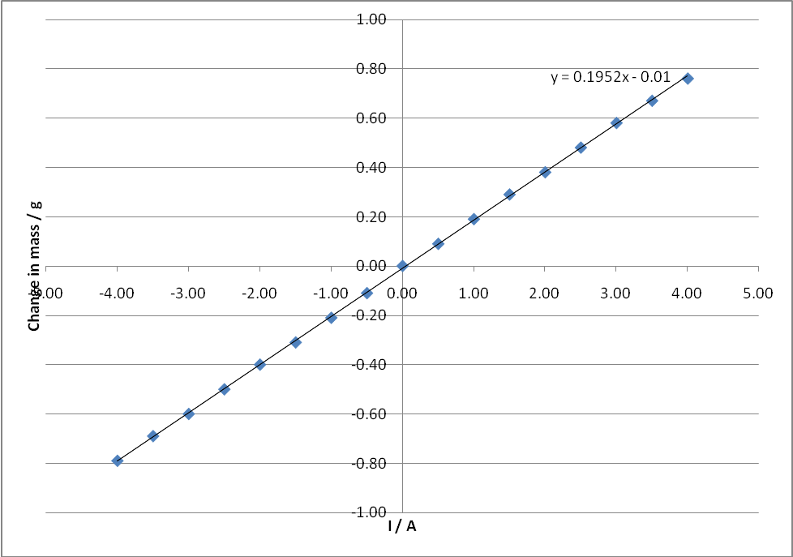
Graph of change in mass reading against current
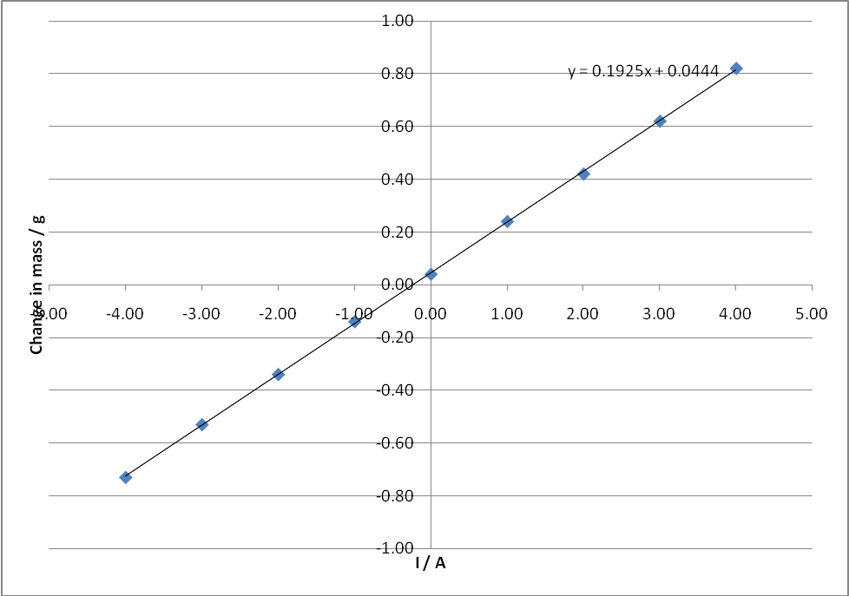
As above, but with deliberate introduction of systematic uncertainty

