Food Dyes and Electrophoresis

At least two of the Curriculum for Excellence outcomes for science [1] relate to studies of DNA which can be explored through practical work:

- I have extracted DNA and understand its function. I can express an informed view of the risks and benefits of DNA profiling [SCN 3-14b].
- I can use my understanding of how characteristics are inherited to solve simple genetic problems and relate this to my understanding of DNA, genes and chromosomes [SCN 4-14c].

Through the Science 3-18 website [2], SSERC provides access to a number of practical activities which can be used to support teaching and learning associated with the above outcomes. One of the most popular of these activities is the so-called ‘Wonderful Wizardry of Finding a Gene’ and details of the protocols have been published in previous issues of this Bulletin [3, 4]. In this scenario, which has its roots in the Harry Potter genre, students are asked to identify the wizard who has special powers. Briefly the experimental basis of the activity relies on the fact that mixtures of food dyes can be separated by electrophoresis using agar gels. The basic electrophoresis equipment required can be obtained from the National Centre for Biotechnology Education (NCBE) [5] but is probably already available in the majority of secondary schools throughout Scotland.

Over the past few months members of the Biology Team within SSERC have received a number of enquiries indicating that the experiment has failed to work effectively. Here we wish to report our suggestions as to how one might overcome such problems. The protocols as originally written recommended the use of combinations of blue, black, yellow and green food colours from Dr Oetker or Supercook [6]. Table 1 below lists the dyes used in the food colorants (information taken from labelling on sample bottles).

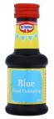  Blue | 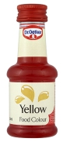  Yellow | 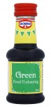  Green | 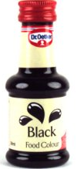  Black
- Brilliant Blue (E133, Food Blue 2 CI 42090) | - Quinoline yellow (E104, Food Yellow 13 CI 47005)  - Allura red (E129, Food Red 17 CI 16035) | - Quinoline yellow (E104, Food Yellow 13 CI 47005)  - Green S (E142, Food Green 4 CI 44090) | - Quinoline yellow (E104, Food Yellow 13 CI 47005)  - Green S (E142, Food Green 4 CI 44090)  - Carmiosine (Azorubine) (E122, Food Red 3 CI 14720)
Table 1 - Dr Oetker Food Colours and list of colorants used.

Dr Oetker’s Yellow Food Colouring has recently been replaced with Dr Oetker’s Natural Yellow Food Colouring and lutein is used in place of Quinoline yellow and Allura red [7]; Dr Oetker’s Black Food Colouring has been replaced by Dr Oetker’s Natural Black Food Colouring and carbon black is used in place of a combination of Carmiosine, Quinoline yellow and Green S [7]. On a recent visit to our local supermarket we did manage to obtain samples of Dr Oetker’s Black Food Colouring rather than Dr Oetker’s ‘Natural Black Food Colouring although it is probably a matter of time before stocks of ‘Black Food Colouring’ are depleted. The change in composition of the food colourings makes the Wizard Genes practical problematic in its current format.

The dyes in the original food colourings work well and so we have set about trying to identify alternative sources. To that end we note that all are available from FastColours [8] with the current cost being £6.00 + VAT for 10 g samples. It is possible, therefore, to prepare your own samples of concentrated colourings. While Blue and Green Food colourings continue to be produced by Dr Oetker there would be no need to buy samples of Brilliant Blue although if one wishes to follow the original protocol it would be necessary to purchase the other 4 dyes. We have done a series of trials using dyes from FastColours and we recommend that you prepare stock solutions in distilled water as follows: Green S - 0.2%; Brilliant blue - 0.2%; Allura red - 0.2%; Quinoline yellow - 0.4%; Carmiosine - 0.5%.

The dyes can be combined in the flowing ratios to simulate the original Dr Oetker food colourings:

- Black - Carmiosine, Quinoline yellow, Green S in the ratio 2:2:1
- Green - Quinoline yellow, Green S in the ratio 2:1
- Yellow - Quinoline yellow, Allura red in the ratio 2:1
- Blue - brilliant blue

In all other respects the protocols as published previously [3, 4] can be used. The data in Figure 1 were obtained using samples from FastColours and are to all intents and purposes identical to those shown in previous articles on this subject [3, 4].

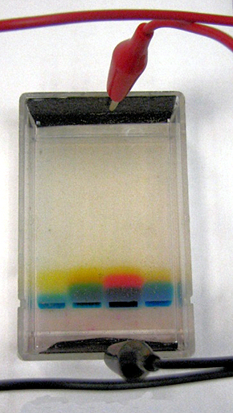 | Figure 1 - Gel electrophoresis of mixtures of food dyes supplied by FastColours. Lanes numbered left to right [8].  Lane 1 – mixture of Quinoline yellow and Green S  Lane 2 – mixture of Brilliant blue, Quinoline yellow and Allura red  Lane 3 – mixture of Quinoline yellow, Green S and Carmiosine  Lane 4 – mixture of Brilliant blue, Quinoline yellow and Green S.
References
- Curriculum for Excellence: Sciences - Experiences and outcomes – available at http://www.ltscotland.org.uk/learningteachingandassessment/curriculumareas/sciences/eandos/index.asp (accessed September 12th 2011).
- The Science 3-18 website is available at www.science3-18.org. Please note that to access all resources on the website you will need to register and be provided with a log-on ID and password.
- The Wonderful Wizardry of Finding a Gene, SSERC Bulletin (2007) 221, 2-4.
- The Wonderful Wizardry of Finding a Gene – Battery Free Method, SSERC Bulletin (2007) 222, 11.
- The National Centre for Biotechnology Education price list is available at www.ncbe.reading.ac.uk/NCBE/MATERIALS/PDF/NCBEpricelist.pdf (accessed September 12th 2011).
- A variety of food colours are available from the Dr. Oetker Online Shop at http://www.oetkeronline.co.uk/categories/Colours-%26-Flavours/ (accessed September 18th 2011).
- Information about the ingredients in the Dr Oetker Natural Yellow and Natural Black Food Colours was obtained at www.tesco.com/groceries/Product/Details/?id=256459508 and www.tesco.com/groceries/Product/Details/?id=258153734 respectively (accessed September 18th 2011).
- FastColours (2011), Food dyes and Lakes – available at http://www.fastcolours.co.uk/food-dyes--lakes-9-c.asp (accessed 18th September 2011).

