Demonstrating Frustrated Total Internal Reflection (FTIR)
This is a good practical activity for Advanced Higher as FTIR has strong similarities to quantum tunnelling.
You will need:
- Class 2 laser (not laser pointer)
- 2 semicircular glass or acrylic prisms
- Small piece of thin paper or aluminium foil
Class 2 laser
Semicircular prism
It will be much easier to observe the effect we are looking for if light levels are low.
Put the semicircular prism flat on the bench.
Aim the laser through the curved surface at the midpoint of the flat face. The laser beam then meets the curved surface at zero degrees to the normal and does not deviate at this boundary.
Adjust the angle of the block until total internal reflection is evident. No light is escaping from the flat face.

Now place a second block alongside the first as shown.
Thin paper or foil
Squeeze
Squeeze
Make the blocks touch at one end but separate the other ends with a thin piece of paper or foil. This forms a very narrow wedge-shaped gap between the blocks.
At this point, it is unlikely that you will see any light transmitted in the second block.
Squeeze the blocks together.
You should now see a transmitted beam in the second block. If you place a piece of card vertically in its path, you may be able to see more clearly that more light is transmitted as you squeeze harder.
Safety
- Use only a Class 2 laser. Do not use a laser pointer as there is a strong possibility that it could be more powerful than the labelling suggests.
- Do not look directly at the beam.
- Ensure that the beam is not pointing at anyone else.
- If necessary, use a beam stop.
- Watch out for stray reflections.
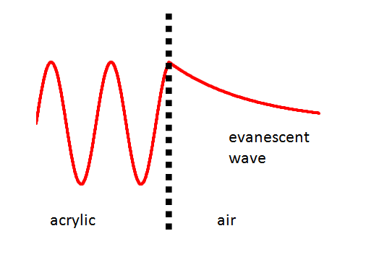
Theory (and relationship to quantum tunnelling)
When total internal reflection occurs, no energy is carried by a wave across the acrylic/air boundary. However, the wave that is incident on the boundary is not simply "cut off". It exists beyond the boundary as an evanescent wave, tailing off exponentially and, as mentioned, transferring no energy.
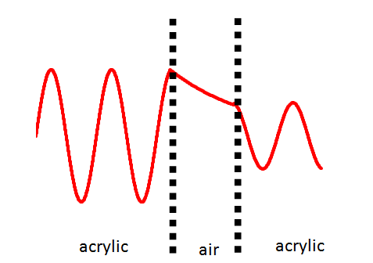
If we were to bring a second piece of acrylic in perfect contact with the first there would be no internal reflection and no evanescent wave. The original wave would continue into the second prism.
Even if the second piece of acrylic does not touch the first, the evanescent wave can become a conventional travelling wave again inside this block. Energy is transferred and total internal reflection is "frustrated".
Because the evanescent wave tails off exponentially, the effect is only perceptible over a short distance - a few wavelengths or so. Since the wavelength of light is of the order of a few hundred nanometres, the blocks have to be no more than a couple of micrometres apart.
When quantum tunnelling is discussed, the term "potential barrier" is often used and this can be a bit abstract for students. If we were dealing with an electron, a potential barrier could be insulating material that, classically speaking, the electron did not have the energy to pass through. We know that the electron has a wavefunction associated with it and that this wavefunction describes the probability of the electron being in a particular location. As with light undergoing TIR, this wavefunction does not simply become truncated when it meets a boundary that, classically, it could not cross. Instead, the electron's wavefunction becomes evanescent at this point - it tails off exponentially. This means that there is still a probability that the electron can be found at the other side of the barrier. We say that such electrons that are found to have crossed the barrier have "quantum tunnelled" through it.
Frustrating FTIR
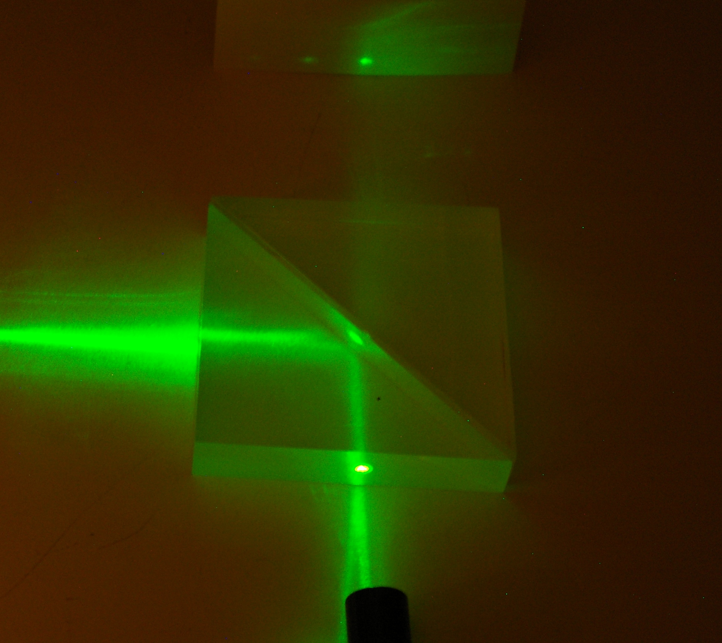
This demonstration took us some time to get working. The picture on the right shows a false start - The green laser is reflected at the boundary, but when a second block is put in place, there appears to be transmission in the direction of the original beam. However, these blocks are about 1 mm apart and separating them further does not dramatically reduce the irradiance of the onward beam. On closer examination, some light was emerging from the hypotenuse face of the prism and simply entered the second prism when it was put in place.
Sometimes, no FTIR was visible when the prisms were placed in direct contact, without the foil spacer. This seemed to be largely dependent on the types of prisms used. At times, FTIR could be seen if the blocks were subsequently squeezed together. We concluded that either the surfaces in contact were not at all smooth at the micrometre level, or that they were in some way bowed or otherwise distorted.

