
It is possible to make a few calculations from this reaction:

A) Chemical calculations such as reaction volumes and enthalpies of combustion.

CfE Higher – Chemistry in Society
Getting the most from costly reactants
Chemical Energy - Bond Enthalpies

B) Physics calculations – using the equations of motion to determine the speed and acceleration of the rocket and hence the forces and energy involved.

Simple Chemical Reactions
Ethanol Rocket
Calculations

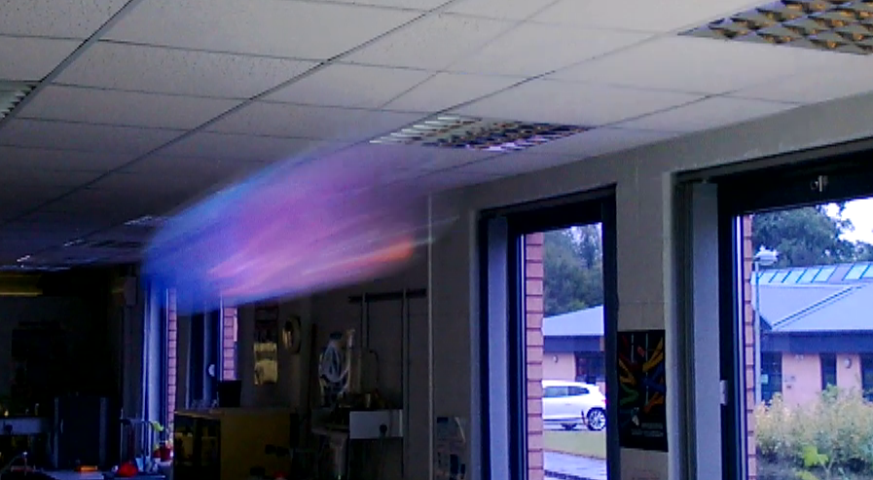
Introduction
If you film the rocket, it is possible to do some calculations regarding its flight. You can use Tracker, a program well loved by the Physics department here, or (for the less technically minded) simply count the number of frames taken for the rocket to cross a certain distance. Video editing software that allows you to advance the footage one frame at a time is ideal for this.
Acceleration
A typical test here took 8 frames (at 25 fps) to cross a distance of 4.75 m, which corresponds to 0.32 seconds
Starting with s = ut + ½ at² it is simple, given that u = 0, to rearrange the equation to give a = 2s
t²
Putting in the figures above gives an acceleration of 121.2 ms⁻². This is 12.3g!
Velocity
Using the same data above, a = v/t, which can be rearranged to give v = at
V = 121.2 * 0.32 = 33.9 ms⁻¹ This is over 75 mph!
Energy
Now we have the energy, it is easy to work out the energy required to accelerate the rocket.
E = ½ mv²
The bottle weighs 46.3 g = 0.0463 kg
E = (0.0463 x 33.9²) / 2
= 26.6 J = 0.0266 kJ
Theoretical energy available
It is possible to estimate this using the bond energies (although we are making several assumptions):
In a 2 litre bottle, 400 cm³ will be oxygen. At room temperature, an ideal gas has a volume of 24,000 cm³ per mole. So in the bottle there are 400/24000 moles of oxygen = 0.0167 mol.
CH₃CH₂OH + 3O₂ = 2CO₂ + 3H₂O
So complete combustion, assuming all the ethanol evaporates, requires 0.0167 ÷ 3 moles of ethanol = 0.0055 mol. (This equals 0.32 ml so the ethanol is in excess. The oxygen is thus the limiting factor)
Now look at the bond energies:
Bond | Energy  (kJ mol⁻¹) | Number broken | Energy in  (kJ mol⁻¹) | Number formed | Energy released  (kJ mol⁻¹) | Energy released  (kJ mol⁻¹)
C-H | 99 | 5 | 495
C-O | 85.5 | 1 | 85.5
O-H | 111 | 1 | 111 | 6 | 666
C=O | 192 |  |  | 4 | 768
O=O | 119 | 3 | 357
 |  |  | 1048.5 |  | 1434 | 385.5

So the theoretical energy release from the ethanol in our rocket is 385.5 x 0.0167 = 2.12 kJ
Efficiency
It is now possible to see what proportion of the chemical energy available has been used to impart acceleration to the rocket.
(0.0266 / 2.12) x 100 = 1.25%
Conclusions
Using a ‘wire’ to keep the rocket to a known path makes the ethanol rocket a safer classroom activity. It also facilitates easy filming which in turn can be used for some interesting cross-curricular work with the physics (+ maths) department.
Work with different alcohols gives the surprising result that although the energy per mole increases as you go from methanol to ethanol to propanol, the rocket performance decreases. Speed of combustion is more important in this case that the total energy released.

