
This reaction can be applied to curriculum for excellence.
Through experimentation, I can identify indicators of chemical reactions having occurred … and can relate my findings to the world around me.
SCN 3-19a
N4 Chemical change & structure
- Energy changes of chemical reactions
N4 Nature's Chemistry
- Fuels
N5 Nature's Chemistry
- Energy from Fuels
CfE - Chemistry in Society
Chemical energy – Energy calculations / bond energies
Simple Chemical Reactions
Ethanol Rocket

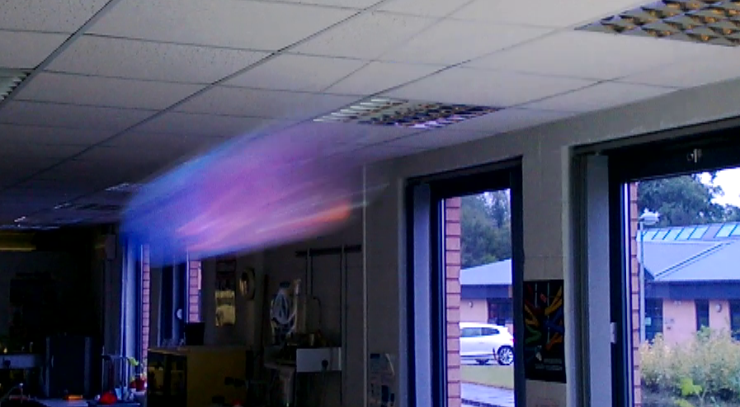

Introduction
The SSERC ethanol rocket is projected along a guide cable. There are a couple of advantages of this:
- from a safety perspective, the fact you know the trajectory means is it much easier to ensure there is no risk of the rocket veering off course and hitting someone or something which it shouldn’t
- with the trajectory controlled in this way, it is easier to take good stills/video footage to allow estimates of velocity.
You will need:
- A dry 2-litre PET carbonated drinks bottle, with lid. (The bottle will either say PET or have a ‘1’ inside the recycling triangle)
- 2 screw-in hooks or eyes (if there are no suitable fixings already).
- A length of string or wire (we have been using nylon fishing line).
- A couple of ‘runners’ (lengths of straw will do though the best we have found are a couple of short lengths of glass tubing).
- A cork borer/glass rod/drill to make the hole on the bottom of the bottle.
- A small bung to fit the hole you make.
- Tape (Sellotape®, masking tape etc)
- Ethanol (caution - flammable)
Preparation
- If there are no fixing points in place, screw the hooks/eyes into somewhere appropriate. A door frame is good for this.
- To make the runners, either cut two sections of straw or break and smooth the ends of two pieces of glass tubing, roughly 3-4 cm in length.
- Slip the runners over one end of the string/wire before fixing.
- Tie the two ends of the string/wire to the hooks/eyes, making sure it is tight. This is especially important if using fishing line as the nylon is elastic and will stretch.
- Make a hole (a heated cork borer is an ideal tool for this) in the base of a 2 litre drinks bottle ca. 5-6 mm is a good size.
- Ensure the bottle is dry. Water in the bottle will affect the combustion, leading to disappointing effects.
- Put 0.5 - 1 cm³ of ethanol (ordinary meths is fine) into the bottle, insert the bung (or put the lid on depending on which hole you put the fuel in) and shake the bottle to evaporate the ethanol.
- Use the tape to fix the bottle to the two runners.

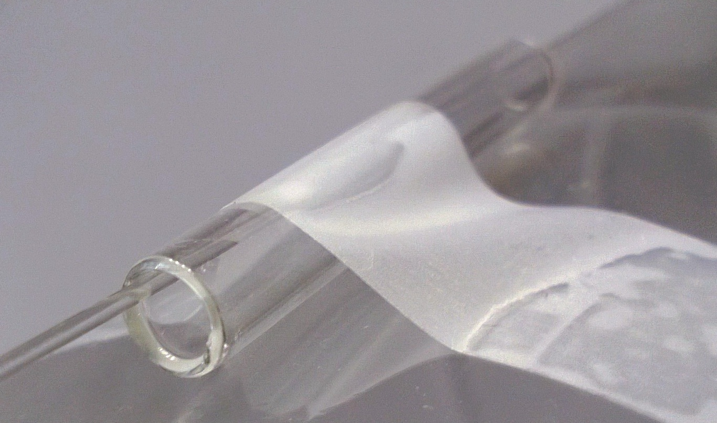

Fig 1: Glass ‘runners’ on the ‘wire’, fixed to the rocket.

The launch
- Make sure everyone is standing well clear of the flight path.
- Wearing eye protection, remove the bung from the bottom of the bottle and apply a flame to the opening, using a splint or a Bunsen lighter at arm’s length.
The rocket will shoot along the string/wire with a dramatic hiss.

Disposal
If you only use 1 cm³ (or less) there should be no significant ethanol to dispose of. If you use more, any spare ethanol can disposed of down the sink, followed by plenty of water, before firing the rocket.

Safety
- If this is being done with a single fuel, as a demonstration, ethanol is preferable to methanol as it is less toxic. It is, however, quite acceptable, with all due precautions, to use methanol as an alternative, looking at different fuels.
- Propanol will also work.
- The audience and demonstrator should be wearing safety glasses.
- This demonstration should never be attempted using a glass bottle.
- Never enrich the mixture with oxygen.
- Check the bottle for cracks or melting from previous demonstrations and use another bottle if there is any sign of damage.
- It is the responsibility of teachers doing this demonstration to carry out an appropriate risk assessment.

Discussion
Dryness of the bottle – the other versions of this we have seen take their lead from the whoosh bottle and insist on a dry bottle. Indeed, several of the whoosh bottle protocols suggest drying for at least 24 hours. This seems to be rather over the top but a dry (or at least fairly dry) bottle works better than a wet one.
Re-use of bottles – if the bottle is showing signs of cracking (or more likely warping from the heat), replace it with a new one (they are not expensive).
If you are short of bottles and want to do a repeat fairly soon after the first rocket, make sure it is cool and blow fresh air through the bottle to remove the accumulated CO₂ that would otherwise interfere with the combustion.
Fuels – this reaction works well with ethanol, methanol and propanol. Care should be taken using methanol as it is extremely flammable as well as toxic.

