SOME EXPERIMENTS ON THE DOPPLER EFFECT
EXPERIMENT 1. Moving source/ stationary observer

A trolley, with a Doppler ball attached, was placed on a friction compensated track. A light gate was connected to a timer and positioned on either side of the track. A microphone connected to a laptop was used to detect the sound emitted from the ball. This sound was analysed using the free audio frequency software Spectrum Lab which can be used as a frequency spectrum analyser.

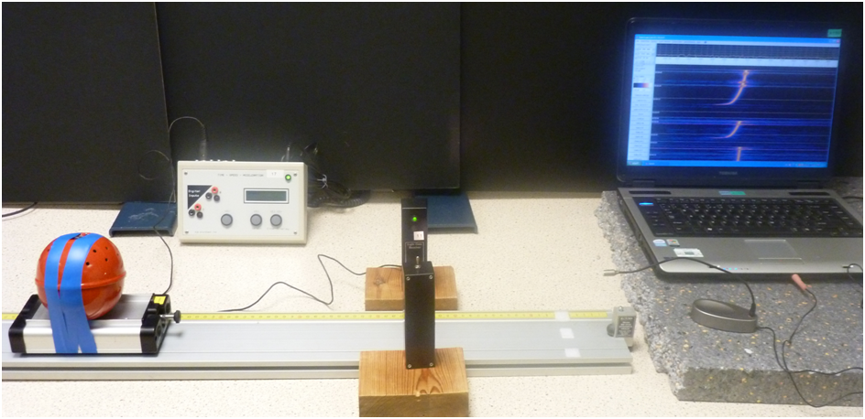

The Doppler ball was modified (by soldering a 4.7 kΩ resistor internally on to the track side of the PCB circuit) in order to increase its maximum frequency to around 4700 Hz which is at the upper limit detectable by Spectrum Lab. The trolley was then pushed down the slope and its constant velocity measured using the data logger. The resulting frequency spectrogram obtained was analysed to determine the frequency, f, of the sound detected when the source was stationary and the apparent frequency f¹ when the source was moving. This was repeated for different velocities of the source. These quantities are related through the equation:-

v
v - v_{s}

+ v

x f
where v is the velocity of sound through the air
v_{s} is the velocity of the moving source

f¹ =

This relationship can be modified to be of the form:-

So the graph of against should be a
straight line with an intercept of 1 and a
gradient of , the negative reciprocal of the
velocity of sound in air.
f
v_{s}
f

v_{s}

f¹
=
1 -
v

f¹

-1
v

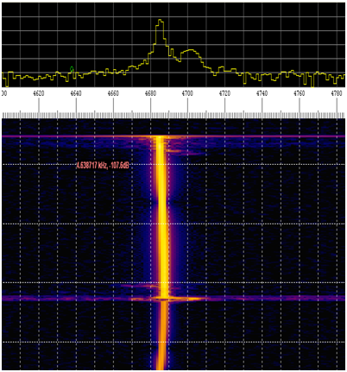
C
A
S
C
A
D
E
S
DOWN
An example of the frequency spectrogram produced in this experiment is shown opposite. The distinctive displacement spike on the cascading frequency stream to the right in the lower part of the chart can be seen (the fainter shadow effect to the left is due to reflections).
This spike indicates that the frequency has been shifted upwards. The data from each of the spectrograms, corresponding to the different velocities of the ball, was analysed and used to plot the graph shown below.
The negative reciprocal of the gradient gave a value of 333 ms⁻¹ for the speed of sound through the air.
Using the LINEST Excel spreadsheet function
the %uncertainty in this gradient (and therefore % uncertainty in the speed) was calculated as 4.3%.
So the final answer can be quoted as :
Velocity of sound = 330 ± 10 ms⁻¹

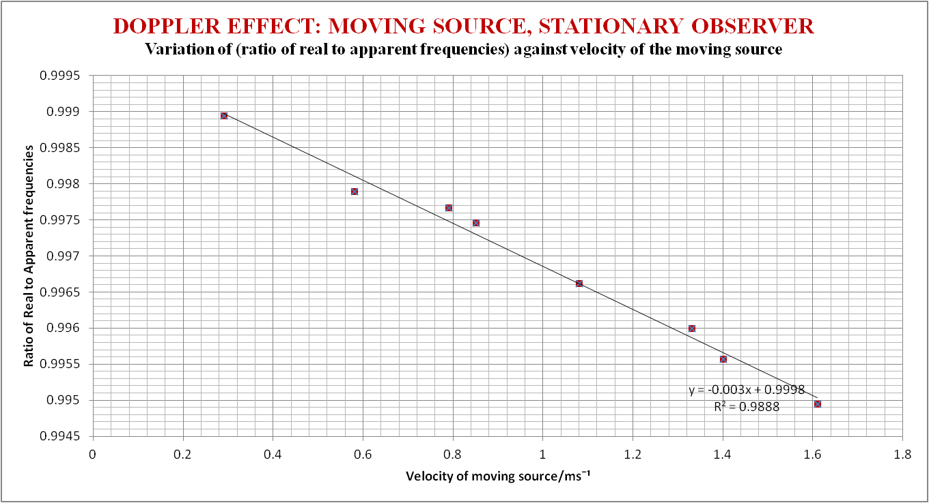
Notes
- The Doppler Ball is a 90 mm plastic ball with a PP3 battery powered tone generator and speaker inside. The pitch can be varied as necessary. [ Stockcode SO76360 from Timstar ; £74.61].
- The highest frequency emitted from the ball without modification was around 3100 Hz. When the experiment was initially carried out using this frequency, reasonable results were also obtained.
- The Doppler ball was modified to emit a higher frequency so that the change in frequency of the sound would be larger for a given velocity of moving source, thus reducing percentage uncertainties.
- The slope was friction compensated so the trolley (with Doppler ball attached) would travel with constant velocity during the duration of its travel down the slope. Thus the change in frequency detected on the spectrogram ( the displaced spike) would be clearer and more discernible.
- The laptop was placed on a foam mat to prevent vibrations from its internal fan passing through the bench top (and air) and so affecting the results.
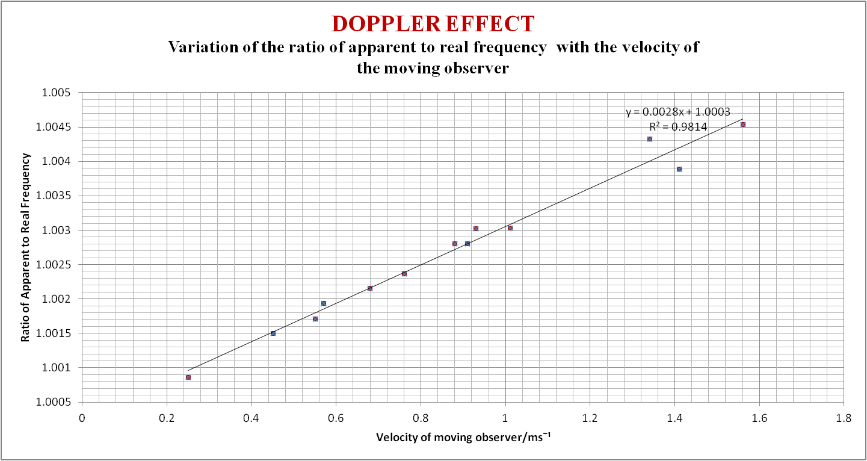
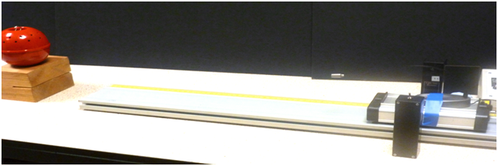
STATIONARY SOURCE, MOVING OBSERVER
EXPERIMENT 2. Moving observer/ stationary source

v
f¹
=
v + v_{o}
x f
where v is the velocity of sound the air
v_{o} is the velocity of the moving observer

This relationship can be modified to be of the form:-

v
f¹
f
1 +
v_{o}
=
So this time the graph of against should be
a straight line with an intercept of 1 and a gradient of
, the reciprocal of the velocity of sound in air.

f¹
f
v_{o}
1
v

The resulting frequency
spectrogram produced by
Spectrum Lab was analysed to
determine the frequency, f, of
the sound when the source was
stationary and the frequency f¹
when the microphone was
moving towards the source. This was repeated for different velocities of the microphone on the
trolley. In this situation these quantities are related through the equation:-

The reciprocal of the gradient (0.002797) this time gave a value of 358 ms⁻¹ for the speed of sound through the air with the LINEST function estimating the % uncertainty as 4%. So the final value for the speed of sound = 360 ± 10 ms⁻¹.
In this experiment the source of sound (the Doppler ball) was kept stationary whilst the detector (the microphone) was allowed to move. The ball was positioned at the bottom of the friction compensated slope and the trolley with microphone on top was allowed to move cleanly down the slope towards the ball.
EXPERIMENT 3. Moving observer/ moving source
In this experiment the trolley (with microphone attached) was set up so that it moved away from the Doppler ball which itself was swinging towards (and away from) the microphone. Firstly, the ball was released from a fixed height and its velocity at the lowest point of its swing, as it moved back and forth, monitored using the light gate. This was repeated a few times and found to stay in the range 1.64 ms⁻¹ ± 4% for the first few swings. The trolley was then allowed to move away from the source with a constant speed which was measured using the light gate. The spectrogram produced on Spectrum Lab is shown below. It displays two distinct displacement spikes to the right on the chart corresponding to two separate runs of the trolley down the slope. ( The effect of the gradually diminishing amplitude of the swing of the pendulum on the frequency of the sound can be clearly seen.) It was decided to focus on the minimum frequencies throughout this experiment. Therefore the image was analysed to determine the minimum frequencies detected when the microphone was stationary then moving. This was repeated for various different velocities of the trolley moving down the slope, ensuring that the ball was released from the same height each time so that the velocity of the ball at the bottom of its swing remained fairly constant.

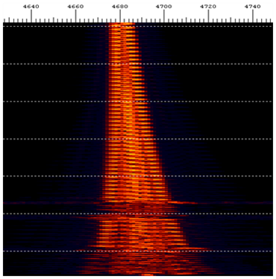
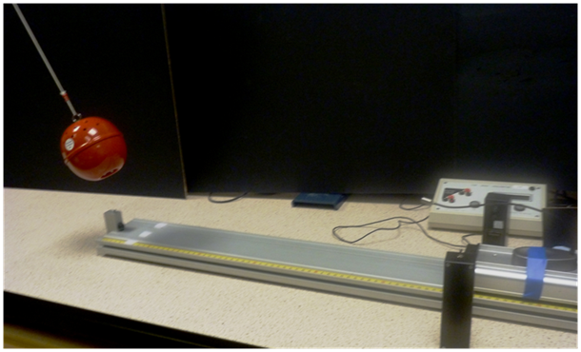
If the minimum frequency detected when the microphone is stationary is represented by f and the minimum frequency when the microphone was moving away from the ball is represented by f¹, then these quantities are related through the equation:
where v is the velocity of sound through the air
v_{o} is the velocity of the moving observer
v_{s} is the velocity of the moving source

f¹
f
=
v - v_{o}
v + v_{s}
This relationship can be modified to be of the form:-

v + v_{s}

f¹
f
=
v
v + v_{s}
-
v_{o}

So the graph of f¹ against v_{o} should be
A straight line with an intercept of v

and a gradient

v + v_{s}
So the graph of against v_{o} should be a straight line with an intercept of and a
gradient of
The data from this experiment is plotted in the graph shown below.
f¹
v
f
-1
v + v_{s}

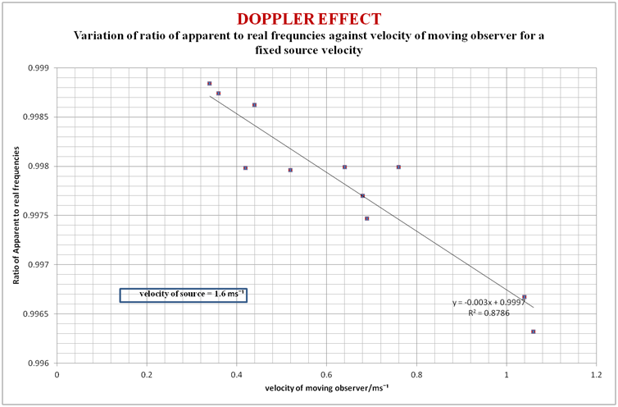
MOVING SOURCE, MOVING OBSERVER
Using the gradient (-0.00298) the velocity of sound was calculated as 336 ms⁻¹ . This time the % uncertainty was estimated as 12% due to the greater scatter of points on the graph.
So the speed of sound through the air this time worked out as 340 ± 40 ms⁻¹.

EXPERIMENT 4. To determine the changing radial velocity of the Doppler ball as it
orbits as a conical pendulum by analysis of its frequency spectrum

This experiment simulates a method used to detect exoplanets. As a planet orbits a distant star its gravitational pull will cause the star to “wobble”. The light emitted from the star will therefore exhibit a blue and red shift which can be measured using a sensitive spectrometer. From this change in frequency the speed of the star as it “wobbles” can be calculated. The wobble is indicative of some object orbiting the distant star and calculation of the speed of the movement can be used to estimate the mass of the exoplanet. For more information refer to these sites:
http://www2.astro.psu.edu/users/caryl/a10/lec21_2d.htm
http://eo.ucar.edu/staff/dward/sao/exoplanets/methods.htm
http://eeyore.astro.illinois.edu/~lwl/classes/astro330h/spring12/Lectures/lecture10.pdf

This experiment uses the same principle only it is the changing frequency of sound waves emitted from the orbiting ball that is analysed to determine its radial velocity as it moves in a circle (or “wobbles”).
The Doppler ball was suspended from a long cord and set in rotational motion, in effect producing a conical pendulum. The sound detected by a stationary microphone was analysed using Spectrum Lab.

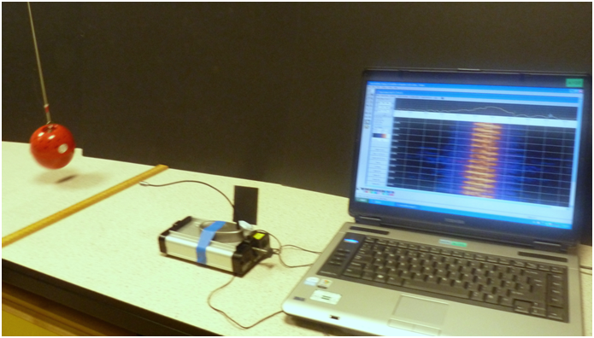
microphone
conical pendulum

When the ball moves towards the microphone in its orbit, the sound detected will apparently increase in frequency and when it is moves away it will display an apparent decrease in frequency. However when the ball moves such as there is no velocity component towards or away from the microphone then there should be no change in frequency. The diagrams below show (i) the spectrogram produced during the experiment and (ii) a simplified diagram, labelled A – I, indicating the variation of frequency at different points in one cycle of the Doppler ball’s orbit.

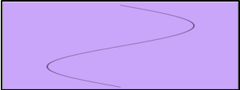
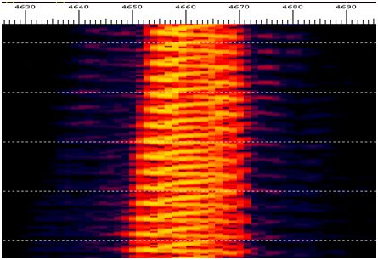
diag. (i)
diag. (ii)
A
E
I
F
G
H
B
C
D
lower frequency

higher frequency

microphone
E
A
C
G
F
H
B
D
Points A, E (and I) correspond to positions when the ball is moving in such a way that there is no velocity component towards or away from the microphone and therefore the frequency measured will be the ‘real’ frequency emitted from the ball. Point C will correspond to when the ball is moving at its maximum velocity away from the microphone in its orbit and so shows an apparent minimum in the frequency of the sound, whilst point G corresponds to when the ball moves towards the microphone showing an apparent maximum in the frequency of the sound. Points B, D, F and H are intermediate positions along the circular path when the frequency will be smaller (B, D) or greater (F , H). By using the time scale on the cascading spectrogram it was possible to apply the Doppler Equation to determine the speed of the ball at the particular times corresponding to the points A – I and so plot a velocity /time graph of the “wobble” of the ball.

view from above conical pendulum

The radial velocity/time graph obtained from the data on the spectrogram is plotted below.
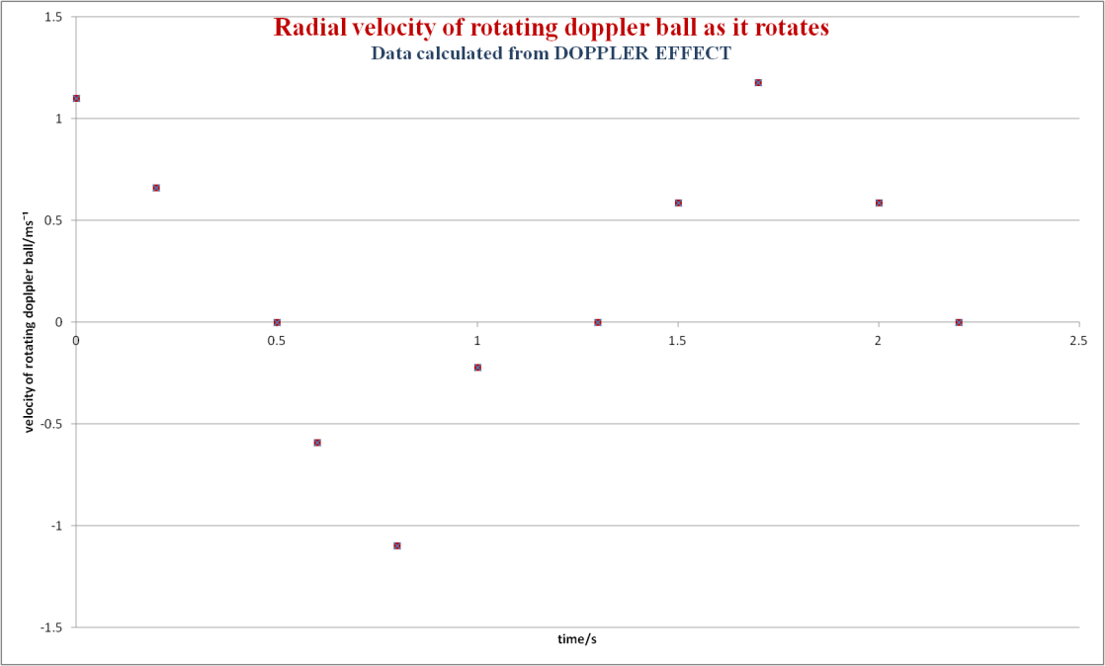

In order to compare these values with the orbital speed of the ball as measured directly in the laboratory, the period of the conical pendulum in its orbit and the diameter of its orbit (using a metre stick) were found at the beginning of its orbiting cycles.
Period of orbit = 1.64 s
Diameter of orbit = 50 cm
Constant speed in its orbit = = = 0.96 cms⁻¹

This compares very favourably with the maximum radial velocities recorded in the graph above.

2πr
t
2 x π x 25
1.64

