Central Acceleration and Angular Velocity

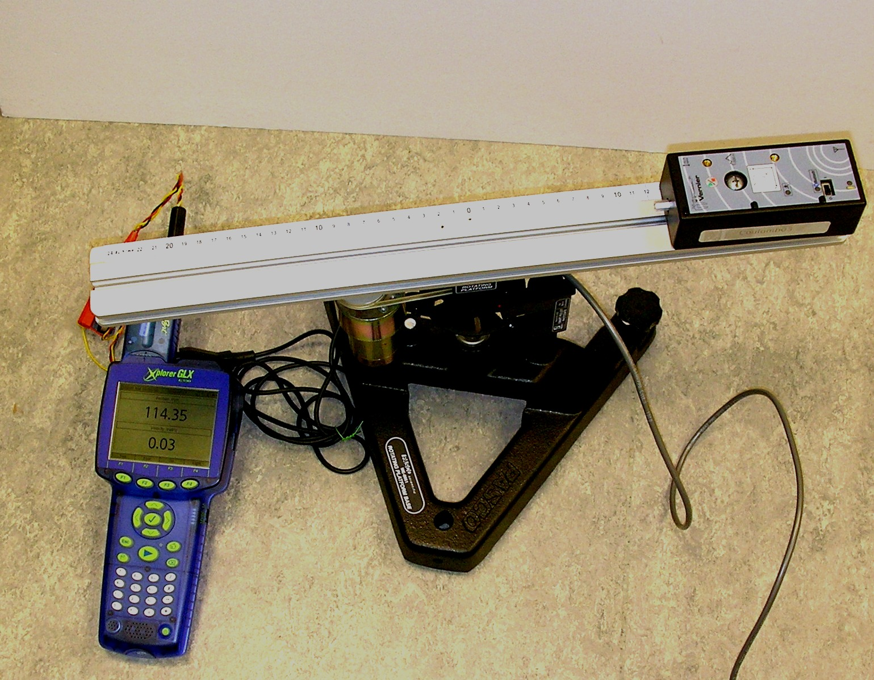 |  | This experiment uses modern interfacing equipment to investigate the relationship between central acceleration a and angular velocity ω.  The experiment uses a rotating platform that is driven by an electric motor whose angular speed can be controlled by a variable power supply. A smart pulley is used along with a Pasco Xplorer GLX interface to measure angular velocity.  Central acceleration is measured using a Vernier wireless accelerometer.
Part 1- Setting up the Xplorer GLX
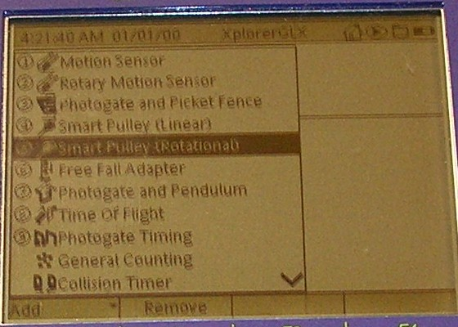 | 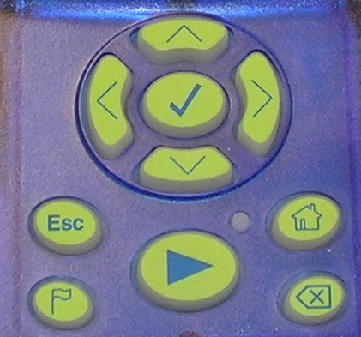  The smart pulley consists of a spoked wheel and photogate. The photogate should be connected to channel 1 of the Digital Adapter which is inserted into one of the Xplorer’s ports.  When this is done, the screen on the left should appear. Use the cursor keys (right) to move down to Smart Pulley (Rotational) and press the tick key.
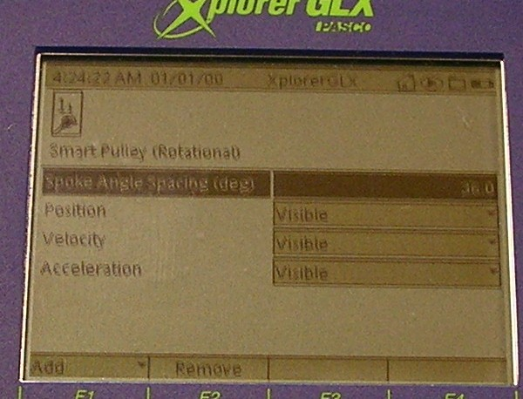 | The next screen shows the spoke angle spacing of the smart pulley. This should be 36° as our pulley has 10 spokes.  (360 ÷ 10 = 36).  You should not have to change this. Press the home button (the one that looks like a wee house).

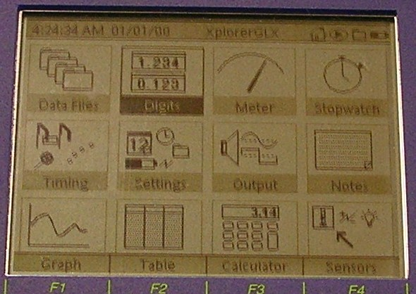 | The home screen is shown on the left. Use the cursor keys to move to Digits, then press the tick.
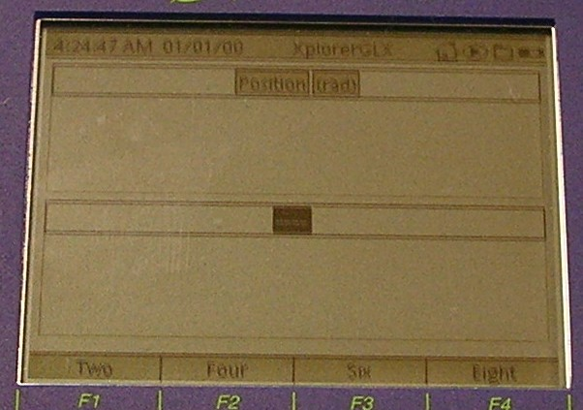 |  | When the screen on the left appears, press the tick again. This should highlight the word Position. Use the down cursor key to move to  -----. We are going to make this display show angular velocity.  When ------ is highlighted as shown left, press the tick again.
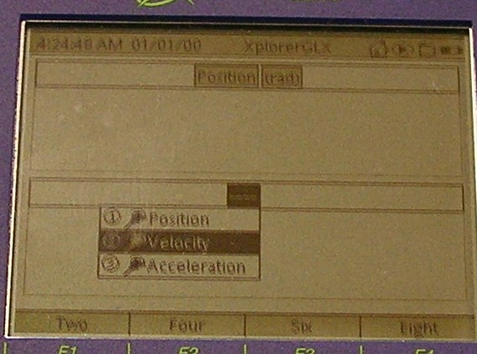 |  | A little menu (left) showing the options for the display should appear. Move down to Velocity and press the tick.
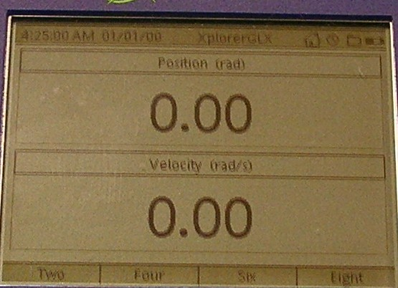 |  |   To check that everything is working, press the start / stop key:  Rotate the platform. Readings of position and velocity should appear.  Press the start / stop key again to cease logging.

Part 2- Setting up the Wireless Accelerometer
Set the slider switch on the sensor to 1 (on).
Make sure the Bluetooth “dongle” is inserted in a USB port on the laptop. Start up the Logger Pro software.
Go to Experiment. Choose Connect Interface, then Wireless followed by Scan for Wireless Devices.  Very often, a message comes up saying that no new devices have been founded. You are then asked if you want to scan again, which you should do.  You should then see this:  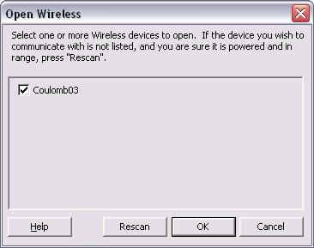 |  | 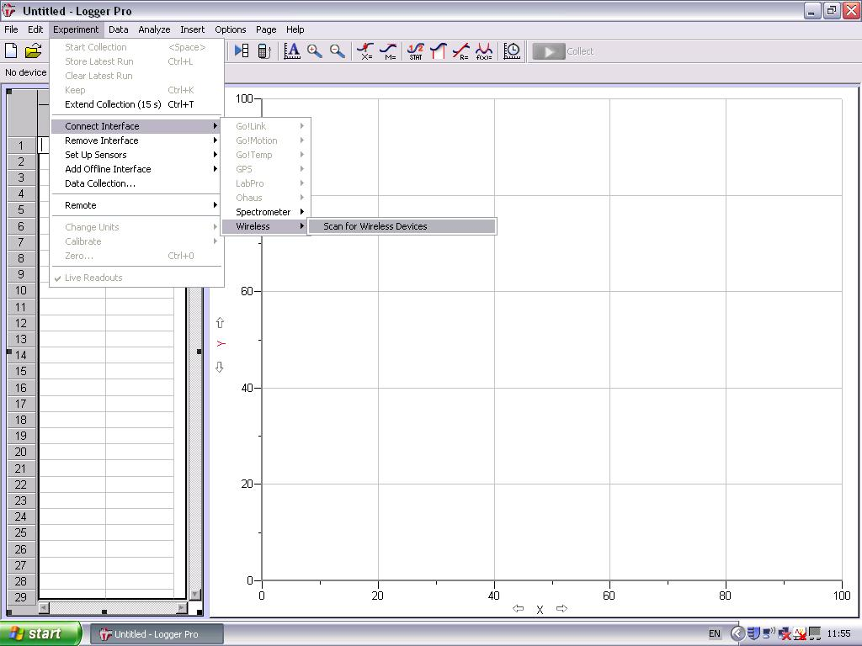
The name displayed may not be Coulomb 03- each sensor has a different name to allow more than one to be used in a class. Click OK.
Click the zero button (right).
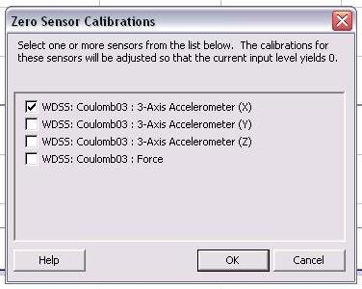 |  |  | A window like the one on the left should appear.  You can zero all the accelerometers if you wish, but we will only be processing data from the x axis.  Zeroing the x-axis accelerometer is an important stage in this experiment.

Click on the y-axis label of the upper graph displayed on your screen.  As shown right, you now have the option to choose the quantity you want to display on the graph. The default is all three accelerations, but we will select only the x-axis acceleration. | 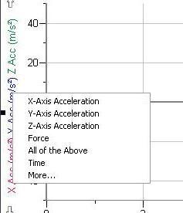
Check that everyone is clear of the rotating arm. Turn the power supply that is connected to the motor drive down low.
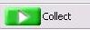
Press on the Xplorer.
Switch on the power supply and gradually increase the voltage until the platform rotates at a steady angular velocity.
Click on the LoggerPro screen. You may be asked at this point if you want to store the latest run or erase and continue. Choose the latter.
1000 readings of angular acceleration are taken in 10 seconds if the default settings are used.  Once logging has finished, move the mouse on to the graph area of the screen. The mouse cursor should change to a cross hair. Drag across all the plotted points as shown on the right. | 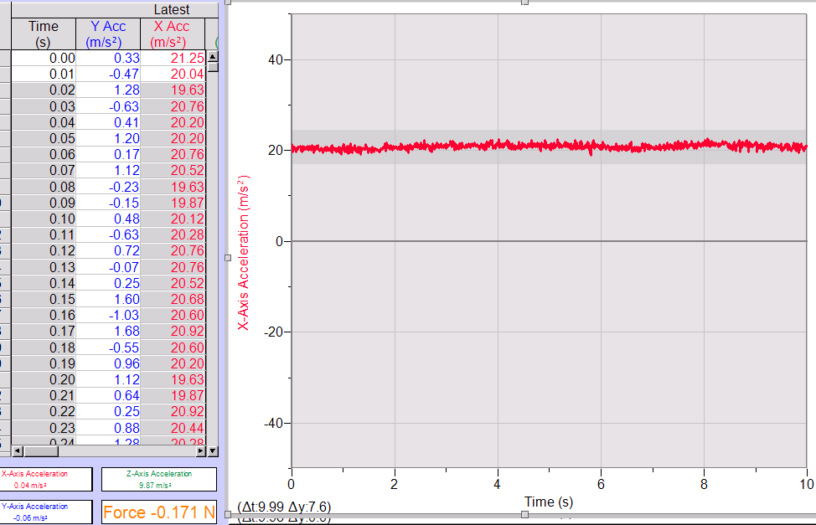
Click the STAT (statistics) button on the LoggerPro toolbar.  As shown on the right, you should see the minimum, maximum, mean and standard deviation values for the selected points.  You can now use these techniques to find the central acceleration at a variety of angular velocities. Note that at high angular velocities the apparatus may begin to wander around.  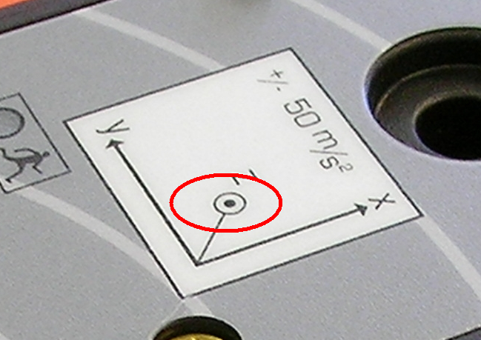You can plot a versus ω². The radius of rotation can also be found as the point where the accelerometers are located is clearly marked on the WDSS: | 