Central Force and Angular Velocity
m_{r} : rotating mass
m_{s} : suspended mass
pen tube
radius of orbit r

This experiment is a budget alternative to the one using the wireless accelerometer or to those using air turntables.
It has a reputation for being tricky to perform and for yielding poor results.
These issues can be addressed by carefully choosing values of m_{r} and r.
The usual method is to make a mark on the string just where it enters the lower end of the pen tube, then to whirl the mass with an angular velocity that is such that the mark is stationary. An assistant finds the time for 20 revolutions and hence the period T.
The method equates the central force (m_{s}g) with m_{r} rω², where ω is the angular velocity in rad s⁻¹.
Since ω = 2π /T, a graph of T⁻² versus m_{s} should be a straight line through the origin.
T increases with m_{r}. However, the above diagram is inaccurate in one particular respect. The mass cannot orbit in a horizontal plane (why not?) The greater the mass m_{r}, the smaller the angle θ in the diagram on the left.
θ
Using a rubber bung of mass approximately 3 g and a radius of orbit 0f 50 cm gives the following theoretical values for 20T.
Suspended mass (g) | 20T (s)
10.0 | 15.54
20.0 | 10.99
30.0 | 8.97
40.0 | 7.77
50.0 | 6.95
60.0 | 6.34
These times proved to be measurable and repeatable.

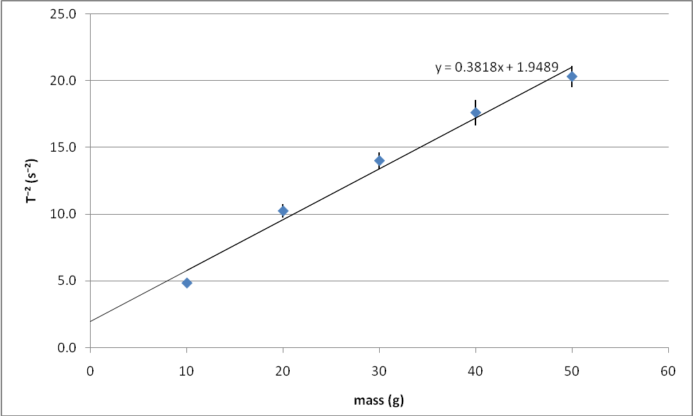

We obtained the above results with a rubber bung of mass 2.5 g and a radius of orbit of 25 cm. You might like to compare the theoretical value of the gradient with the value displayed on the graph. Measurement of radius was made from the point where the thread entered the top of the pen to a position on the bung where its centre of mass was estimated to lie. Thin thread was used. Ideally, this should be monofilament.
Note that the best fit line does not pass through the origin. The results suggest that even without a central force from the suspended mass, the bung is still capable of travelling in a circle, suggesting that there is still a small central force acting on it. Where does this force come from? Can it be reduced or eliminated? If not, can it be measured?
Safety!
Spectators or assistants should be kept out of range of the whirling bung.
The operator should take care not to be struck by the bung.

