Effervescent Enzymes Pupil Materials

Activity 2 The Effect of Catalase Concentration on Reaction Rate.

Hydrogen peroxide is a harmful substance produced by chemical reactions in living cells. Cells produce an enzyme called catalase which has the job of removing the hydrogen peroxide. Catalase does this by speeding up the breakdown of hydrogen peroxide into two harmless products – oxygen and water. If this reaction happens in a solution, you will see bubbles of oxygen gas.
Hydrogen peroxide + catalase ➔ oxygen + water

In this investigation you will use a culture of yeast cells, or unicellular algae, in water. The culture has been diluted several times to produce a range of dilutions. Your teacher will explain how this is done. The weakest dilution (10-⁴) will contain the fewest cells and will therefore contain the least catalase. The strongest dilution (stock culture) will contain the most cells and will therefore contain the most catalase.

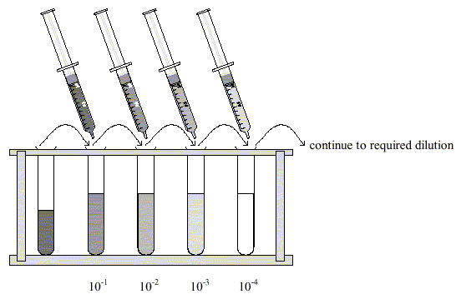
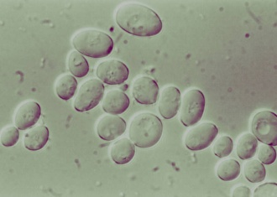
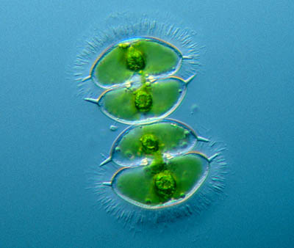
Yeast cells Unicellular algae

Before you begin your investigation, read through the method and construct a table for you results. Consider which headings and units you should include.

Materials
Yeast cell (or algae) samples: Stock culture, 10⁻¹, 10⁻², 10⁻³, 10⁻⁴ dilutions
5 Pipettes
1% hydrogen peroxide
Measuring cylinder
6 Universal bottles
Forceps
Stop watch
Filter paper discs

Method
Wear eye protection

- Measure 20 cm³ of 1% hydrogen peroxide into a universal bottle.

- Using a pipette, place one drop of yeast cell stock culture
on to a filter paper disc.

- Using forceps, drop the disc into the hydrogen peroxide solution.

- Watching carefully, from the side of the bottle, time (and note) how long it takes the disc to rise to the surface.

- Repeat steps 1-4 with the different yeast cell dilutions. Use a fresh filter paper disc, clean pipette and clean Universal bottle each time.

- As a ‘control’, repeat the procedure using a drop of water instead of yeast cells on a filter paper disc. Why is this step included in your investigation?

Once you have completed your investigation, use your results to construct a graph. Consider what type of graph you should draw and what labels and units you should use.

Compare your results and graph with those of others in your class and write a conclusion which sums up what the investigation tells you about the effect of increasing concentration on enzyme activity.

