Effervescent Enzymes Pupil Materials

Activity 1 Comparing Catalase Activity

Hydrogen peroxide is a harmful substance produced by chemical reactions in living cells. Cells produce an enzyme called catalase which has the job of removing the hydrogen peroxide. Catalase does this by speeding up the breakdown of hydrogen peroxide into two harmless products – oxygen and water. If this reaction happens in a solution, you will see bubbles of oxygen gas.
Hydrogen peroxide + catalase ➔ oxygen + water

You will test a variety of plant and animal tissues to see if they produce catalase. You will also test some non-living surfaces for catalase. You will use discs of filter paper to absorb catalase from different surfaces. Each disc will be dropped into a small bottle of hydrogen peroxide. If catalase is present, oxygen bubbles will be produced as the hydrogen peroxide breaks down. These bubbles attach to the paper fibres and make the discs float to the surface of the solution. By timing how long it takes for each disc to float to the surface, you can compare how fast the oxygen bubbles are being produced. This will therefore tell you which surfaces produced the most catalase.
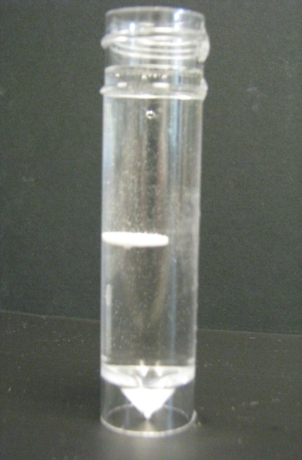

Before you begin the investigation…
- Look at the materials your teacher has provided and prepare a table to record your results.
- What headings will you use?
- What will you measure? Which units do you need to record?
Materials
Bottle of 1% hydrogen peroxide
Measuring cylinder
5 Universal bottles
Forceps
Stop-watch
Filter paper discs
Scalpel / knife
A variety of fruits, vegetables and meat.
Discuss with your teacher which non-living surfaces to test

Wear eye protection

Method

- Measure 20 cm³ of hydrogen peroxide into 5 Universal bottles.

- Use forceps to drop a filter paper disc which has not touched any test surface into one of the Universal bottles. This is a ‘control’ trial. What does the result of this trial tell you?

- Use forceps to hold a filter paper disc against a test surface for 10 seconds. (If you are testing plant or animal material, cut a fresh surface using a scalpel or knife).

- Drop the disc into hydrogen peroxide and observe from the side of the bottle. The disc should sink to the bottom. Be ready to time how long the disc takes to float to the top if oxygen bubbles are produced. Note the time taken in your table.

- Do three other trials with a variety of plant or animal or non-living surfaces, noting the time taken (or ‘no reaction’) in your table.

Once you have completed your investigation. Discuss the results with others and write three things your results tell you about the enzyme catalase.

