 | ‘Effervescent Enzymes’:  Catalase Activities | 

Teacher Notes
The hands on activities described here aim to support the learning and teaching of enzymes at various levels in the curriculum. The activities are based on the action of the enzyme catalase.
Catalase is an enzyme found in nearly all aerobic cells (animals, plants and microbes). The function of catalase is to protect the cell from the harmful effects of hydrogen peroxide generated as a by-product of cell metabolism. It does this by speeding up the breakdown of hydrogen peroxide into molecular oxygen and water.
2 H₂O₂ -----> 2 H₂O + O_{2 (g)}

Some of the many applications of catalase activity
- In the food industry, catalase is used to remove hydrogen peroxide from milk in the cheese making process.
- Some food wrappers use catalase to prevent food from oxidising.
- Hydrogen peroxide is removed from fabrics in the textile industry.
- Some contact lens cleaning products use hydrogen peroxide to disinfect the lens; a solution containing catalase then breaks down the hydrogen peroxide before the lens is used.

The following protocols use a very simple method to demonstrate the above reaction. Oxygen is evolved when filter paper discs which have been soaked in living cells, or which have been in contact with living tissue, are placed in hydrogen peroxide. The oxygen produced is trapped in the paper fibres making the discs buoyant. When the discs are put in to hydrogen peroxide, they initially sink to the bottom of the container then float to the surface as oxygen is produced.

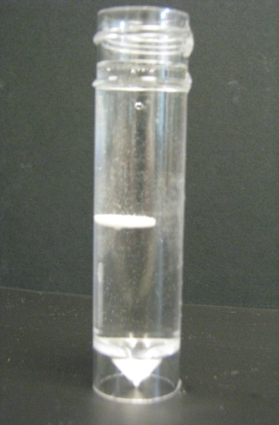
The time taken for the discs to rise to the surface can be used as a measure of reaction rate, and the amount of catalase activity present.

Here we suggest two ways of using this technique:
- Catalase activity in a variety of living and non-living materials is compared. The living materials tested includes both plant and animal tissue.
- A series of dilutions of a yeast or algal culture is used to demonstrate the effects of enzyme concentration on reaction rate.

Activity 1. Comparing Catalase Activity
The aim of this activity is to provide a simple method by which pupils can investigate catalase activity from a number of sources. By pooling class results, they should be able to conclude that (1) Catalase is found only in living organisms and (2) Catalase activity varies depending on the organism, or tissue.
- In this activity living tissue (plant and animal) and non-living surfaces are tested for catalase activity.

- Samples are taken by using forceps to hold a filter paper disc against the test surface for 10 seconds. A scalpel, or knife, is used to cut a fresh surface on plant and animal surfaces.

- The disc is then dropped into a Universal bottle containing 20 cm³ of 1% hydrogen peroxide.

- The disc will sink to the bottom. Then, if oxygen is produced, indicating catalase activity, the disc will float to the surface. Pupils need to be ready to time how long it takes the disc to float to the surface. Therefore younger pupils should probably work in pairs.

- Initially a control trial, where the sample has not touched any test surface, should be carried out.

- Further trials using a variety of plant or animal or non-living surfaces can then be done.

- Pupils can design a table for results and make comparisons of enzyme activity in living / non-living materials and plant / animal tissues.

- Living materials exhibit very different amounts of catalase activity (for example,see the table below).

Catalase activity present | Catalase activity absent
Apricots Carrot  Bananas Cucumber  Parsnips Potato  Cherries Turnip  Broccoli Red cabbage | Apples  Citrus fruits  Peaches  Rhubarb  Tomato

- Catalase activity also varies in animal tissue. For example, liver contains a lot of catalase. This can be related to the role of the liver in the removal of toxins from the body.
- Catalase activity in different tissue such as muscle, kidney and liver could be compared.

Activity 2. The Effect of Catalse Concentration on Reaction Rate.

- In this activity a stock culture of either yeast, or algae, is diluted to give 10⁻¹, 10⁻² ,10⁻³, 10⁻⁴ dilutions. Since more cells, will produce more catalase, and fewer will produce less, the different dilutions of yeast, or algae cells, are used as a measure of enzyme concentration. This would need to be explained to pupils. The serial dilution process could be explained, or demonstrated, to younger pupils. Carrying out the serial dilutions could be done by ‘Higher’ pupils as part of the investigation.
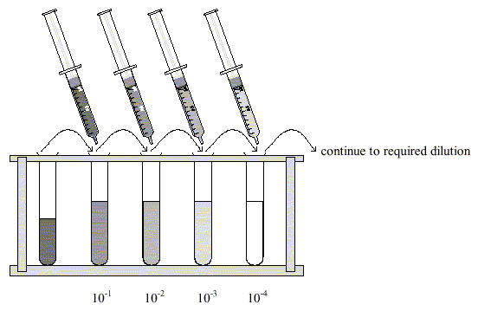

- A pipette is used to place one drop of the yeast, or algal, suspension on to a filter paper disc.

- Forceps are used to drop the disc into the hydrogen peroxide solution.

- The disc will sink to the bottom. Then, if oxygen is produced, indicating catalase activity, the disc will float to the surface. Pupils need to be ready to time how long it takes the disc to float to the surface, therefore should probably work in pairs.

- The process is repeated with the range of dilutions.

- As a control, the process should also be repeated with a drop of water on a filter paper disc.

- Pupils can record their data in tables and graphs and draw conclusions about enzyme activity against concentration.

The protocols for these activities are adapted from Microscale Investigations with Catalase, Student Sheet 24 (available at http://www-saps.plantsci.cam.ac.uk/worksheets/ssheets/SS24.pdf).

Further information about catalase
- All known animals use catalase in every organ. There are particularly high concentrations in the liver.
- Catalase is also found in all plants and many fungi.
- Heavy metal ions act as non-competitive inhibitors of catalase.
- Cyanide is a competitive inhibitor of catalase. By changing the shape of the molecule, it stops the enzyme’s action.

