Audacity and the Doppler Effect

Connect a microphone to your computer.

Start Audacity.

Switch on the Doppler Ball, place it a few cm from the microphone and click to start recording.

If the amplitude of the trace is too large or small, adjust with the microphone slider, as circled in red below.
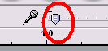
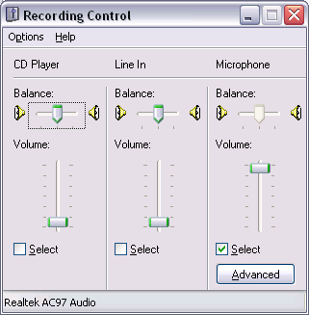
If you are still getting a very small amplitude, you may have to use your computer’s more advanced volume controls.

These vary from computer to computer but often look something like the ones on the left. Try going to Start, then Control Panel. Look for Sounds and Audio Devices. If only a simple volume control is shown, look for a button marked Advanced. Try Options or Properties if the recording controls are not shown.

All being well, you should record something like the trace shown below. Don’t worry if the amplitude isn’t as big as the one shown.

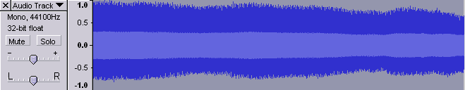
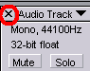
To delete a recording, click the wee cross as shown:

It is possible to calculate the frequency manually by zooming in on a selected part of the trace and finding the time for, say, 10 waves.
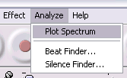
Another way is to select all or part of the trace by dragging over it and going to Analyze and Plot Spectrum.
Something similar to the following should appear:

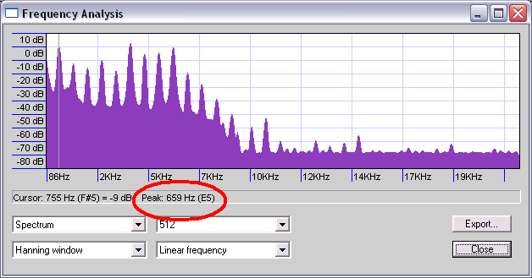

Move the cursor to the first peak. It does not need to be exactly on the peak, just close to it for the software to display the relevant frequency. This is ringed in red above.

Now swing the Doppler Ball like a pendulum, with the microphone positioned as close as possible to the lowest point of the swing. Alternatively, swing the ball in a circle with the microphone placed as close to the circumference of the circle as possible. Either way, you should record something like this:

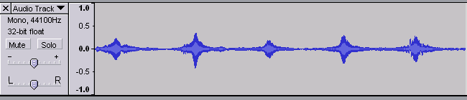
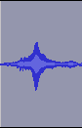
Select one of the bits like the one shown on the right by dragging over it. This section represents the sound getting louder as the Doppler Ball approaches the microphone and quieter as it moves away.

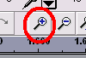
Now click the zoom button to make the trace look like this:

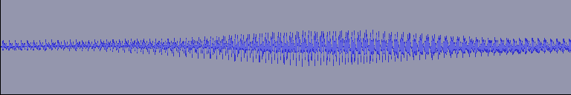

We will now use the Frequency Analysis tool to investigate the frequencies as the ball moves towards and away from the microphone.

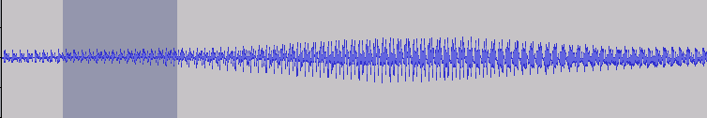

Select an area just before the peak as shown above. Analyse the frequency as before. This frequency should be higher than the frequency of the stationary ball. If no frequency graph appears, see the tips below.

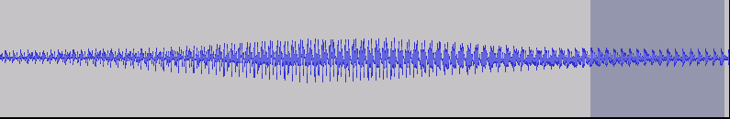

Now select and analyse a region after the peak, when the ball is moving away from the microphone. Here the frequency should be smaller.

The formula for the Doppler effect is
f = v f_{s}
( v ± v_{s} )

Where:

f is the observed frequency
v is the speed of sound
v_{s} is the speed of the sound source
f_{s} is the frequency of sound emitted by the Doppler Ball.

Using, say, 340 ms⁻¹ for the speed of sound, work out the speed of the source as it approaches the microphone. Is the value realistic? Can you verify it by measuring the speed by some other method?

Tips:

- Carry out the experiment in as large a space as possible. If there are strong echoes, the lowered frequency can beat with the higher frequency, giving results that are hard to analyse.
- Don’t analyse the frequency too close to the peak, as this will be the point where it changes from low to high.
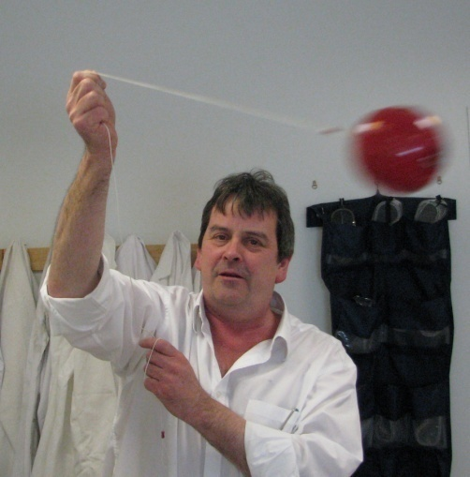
- Choose a reasonably symmetrical region to analyse. Avoid areas where there are spikes or ripples on the trace. All sorts of interference – the string twanging and so forth – can mess up the recorded sound.

See SSERC Bulletin 218 for more advice on using Audacity.

