NEWTON’S RINGS
This is not easy to set up without some practice.
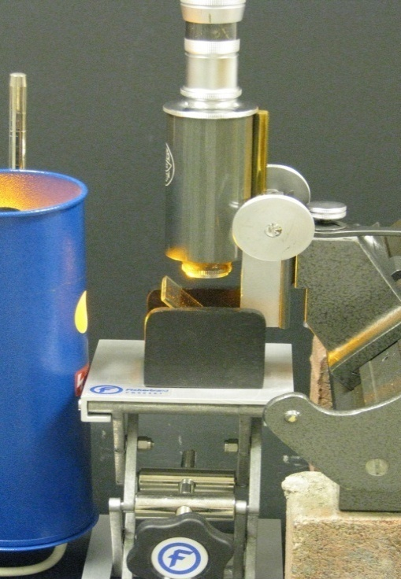
The following may help in obtaining the rings:
- The lens should be plano-convex with a long focal length.
- Work in a darkened room if possible.
- Cover the workbench with matt black paper or card.
- The lens and glass plate should be clean in which case the fringe system should have a central dark spot. A central bright spot may indicate the presence of dust a quarter wavelength thick.
- The bottom glass plate should be optically flat. A good quality microscope slide may do. An optical window would be even better. [see EQUIPMENT below]
- Place the glass plate horizontally on the frame and focus the microscope on the top surface, focusing on the edge of a slip of paper placed temporarily on top of the slide.
- Adjust the position of the aperture of the sodium lamp until optimum illumination of the field of view through the microscope is obtained.
- Insert the lens CURVED SIDE DOWN on the glass plate and adjust until the point of contact is directly on the microscope’s axis.
sodium lamp
travelling microscope
glass plate
Typical distance between microscope objective and glass window is 40 mm.
Typical distance between sodium lamp and glass plate is 400 mm.
The diameters of at least 10 dark rings could be measured with the travelling microscope. The radius of curvature of the convex side of the lens can be found using a spherometer or by employing a
glass slide/window
plano-convex lens
laser reflection method.

The relationship from which a value for the wavelength of
sodium light can be derived is:
d_{m} = ring diameter
d_{m}² = (4Rλ) m R = radius of curvature of lens
m = fringe number

By plotting a graph of d_{m}² versus m, a value for λ can be determined using the gradient.
EQUIPMENT LIST

NEWTON’S RINGS APPARATUS (B8A46229) available from
Philip Harris price £29.75

SUITABLE OPTICAL WINDOW (1” x ½”, 35 – 9331) price approx £9
SUITABLE LENS (f = 1000 mm, diameter = 50 mm, 43 – 0561) price approx £31
both available from

Coherent Ealing, 15 Greycaine Rd, Watford, Herts, WD24 7LN

J.J. THOMSON’S METHOD FOR MEASURING e/m
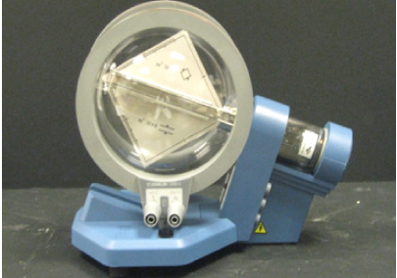
The Thomson tube comprises an electron gun which emits a narrow, focused ribbon of cathode rays within an evacuated, clear glass bulb. A tungsten ‘hairpin’ filament hot cathode is heated directly and the anode takes the form of a cylinder.
The deflection of the rays can be achieved either electrostatically by means of a built-in plate capacitor formed by a pair of deflection plates or magnetically with the help of Helmholtz coils. The cathode rays are intercepted by a flat mica sheet, one side of which is coated with a fluorescent screen and the other side of which is printed with a millimetre graticule so that the path of the electrons can be easily traced. The mica sheet is held at 10º to the axis of the tube by the two deflecting plates.
Two separate methods can be use to determine e/m.

Method 1: By magnetic deflection only
+
-
heater
-
+
anode voltage
Helmholtz coils
Helmholtz voltage
.
A
- Set up the tube as shown opposite.
- The Helmholtz coils are connected in series so that the same size of current flows through each of them and in the same sense.
- Turn on both the heater current and high-tension supply to the anode.
- Energise the Helmholtz coils and observe the path of the beam.
- Adjust the anode voltage until the path of the beam can be seen emerging from a point A on the screen (as in diagram on next page). If the beam is broad due to the electrons having a range of velocities, then the inside edge of the beam, corresponding to the fastest electrons, should be chosen to identify point A.
- The path of the luminous beam is circular, the deflection being in a plane perpendicular to the magnetic field. The relationship from which a value for the ratio e/m can be derived is:
V = Anode Voltage, r = radius of curvature of beam
e/m = 2V/ (B. r) ² B = Magnetic Induction due to Helmholtz coils.
Calculating Radius of Curvature r of Beam.
r
r

A
x
a
C
80 mm
8 x 10⁻³ m
r can be obtained directly from measurements
of the point A at which the electron beam
emerges from the luminescent screen.

r = (c² + a²)
2a
which can be simplified to:-
r = (80² + x² )
√2 .(80 – x)

where x can be read directly from the millimetre graticule scale.
(r will be calculated in mm).

Calculating B
The magnetic induction B generated by coils in Helmholtz geometry carrying current i can be calculated from the following expression:-

_{B} ₌ ₄ ^{3/2} µ₀.n.i
5 R
In this set-up, where n = 320, the coil radius is 68 mm and taking µ₀ to be 4 π x 10⁻⁷
Hm⁻¹, the magnetic induction B midway between the coils can be found (in Tesla) using
the approximation:-

B = (4.2 x 10 ⁻³) x i

Method 2: By Field Cancellation
+
-
heater
-
+
anode voltage
A
Helmholtz voltage
- +
.
plate voltage
Helmholtz coils

- Set up the Thomson tube as in the arrangement shown above. The Helmholtz coils are again connected in series so that the same size of current flows through each of them and in the same sense.
- Turn on the heater current and the anode high-tension power supply.
- Turn on the supply to the deflection plates and observe the deflection of the beam.
- Energise the Helmholtz coils and adjust the current through them until the effect of the magnetic field compensates that of the electric field and the beam is no longer deflected.

Since the force produced by the magnetic field on the electrons cancels out the electrostatic force caused by the electric field between the plates therefore the following expression can be used to derive a value for the specific charge of the electron.

e/m = [E/B]²
^{2V}
where the electric field between the plates is given by
E = V/d V = anode voltage
d = 8 mm = distance between plates.

and the magnetic field B between the Helmholtz coils can be calculated as in previous sheet.
Further work ?: Spread in deflection measured to calculate the range in velocities.
Relativistic effects. {e/m values were erroneous in early experiments due to these effects}

AIR WEDGE FRINGES
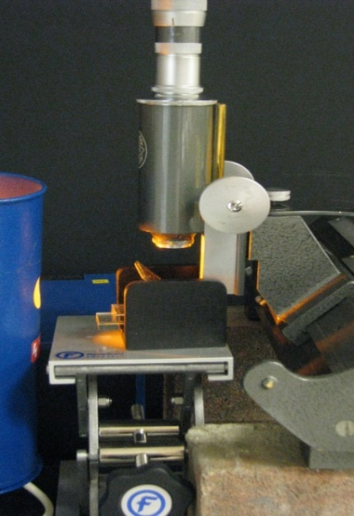
These can be surprisingly difficult to set up without practice. Microscope slides can be used, but they can be unstable while ostensibly at rest. Optical windows are better as they are 6.35mm thick making them sufficiently massive to be fairly stable.
- Work in a darkened room if possible.
- Slides or optical windows should be clean. Ensure that the sodium lamp aperture is lined up with the inclined glass plane.
- Before positioning the upper slide to make your optical wedge, focus the microscope on the top surface of the lower glass. To do this, temporarily place a small piece of paper on the slide and focus on an edge.
- Adjust the sodium source and inclined plate for optimum illumination of field of view as seen through the microscope.
- Now place the upper glass slide on the lower. Insert a single piece of tissue paper under the end, so tilting the upper slide to form an optical wedge.
- Try sqeezing the end of the top slide to see if the fringe spacing increases.
- Thin wire, hair, paper could all be used in place of the tissue paper. The maximum thickness of wedge this method permits is not much greater than a single thickness of standard photocopying paper at 80 gm⁻² .
- If the optical widows are used, the lower glass should be longer. If you alternate between lengths of the upper window then you could confirm that the longer the window the larger the fringe separation.
By measuring the fringe separation, the thickness
Travelling microscope
of the paper, wire or hair can be estimated from
Sodium lamp
the relationship:

d = L λ/2s d = width of paper
Glass plate
s = fringe separation
λ = wavelength of light
Tissue paper
L
L = length of slide
d
Glass window
The effect of increasing the diameter of a wire (by
passing a small current through it) on the fringe
separation provides an interesting investigation.
DOPPLER BALL

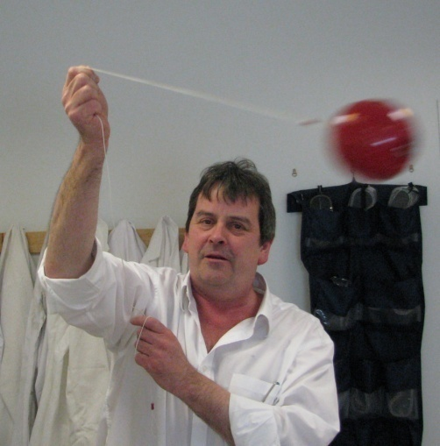
The Doppler Ball provides a sound source which can easily move relative to an observer.
      - Switch on the unit using the small toggle switch in the end recess.
- Choose an area free from obstruction in front of the group.
- Using the cord provided, whirl the ball around in a circle about 1 metre diameter increasing the cord length slowly, if possible.
SAFETY NOTE: Take care that the cord is held firmly and don’t
let go!! Make sure you aren’t likely to hit anyone or anything as
you concentrate on whirling the ball around.
The group should hear an increase in the pitch of the note as the ball approaches them and a fall in the pitch of the note as it moves away.
When the sound source approaches an observer there is a shortening of the wavelength resulting in an increase in the pitch of the note. The opposite is true for a receding source.
But what does the person swinging the ball hear? Try it for yourself.
The Doppler effect is noticeable when emergency vehicles with sirens sounding go past, for example, a stationary car. For a moving source and stationary observer, the frequency detected by the observer will be given by:-
f = frequency detected by observer f_{s} = frequency emitted from source v = velocity of sound v_{s} = velocity of source
f = v fs
v ± v_{s}

In astrophysics a Redshift is observed in light when the source emitting the light is moving away from the observer. If the wavelength detected increases it is said to be shifted towards the red end of the spectrum. When a light emitting source is moving towards an observer it is said to be blue shifted and the wavelength of the light in this case decreases. Planets have been discovered around distant stars by observing how the star wobbles as the planet orbits it. The wobbling star moves towards us then away from us creating a tiny redshift followed by a tiny blueshift in its light. It should be noted that this Doppler Redshift applies only when the velocity of the source is much less than the speed of light. A relativistic Doppler formula is required when the velocity is comparable to the speed of light.
FUN WITH MAGNETS: ELECTROMAGNETIC BRAKING
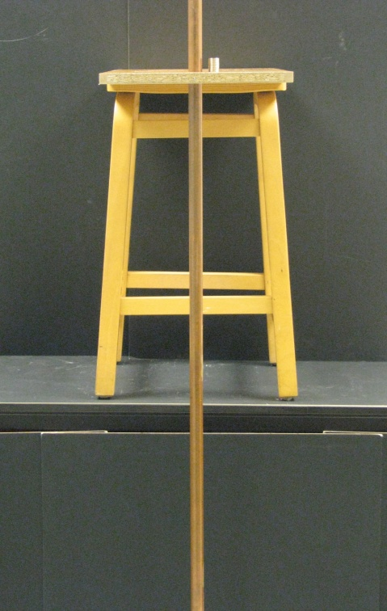
This is an excellent demonstration of Lenz’s Law and eddy currents.
- Thread the copper tube through the 25 mm diameter hole in the wooden frame.
- Place this frame flat on the wooden stool standing it on top of, and at the edge of the workbench with a polystyrene block on the ground under the tube.
Ensure that the tube is vertical by positioning the wooden board such that the tube has almost no bias towards any part of the 25 mm hole.
- Drop the steel ball bearing through the tube and note how long it takes to fall to the bottom.
- Now drop a stack of 4 neodymium magnets down the tube and again time the fall.
N
N
N
N

S
S
S
S

N
N
N
N
N
N
N
N

S
S
S
S

N
N
N
N
S
Weight
Resultant of all
Magnetic Forces
N
Repulsive Force
Attractive Force
You will notice that the magnets fall much more slowly. This is because the copper tube "sees" a changing magnetic field from the falling magnet. This changing magnetic field induces a current in the copper tube. The induced current in the copper tube creates its own magnetic field that opposes the magnetic field that created it.
According to theory the terminal velocity v of the falling magnet is given by the expression:-
M = mass of cylindrical magnets
ρ = electrical resistivity of copper pipe
a = internal radius of pipe
h = height of cylindrical magnets
B = magnetic field on axis of symmetry
r = cross-sectional radius of magnets
w = wall thickness of pipe
= a scaling function depending on

ratio of
lle and again time taken toh
a
2Mgρa²h²
h
a
V =
_{πB}²_{r}⁴_{w (h}² _{+ r}²_{) f}
( )

h
a
f ( )

Extension material:
Copper
pipe
w
a
magnets
h
r

The above expression could be used as the basis
of study into further interesting investigations such as:-

- Varying the radius of the copper pipe.
{The greater the radius a of the pipe the greater
the terminal velocity of the falling magnet}

- Varying the thickness w of the wall of the pipe.
{The thicker the wall w the smaller is the terminal velocity of the falling magnet}

- Cutting a slit along the length of the tube or cutting a series of rings along the length .
{both increase the terminal velocity appreciably but do not remove the
electromagnetic braking completely}

- Altering the orientation of the magnet as it falls through the tube has an effect.
{flat orientation in tube results in a smaller terminal velocity compared to one falling end-on: a tumbling magnet has an even smaller terminal velocity}

- Since terminal velocity is reached as the magnets fall through the tube, there must be an upward force (due to the electromagnetic induction) acting on the magnets which should be equal in size but opposite in direction to the magnets’ weight. The copper pipe could be set up on the pan of an electronic balance and weighed. The reading of the balance will rise as the neodymium magnets are dropped down the pipe. The difference in readings should equal the weight of the stack of magnets.

Interesting Websites: http://users.hubwest.com/hubert/mrscience/eddy.html
http://www.16pi2.com/eddy_currents.htm
http://www.coolmagnetman.com/magpipes.htm
www.if.ufrgs.br/~levin/Pdfs.dir/AJP000815.pdf

MOMENT OF INERTIA: ROLLER DERBY
Two cylinders of the same mass and radius are placed at the top of an inclined plane and allowed
to roll freely to the bottom. Which one reaches the bottom of the slope first?
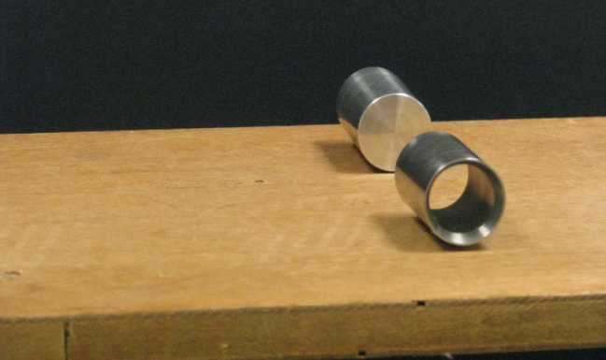
If these two objects are released simultaneously the solid cylinder will reach the bottom first. But why?
Less of the solid cylinder’s gravitational potential energy becomes rotational kinetic energy and therefore more becomes translational. In general, for any object rolling to the bottom of a slope the potential energy lost will equal the translational energy plus the rotational energy gained at the bottom.
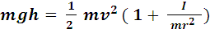 m = mass of object, r = radius of object ,
v = velocity of cylinder at bottom, I = moment of inertia of object.
So the larger the moment of inertia I of the object, the smaller will be the linear velocity v of the
object at the bottom and so the less time it will take to reach the bottom.
In fact if the moment of inertia of some regular objects is substituted into the above equation
then the final velocty at the bottom can be calculated for each.
Hollow Cylinder :
Solid Cylinder :
Hollow Sphere: 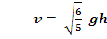
Solid Sphere: 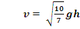
So the solid sphere should win in a straight rolling race down the slope !!
But what would be the placings in a race between the sphere, the solid cylinder, the hollow sphere (all of the same mass and radius) rolling down the slope along with a particle of the same mass sliding down the slope, ignoring any frictional losses?

1st Place: Sliding Particle
2nd Place: Solid Sphere
3rd Place: Solid Cylinder
4th Place: Hollow Cylinder
Particle
Sphere
Cylinder
Hoop
All mass m
Radius r

Final Puzzle: The Great Egg Race

If a hard boiled egg and a raw egg were released from the same position at the top of the slope and allowed to roll down freely, ignoring the effects of friction, which of the eggs would reach the bottom first ? Explain!
Hard boiled egg
Raw egg
ROTATING CHAIR

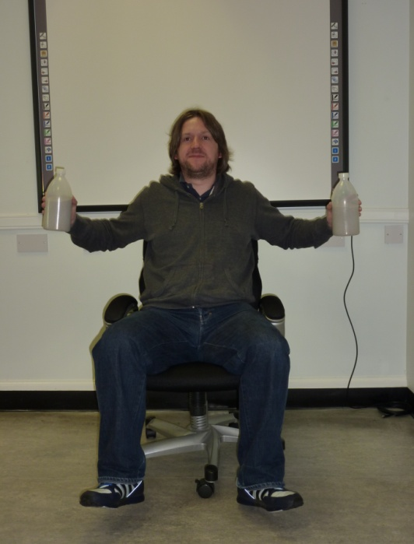
The Rotating Chair is an entertaining demonstration of the conservation of angular momentum.
Rotating Chair with hand-held masses.
- Sit on the chair holding a mass in each hand close to your chest.
- With your legs up off the ground ask a colleague to set the chair rotating.
- Now move the masses out slowly away from your body then back in again.

Why does your rotational velocity change in the way
it does ?

According to the law of conservation of angular momentum,
the total angular momentum before extending your arms is equal to the total angular momentum after (of course, in the absence of all external torques).
L
ω₁
I₁
Since angular momentum L is given by the expression Iω,
then during this activity,
I _{before} ω _{before} = I _{after} ω _{after} -------- eqn 1
where I = Σ mr² {moment of inertia}
By extending your arms outwards, your moment of inertia
L
about the central axis of your rotation must increase.
ω₂
I₂
So I _{after} > I _{before}
and therefore for equation 1 to hold,
ω _{after} < ω _{before}

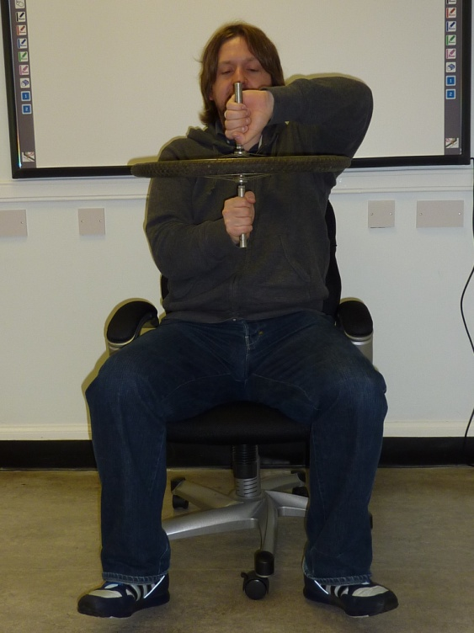
Rotating Chair with bicycle wheel

This is a variation on the same theme and can be used to demonstrate the vector nature of angular momentum.

- Sit on the chair and hold the bicycle wheel with its axis orientated vertically.
- Spin the bicycle wheel keeping its axis aligned vertically.
- Now with your legs lifted off the ground, slowly turn the axis of the wheel through 180º.
- Why does your chair rotate the way it does ?
L_{after}
L_{wheel}
ω₁
ω₂
L_{before}
L_{man}
Again, according to the law of conservation of angular momentum :-
the total angular momentum before the wheel is turned over total is equal to the total angular momentum after (in the absence of all external torques).
Since angular momentum L is a vector quantity, it therefore has direction.
If the wheel was initially spinning in such a way as to have its angular momentum pointing upwards, turning the wheel upside down now causes its angular momentum to point downwards.
But the total angular momentum of the whole system [wheel, chair and you!] must remain the same throughout.
So the chair will rotate in the same angular direction as the wheel did originally to ensure that the total angular momentum remains unchanged.

POLARIZATION
Using Microwaves
In this experiment, a Gunn oscillator is used as a microwave source. It operates at a frequency of 9.4 MHz and releases a power of approx 10 mW via a connected horn antenna. An E-field probe, which does not affect the field distribution, is used to measure the electric field strength due to the microwaves at a single point. In the probe, short wires, which are soldered to a high-frequency diode, act as a dipole antenna for the microwaves. Strictly speaking, the E-field probe measures the electric field’s component that is parallel to the longitudinal axis of the probe and rectifies the signal. The diode characteristic is not linear; in fact the output signal is approximately propotional to the square of the field component. The Gunn power supply is equipped with an integrated amplifier to supply the output signal of the E-field probe.
a
b
c
E-field Probe
a high frequency diode
b dipole antenna
c twisted copper wires to
avoid magnetically
induced voltages.
The polarization grating, which is designed like a printed circuit on a board, is used as a polarizer for microwaves. Strips of tin-plated copper prevent formation of an electric field parallel to the strips due to their high conductivity. The electric field can only build up perpendicularly to the metal strips.
Experiment 1
- Place the E-field probe in normal vertical alignment a distance of about 20 cm from
the horn antenna. Measure the received signal strength using the Pasco GLX Xplorer.
Polarization grating
E-field probe
Horn antenna

XplorerGLX
Gunn oscillator

- Now hold the probe horizontally at the same distance from the antenna and again take
a reading using the interface.

Explain the difference!

Experiment 2
- Set up the E-field probe in vertical alignment a distance of 50 cm in front of the horn antenna.
- Place the polarization grid about midway between the probe and the antenna.
- Start logging data on the laptop and slowly rotate the polarization grating from 0º round through 360º. Try to maintain a constant angular speed as you turn the polarization grid.
- Stop logging data.
Can you explain the shape of the graph shown on the display?

Experiment 3
- Remove the horn antenna from its stand and screw it back into position only this time in the vertical orientation.
- Set up the horn antenna at the same distance from the polarization grating and the E-field probe as before.
Before rotating the the polarization grating through 360º as before, can you predict what the
graph of signal strength against angular position of grating will be this time?
- Try it and see! Remember to keep the rotational speed as constant as possible.
Using Laser Light

This is the optical equivalent of the previous experiment. Laser light is transmitted through a polarizing film which acts as an analyser and the resulting signal strength monitored.
Generally the polarization vector of radiation from an educational HeNe laser rotates slowly with time. The period of rotation can vary from 25 s to 10 min at switch-on, depending on type, and typically lengthens to perhaps 30 min after two hour’s operation once the device has fully warmed up. These lasers are therefore unsuitable for polarization experiments. An exception is the HeNe laser model sold by Griffin (XFV-540-010V), which has a stable plane of polarization. In contrast the radiation from all the laser diode modules we have tested has been found to be have a stable plane of polarization. In any application where comparative measurements of laser radiation irradiance are to be made the entire beam should fit within the bounds of a planar photodiode.
Large area
photodiode
detector
Laser
polarizing
filter
beamstop
Experiment 4
- Position the polarizing filter on the track and arrange the laser beam so that it passes through this filter and on to the photodiode detector.
- Click on Start to begin data logging and rotate this filter until a maximum reading is obtained on the detector. Stop logging. Keep the polarising filter in this position in its holder.
This replicates the E-field probe’s alignment with the source.
- Now place the rotatable analyser on the track and rotate it slowly until the detector shows a minimum reading. This replicates the initial alignment of the grating in the microwave experiment.
Large area
photodiode
detector
Laser
rotatable analyser
polarizing
filter
beamstop
- Now click on Start to begin data logging and rotate the analyser cylinder with constant angular speed through 360º. Stop logging.
- Display the measurements in graphical format.

Does the display agree with the microwave results?

Experiment 5
- Rotate the analyser cylinder again until a minimum is registered on the detector.
- Turn the laser equipment on its side so that the beam is at right angles to its original arrangement [this set-up is now similar to microwave experiment 3 above].
- Click on Start to begin data logging and rotate the analyser cylinder with constant angular speed through 360º just as before. Stop logging.
How do the results from this experiment compare with those from the microwave experiment?

Explanation
Microwave experiment
The received signal is approximately zero if the E-field probe is aligned horizontally in front of the horizontal horn. This means that the waves transmitted by the horn are linearly polarised perpendicularly to the broad side of the horn.
In experiment 2, if E_{o} is the electric field strength transmitted from the horn and θ is the angle between the metal strips of the polarization grating and the vertical, then the strength of field transmitted through the grating strips will be E_{o}sin θ, i.e. the component perpendicular to these strips.

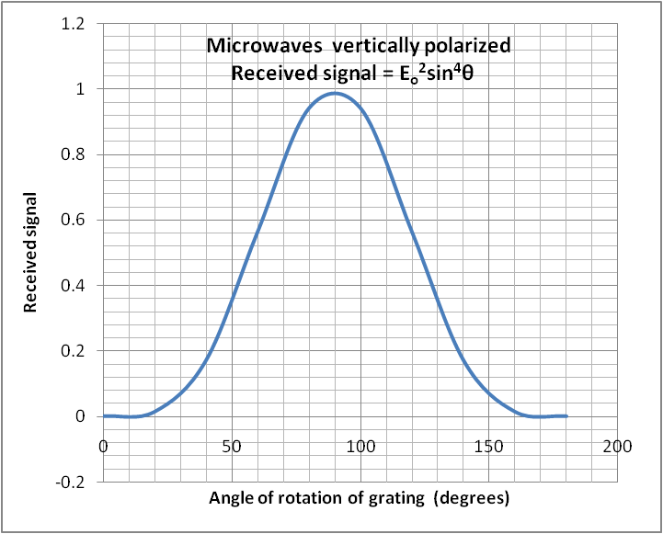
E_{o}
θ
E_{o}
E_{o}sinθ
E_{o}sinθ
90 - θ
[E_{o}sinθ]cos (90-θ)
= E_{o}sinθsinθ
= E_{o} sin²θ

Microwave signal
vertically polarized
Polarizing grating rotated through θ degrees to vertical
E-field probe aligned to receive
vertically polarized signals
grating orientation
transmitted
signal

component
probe ‘sees’
transmitted
signal

Since the E-field probe is vertically aligned, the signal it ‘sees’ will be the vertical component of this E_{o}sin θ transmitted signal which will be E_{o}sin θsin θ. Since the square of this electric field component is a measure of received signal, the reading on the detector wil be proportional to (E_{o}sin θsin θ)² = E_{o}²sin⁴θ. The graph shows how the strength of the receved signal should vary theoretically with the angle of rotation of the grating.

If the horn is turned on its side as in experiment 3, the microwaves will now be horizontally polarized and the signal passing through the polarizing grating will be given by E_{o}cosθ.

θ
E_{o}
E_{o}cosθ
E_{o}cosθ
θ
E_{o}cosθsinθ

Microwave signal
horizontally polarized
Polarizing grating rotated through θ degrees to vertical
E-field probe aligned to receive
vertically polarized signals
θ

grating orientation
transmitted
signal
transmitted
signal
component
probe ‘sees’
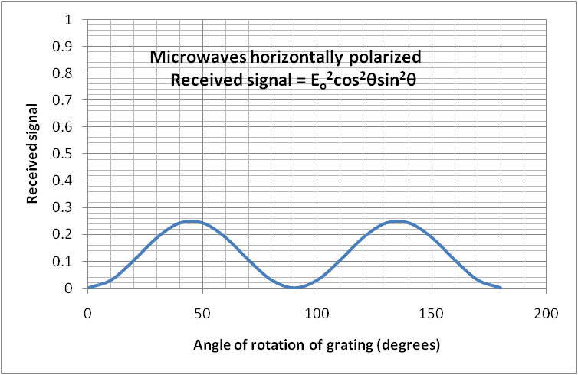

The E-field probe still only ‘sees’ the vertical component of this signal which this time will be E_{o}cosθsinθ and the reading on the detector will now be proportional to E_{o}²cos²θsin²θ . The graph shows how the received signal should now vary with angle of rotation of grating.

ADDITIONAL EXPERIMENTS
A study into the effect of the laser beam having a slight angular offset (e.g. 5º, 10º) from its initial vertical orientation can be interesting.
Laser
rotatable analyser
polarizing
filter
Laser tilted through small fixed angle from its initial orientation
beamstop
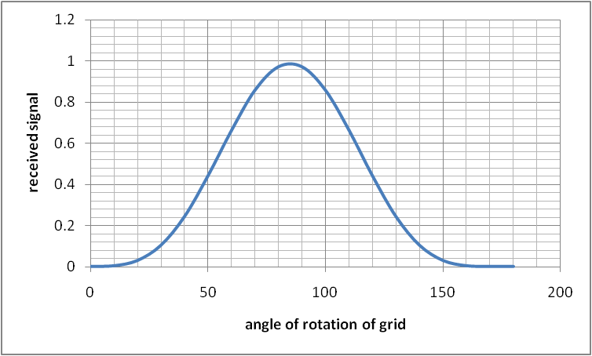
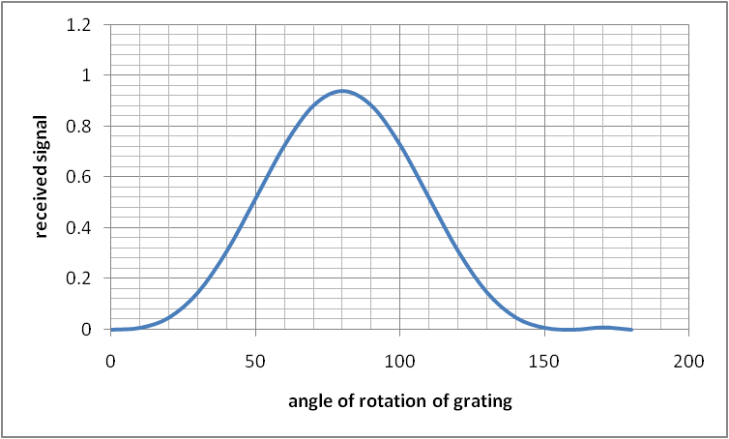
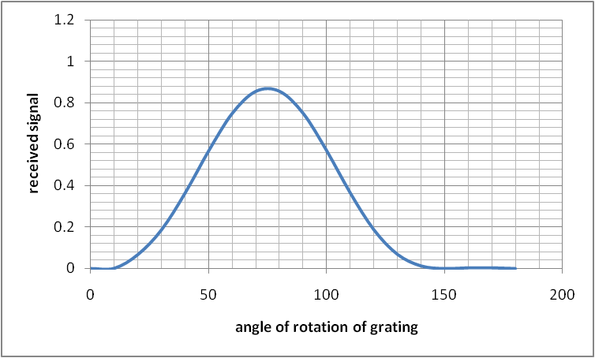
The graphs show the effect of the beam having an initial anticlockwise offset of 10º, 20º and 30º.
Plane of polarization offset by 10º anticlockwise
from initial vertical orientation of horn
Plane of polarization offset by 20º anticlockwise
from initial vertical orientation of horn

Plane of polarization offset by 30º anticlockwise
from initial vertical orientation of horn

A number of effects can be observed:
- The height of the peak is reduced as the angular offset is increased
- The position of the peak is displaced to the left for an anticlockwise offset; the greater the offset the greater this displacement.
- A very small secondary peak begins to appear to the right of the main peak.

If an offset is introduced when the laser beam is initially aligned in the horizontal plane then the graph is altered to produce two peaks of unequal height, the relative sizes of these peaks depending on the size of the offset.

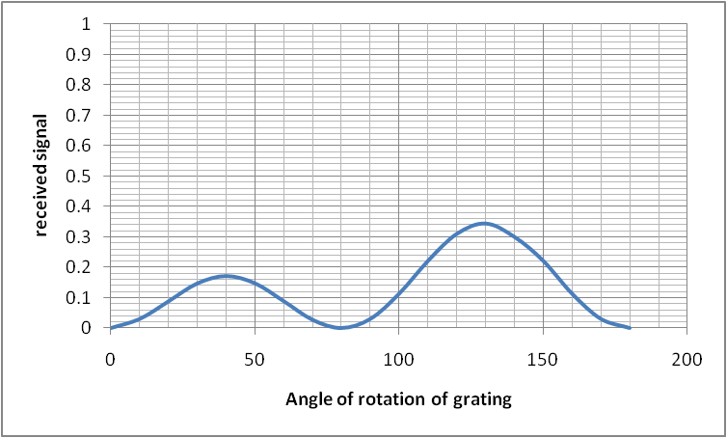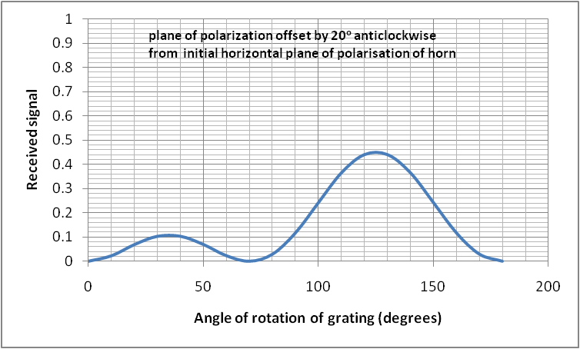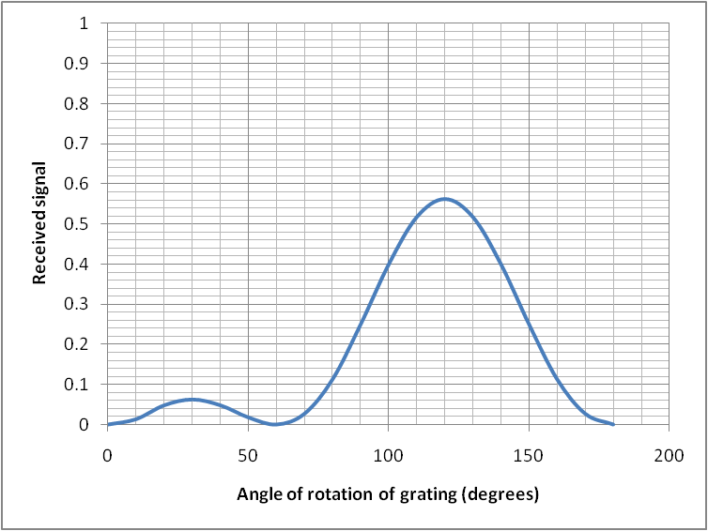
Plane of polarization offset by 10º from
initial horizontal horn orientation
Plane of polarization offset by 30ºanticlockwise
from initial horizontal plane of polarisation of horn

Plane of polarization offset by 30º anticlockwise
from initial horizontal plane of polarisation of horn

Again a number of effects can be observed:
- The relative heights of the peaks vary as the angular offset is increased; the smaller one becomes smaller, the larger larger.
- The width of the larger peak increases whilst that of the smaller diminishes.
These points could be reseached more thoroughly as part of a more detailed investigation.

