A Wee Bit of Physics
The Nintendo Wii® games system uses a wireless motion sensing controller, sometimes called a Wiimote. It contains a 3-axis accelerometer and uses Bluetooth to communicate with the console. Some people have developed applications that capture the accelerometer data on to a Bluetooth-equipped computer. One such person is Martyn Wheeler, whose free software can be downloaded from http://www.wiiphysics.site88.net/. When you set up the software, it may ask you to download “.NET” from Microsoft to make it work.

Here we look at connecting a controller to a computer and the basics of using the software.

Connecting your controller

Method 1 – try this if your computer has built-in Bluetooth or you already have a working Bluetooth dongle for your computer.

At the bottom right of your screen is the system tray. Look for the Bluetooth icon in the tray (pictured right), then click it. If it isn’t there, go to the Start menu, choose Settings and then Control Panel. You should see the Bluetooth icon there.  Select Add new Bluetooth device from the menu that pops up. | 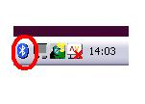
A window like the one on the right should appear.  Check (click) the My device is set up…. box.  Press buttons 1 and 2 simultaneously on the controller. Four lights should flash on the controller. If they stop flashing at any time during the pairing process, press 1 and 2 again.  Click Next. | 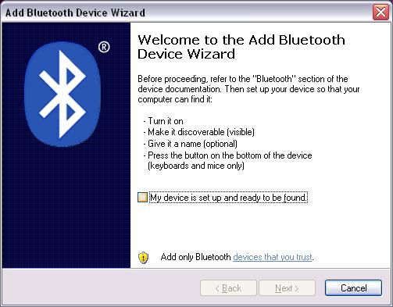
You should then see a list of all the Bluetooth-enabled devices in range. Expect to see some mobile phones as well as the Nintendo controller. Select the controller, then click Next.  If you don’t see the controller, try pressing buttons 1 and 2 again and clicking Search Again. If you can’t see it after trying a few times, it may be that your Bluetooth setup is not compatible with the controller. The best thing to do now is to either find a computer with hardware that is compatible, or to jump to Method 2. | 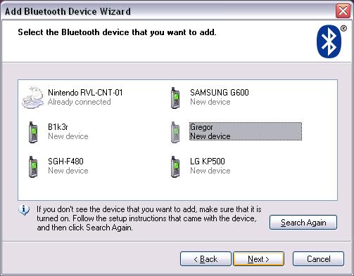

On the next window, select Don’t use a passkey before clicking Next. | 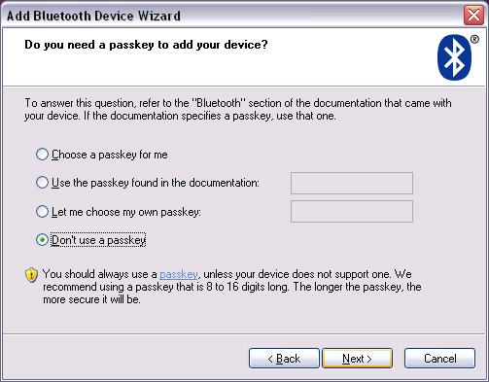
You should be informed that your controller is connecting, then that it is connected.  Click Finish. | 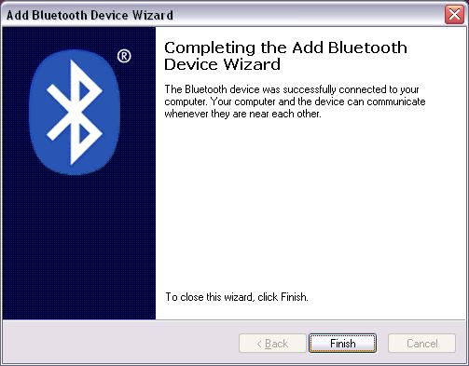
Expect to see balloons popping up around the system tray area saying that devices have been successfully installed.

Method 2 – try this if Method 1 didn’t work.
Install the software that came with the Belkin dongle given to you on the course.  Leave the CD in the computer and insert the dongle. The drivers should install.  Run the program My Bluetooth Places.  Select Add a Bluetooth Device  Press buttons 1 and 2 on the controller. | 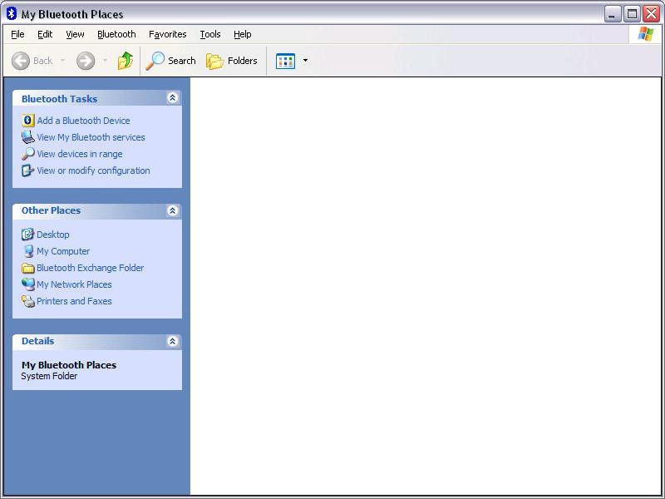
You should see the controller listed.  Click on it, then click Next. | 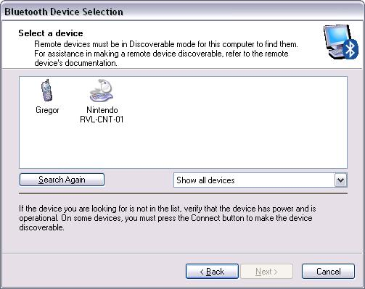
The software now wants a Passkey, which you don’t have, and there appears to be no way of skipping the step.  The trick is to hold down the Alt key and press S (Alt+S). This forces the software to skip a step. | 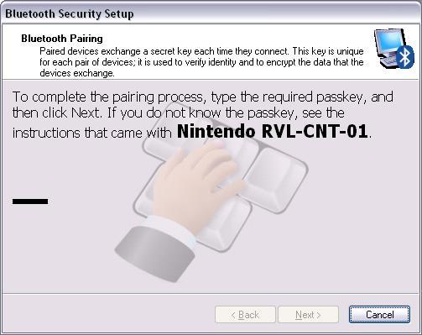
In the next window, check the box, then click Finish.  Your controller should now be connected.  Expect to see balloons popping up around the system tray area saying that devices have been successfully installed. | 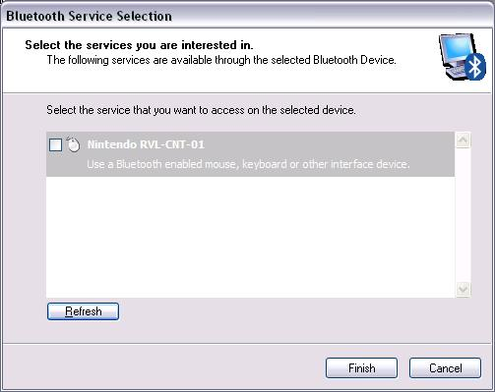
Using the Wiiphysics software
Make sure that your controller is connected (see above).
Start the software.  If all is well, you should see some green bars below the picture of the controller as it connects.  Several times our controllers failed to register with the software. We closed the software down and went back through the Bluetooth connection process . Once the controller was successfully linked with the software it tended to stay connected whilst the software was running. | 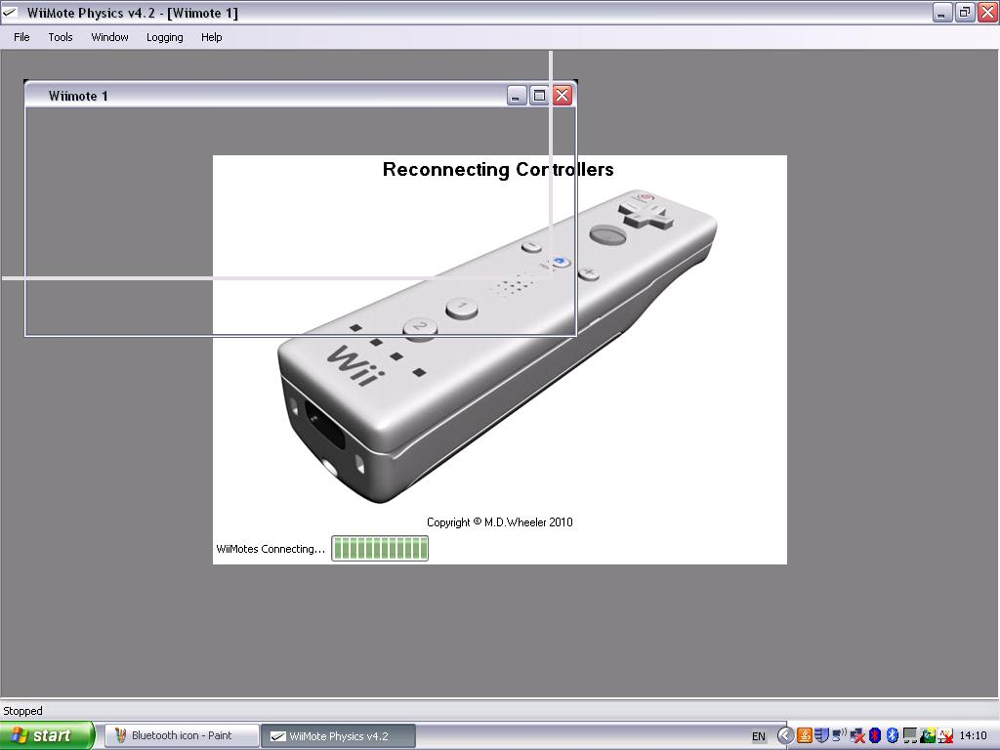
Press button A on the controller to begin capturing data.  Wave it around a bit, turn it through different angles and observe the screen.  Button 1 pauses capture.  Button 2 pauses capture but when you restart, it starts afresh.  Data capture can also be controlled via the Logging menu. | 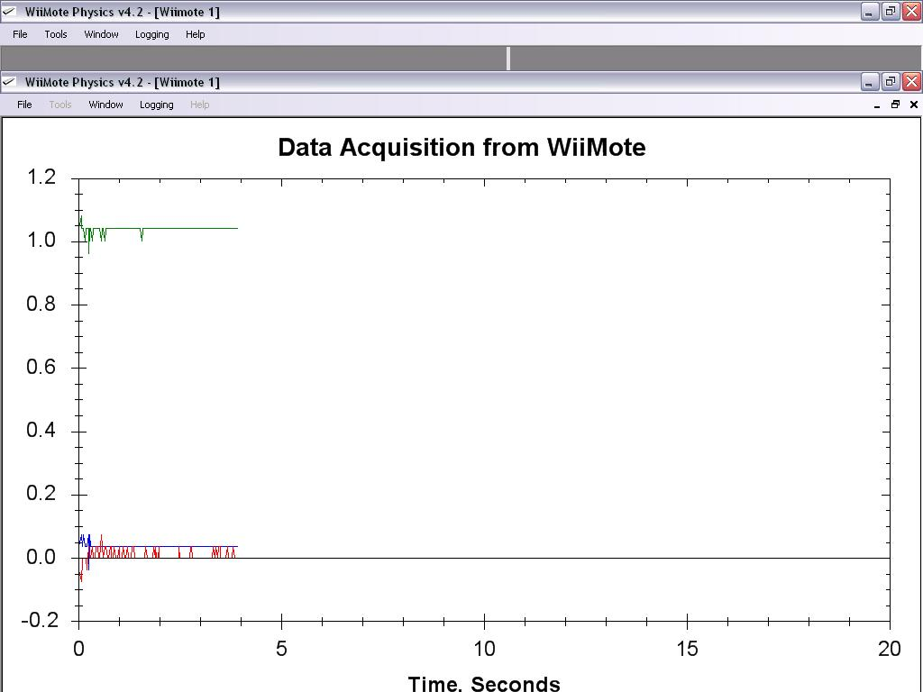
With capture paused, it is possible to drag over an area of the graph in order to zoom.  Right-clicking on the screen brings up a menu that allows you to reset all zooms. | 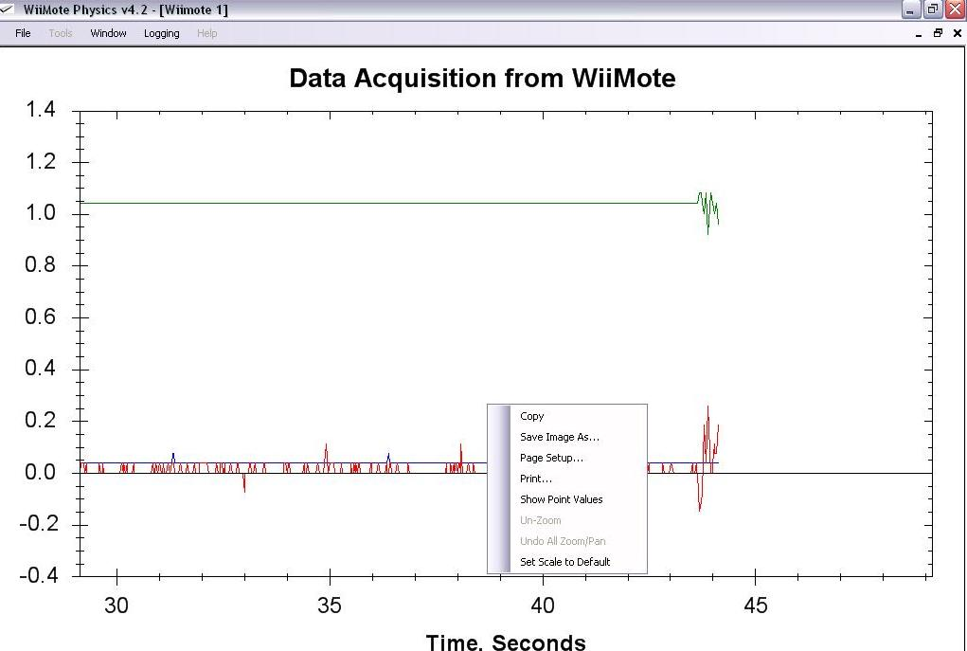
Options under the Tools menu let you set data collection time. You can also choose whether to display data from all three axes or a selection from the x, y and z data.
Notes
- Persevere with Bluetooth. Even with some expensive commercial hardware and software, connection can be a bit hit or miss.
- If you repeatedly have difficulty connecting your controller first time round, try going to the Bluetooth Devices icon on the Control Panel. If your controller is already listed, click on it, then click Remove. Now try going through the Add process again.
- We had some success with a free piece of software called wiimoteconnect. It can be downloaded from www.wiimoteproject.com. It is a utility that helps to connect the controller to a host computer. Often we had to run it two or three times in succession.
- Remember: buttons 1 and 2 on the controller need to be pressed (and released) to allow the controller to be recognised by the computer during connection. Connection is sometimes called “pairing”. Sometimes you need to press them repeatedly throughout the connection process.
- Some Bluetooth devices, once they’ve been connected once, will connect automatically ever after. The Wii controller doesn’t seem to do this and has to be re-introduced to the computer every time it is used.
- The software expresses acceleration in terms of g. Therefore an acceleration of 2 means 2 x gravitational acceleration, i.e. about 20ms⁻².
- Data can be saved in spreadsheet-compatible format via the File menu.
Experiments
- Hang the controller from a spring and watch it record acceleration during SHM.
- Mount the controller on a turntable with one axis pointing to the centre. Investigate the relationship between angular velocity and central acceleration.
- Mount the controller on a trolley and log deceleration during a collision. See if you can reduce it by fitting a crumple zone to the trolley. Note that collisions have to be fairly gentle to be captured correctly. See the SSERC activity Pimp My Trolley.
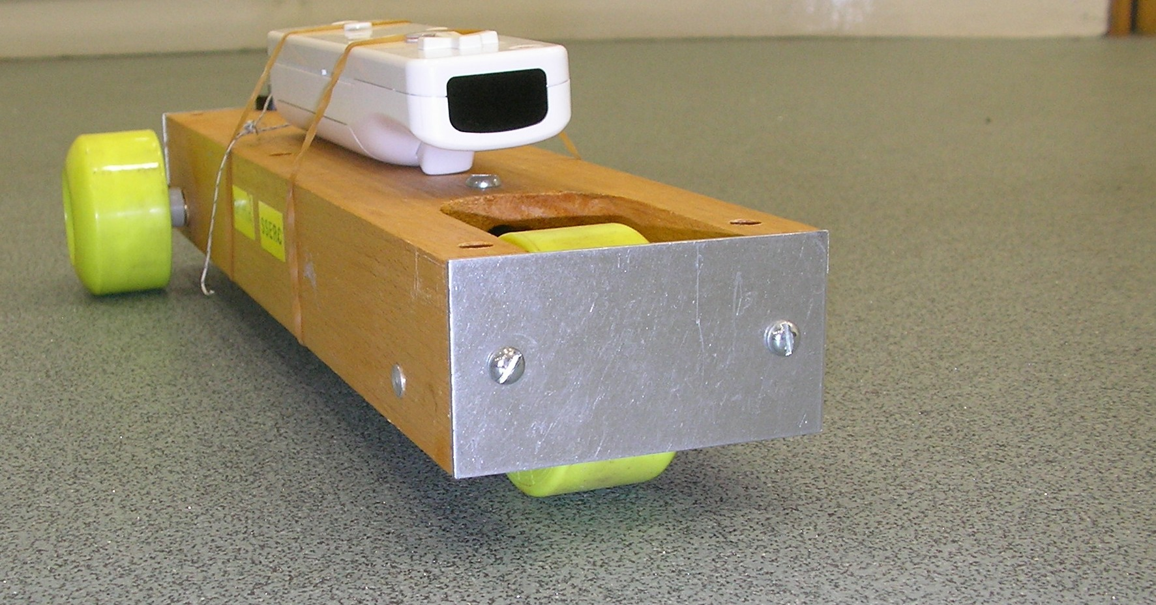

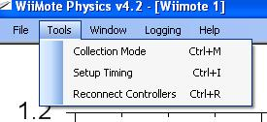 | As well as an accelerometer, the wiimote has an infrared camera that it uses to determine position. It requires two infrared sources in order to triangulate. Two small filament lamps work well.
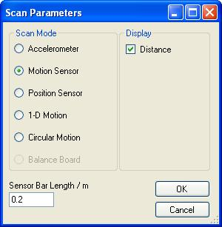 | Set up two filament lamps 20 cm apart. Choose Collection Mode from the Tools menu.  Select Motion Sensor. Note the Sensor Bar Length / m box. It should be set at 0.2 m and corresponds to the separation of the two IR sources. It can be altered.  Click OK. Press button A on the controller to begin data capture. Move the controller back and forward in front of the bulbs. The plot you see is the distance from the controller to the mid point between the bulbs.
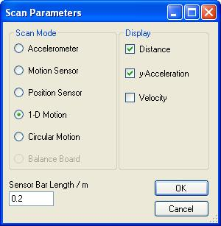 | Choose 1-D Motion from the Collection Mode options. Tick the boxes as shown left.  Suspend the Wiimote from a spring above the two bulbs and set it oscillating. You should be able to log position and acceleration versus time and note that they are 180° out of phase.  You may have to experiment with the distance between the controller and bulbs to get a good trace.
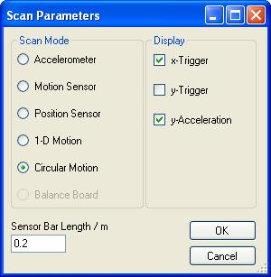 | Place the Wiimote on a rotating turntable with the IR camera facing outwards. Place a single bulb on a stand in the plane of the controller, so that the camera sweeps past it when the turntable rotates.  Select the Circular Motion option. Tick the boxes as shown left.  When you log data, you should see the central acceleration, plus a blip on the screen every time the camera passes the bulb. How could you use this set up to investigate central acceleration? versus angular velocity?

