 | Respiration of Sugars by Yeast

[Taken, with minor modifications, from Redding, K. & Masterman, D. (2007), Biology with Vernier, Vernier Software & Technology, Beaverton, OR 97005-2886, USA.
ISBN 978-1-929075-43-0. Aspects of this protocol can be downloaded at http://www.vernier.com/files/sample_labs/BWV-12A-COMP-respiration_sugars_by_yeast.pdf].

Yeast is able to metabolise some foods, but not others. In order for an organism to make use of a potential source of food, it must be capable of transporting the food into its cells. It must also have the proper enzymes capable of breaking the food’s chemical bonds in a useful way. Carbohydrates are vital to all living organisms. Yeast is capable of using some, but not all, carbohydrates as a food source. Yeast can metabolise sugar in two ways, aerobically, with the aid of oxygen, or anaerobically, without oxygen.
In this practical, you will try to determine whether yeast is capable of metabolising a variety of sugars. When yeasts respire aerobically, oxygen gas is consumed and carbon dioxide, CO₂, is produced. You will use a CO₂ Gas Sensor to monitor the production of CO₂ as yeast respires using different sugars. The four carbohydrates that will be tested are glucose, starch, fructose, and lactose.

OBJECTIVES
In this experiment, you will
- Use a CO₂ Gas Sensor to measure concentrations of carbon dioxide.
- Determine the rate of respiration by yeast while using different sugars.
- Determine which sugars can be used as a food source by yeast.

MATERIALS
- computer | - disposable pipettes
- Go!Link | - hot and cold water
- Logger Lite software | - Yeast suspension
- Vernier CO₂ gas sensor | - thermometer
- 250 cm³ respiration chamber  - 5% glucose, starch, lactose, and fructose solutions | - beaker (1 x 600 cm³) for water bath  - test tubes (four, 1 x 10 cm)
PROCEDURE
All solutions have been kept in the water bath for at least 10 minutes to come up to the correct temperature.  - Prepare 8% solutions (150 cm³) of glucose, sucrose, fructose, maltose and starch. To each solution add 5 g of dried yeast. Also prepare a yeast solution in water (i.e. without sugar!) at a concentration of 5g per 150 cm³. Pour approximately 5 cm³ of each of these solutions into Universals labeled G, S, F, M, St and W and place them in a water bath at 35ºC; leave for 10 minutes before taking measurements.  - Set the sensor to the Low (0–10 000 ppm) setting. Connect the CO₂ sensor to the Go!Link interface and connect to the computer. | 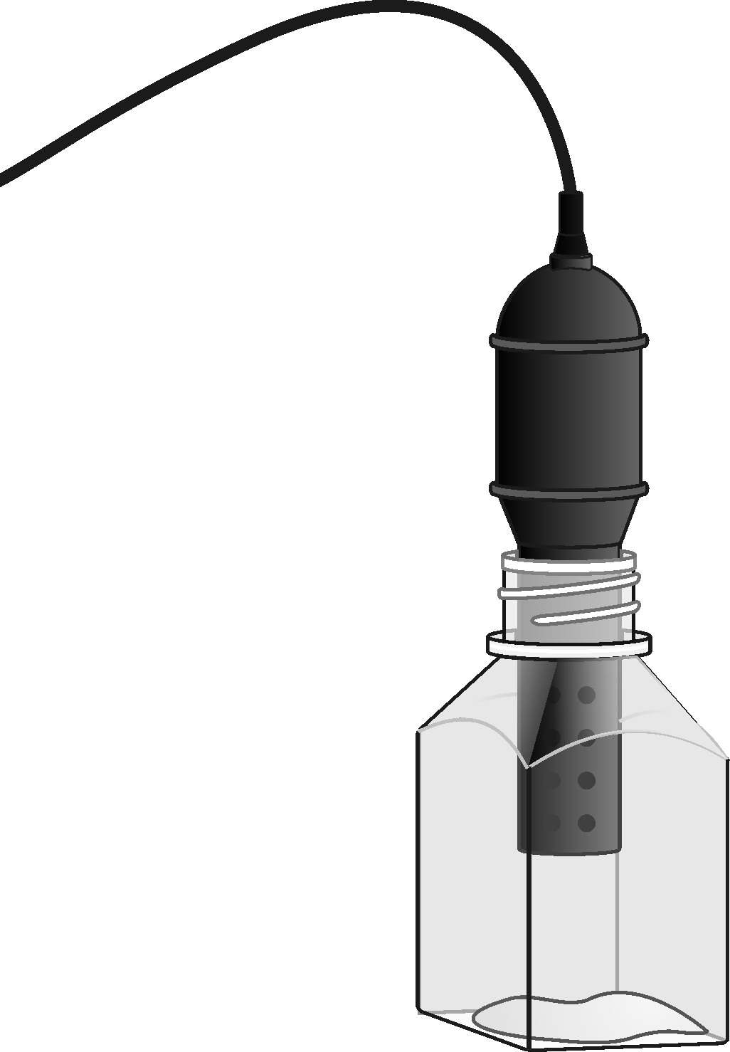  Figure 1
3. When incubation is finished, use a dropping pipette to place 1 cm³ of the solution in Universal G into the 250 cm³ respiration chamber. Note the temperature of the water bath and record as the actual temperature in Table 1.
4. Quickly place the shaft of the CO₂ Gas Sensor in the opening of the respiration chamber.
5. Begin measuring carbon dioxide concentration by clicking . Data should be collected for about 4 minutes.
6. When data collection has finished, remove the CO₂ Gas Sensor from the respiration chamber. Fill the respiration chamber with water and then empty it. Make sure that all yeast has been removed. Thoroughly dry the inside of the chamber with a paper towel.
7. When data collection has finished, determine the rate of respiration:

- Move the mouse pointer to the point where the data values begin to increase. Hold down the left mouse button. Drag the pointer to the point where the data ceases to rise and release the mouse button.
- From the ‘Analyze’ menu select ‘Linear Fit’ to perform a linear regression. A floating box will appear with the formula for a best fit line.
- Record the slope of the line, m, as the rate of respiration in Table 1.

8. Move your data to a stored run. To do this, choose ‘Store Latest Run’ from the ‘Experiment’ menu.
9. Use a notebook or notepad to fan air across the openings in the probe shaft of the CO₂ Gas Sensor for 1 minute.
10. Repeat Steps 3 - 9 for the other 5 test tubes.
DATA
Table 1
Sugar tested | Actual temperature (°C) | Respiration rate (ppm min⁻¹)
Glucose
Starch
Fructose
Lactose
Water (control)

Table 2: Class Averages
Sugar tested | Respiration rate (ppm min⁻¹)
Glucose
Starch
Fructose
Lactose
Water

PROCESSING THE DATA
1. When all other groups have posted their results on the board, calculate the average rate of respiration for each solution tested. Record the average rate values in Table 2.
2. Make a bar graph of rate of respiration vs. sugar type. The rate values should be plotted on the y-axis, and the sugar type on the x-axis. Use the rate values from Table 2.
QUESTIONS
1. Considering the results of this experiment, does the yeast equally utilise all sugars? Explain.
2. Hypothesise why some sugars were not metabolised while other sugars were.
3. Why do you need to incubate the yeast before you start collecting data?
4. Yeasts live in many different environments. Make a list of some locations where yeasts might naturally grow. Estimate the possible food sources at each of these locations.

