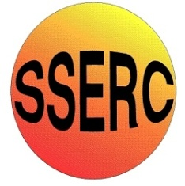
Simple Chemical Reactions
Polymer Slime
CfE
Having contributed to a variety of practical activities to make and break down compounds, I can describe examples of how properties of compounds are different from their constituent elements.
SCN 3-15b
N4 Chemistry in society - materials
N5 Chemistry in society - properties of plastics

Green Boogers

Apparatus you will need
Bench mat
25 cm³ syringe
5 cm³ syringe
Stirring rod
50 cm³ glass beaker

Chemicals you will use
PVA solution (4%)
Food colouring (various)
Borax solution (4%)

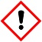
Safety
Wear eye protection. Care with solutions – irritants
Wear gloves

What you will do
- Using a syringe measure out 25 cm³ of PVA and add it to a beaker.
- Now add 2 drops of green food colouring to the PVA and using a stirring rod mix thoroughly.
- Using another syringe measure out 5 cm³ of Borax and to the green mixture. Using a stirring rod mix thoroughly.
- Pour the green goo onto the bench mat and watch your booger ooze.

It is the responsibility of teachers doing this demonstration to carry out an appropriate risk assessment.

