

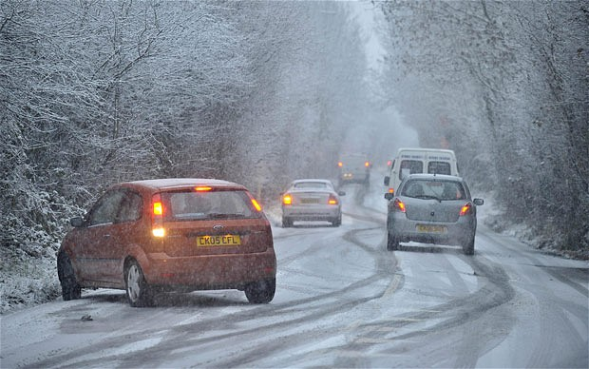
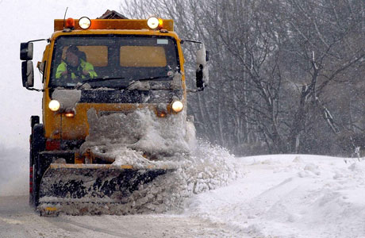
Pupil’s Guide

You will need
1 x spotting tile | 4 x 1cm³ pasteur pipettes
Samples of 4 de-icers | Distilled water
Marker pen | Access to a freezer

- The spotting tiles have 4 x 3 wells. You will use 4 rows of 3 wells.
- Use the marker pen to label your rows 1, 2, 3 and 4.
- In the left hand well of row 1, put 1cm³ of the first antifreeze solution.
- In the second well put 0.5 cm³ of the same solution and 0.5 cm³ of distilled water.
- In the third well put 0.25 cm³ of the same solution and 0.75 cm³ of distilled water.
- Repeat in the next row with a different de-icer.
- Continue until all the wells are filled.
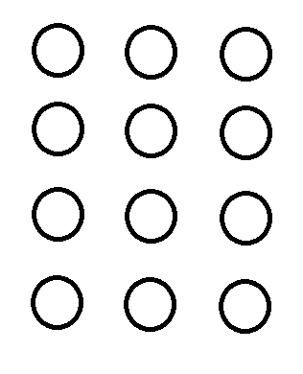
1cm³0.5cm³0.25cm³
De-Icer 1

De-Icer 2

De-Icer 3

De-Icer 4
(Volume of solution)

- Put the tray in the freezer and leave for about 30 minutes.
- Remove from the freezer and inspect the samples. How solid/liquid are they?

Experiment – 1 results sheet

Name | 10% | 5% | 2.5%

Which ‘de-icer’ seems to prevent freezing most effectively? .......................................

..........................................................................................................................
You will need
1 x 250cm³ beaker | 1 x 100cm³ measuring cylinder
1 x funnel | 1 x thermometer
1 x stirring rod | Samples of various de-icers
Crushed Ice | Access to a balance*
Timer | Weigh boat*

* We have weighed out the samples for you
- Weigh out 10g of your first de-icer.*
- Weigh out 100g of crushed ice in the beaker. Put the thermometer in the beaker.
- Take the temperature and record it.
- Add the first de-icer, stir and start the timer.
- Record the temperature every minute for 5 minutes.
- Stir from time to time.
- At the end of 5 minutes, place the funnel in the measuring cylinder and pour the contents of the beaker into it.
- Record the volume of water that collects in the measuring cylinder.
- Empty the cylinder and beaker and repeat the process for each of the rest of the de-icing chemicals.
* Propane-1,2-diol is a liquid. You are being given 10cm³ of it, so subtract 10 from the volume of water you get.

 | Temperature (°C) |  |  |  |  | Volume of water (cm³)
De-Icer | 1min | 2min | 3min | 4min | 5min
- Plot your figures for the volume of melt-water as a bar graph on the grid below

Volume of water (cm³) | 50_
Volume of water (cm³) | 45_
Volume of water (cm³) | 40_
Volume of water (cm³) | 35_
Volume of water (cm³) | 30_
Volume of water (cm³) | 25_
Volume of water (cm³) | 20_
Volume of water (cm³) | 15_
Volume of water (cm³) | 10_
Volume of water (cm³) | 5_
Volume of water (cm³) | 0_
 |  | 1 | 2 | 3 | 4 | 5 | 6 | 7 | 8 | 9 | 10
 |  | De-Icer Number
Minimum Temperature (°C) | 5_
Minimum Temperature (°C) | 0_
Minimum Temperature (°C) | -5_
Minimum Temperature (°C) | -10_
Minimum Temperature (°C) | -15_
Minimum Temperature (°C) | -20_
 |  | 1 | 2 | 3 | 4 | 5 | 6 | 7 | 8 | 9 | 10
 |  | De-Icer Number
- Plot your figures for the minimum temperature as a bar graph on the grid below

Chemicals | Apparatus
Ferroxyl Indicator solution | Spotting Tile
Sodium Chloride | 4 x 1cm³ pasteur pipettes
Calcium Chloride | Marker pen
Magnesium chloride | Clean nails or tacks or fresh iron filings
sugar | Urea
Propane-1,2-diol

- Collect a spotting tile
- Place a sample of clean iron in each dimple.
- Use the marker pen to label the dimples with the chemicals you are going to use.
- Place about 0.1 g of each chemical in each labelled dimple ( a small spatula tip).
- Add 10 drops of ferroxyl indicator solution to each chemical in the dimple.
- Time how long it takes for a blue colour to appear in each.*

* This can sometimes be rather difficult to establish. An alternative is to leave all the samples for the same length of time and then compare the amount of bluing.

De-Icer | Time taken for blue colour to appear | Ranking in increasing order of blueness after __ minutes

