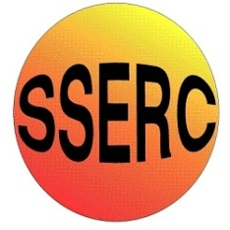


Simple Chemical Experiments
Growing Crystals
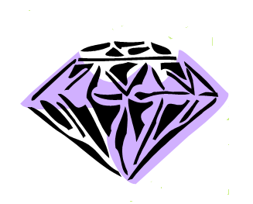
CfE
By contributing to investigations into familiar changes in substances to produce other substances, I can describe how their characteristics have changed.
SCN 2-15a
I can differentiate between pure substances and mixtures in common use and can select appropriate physical methods for separating mixtures into their components.
SCN 3-16a

- Black paper
- Scissors
- petri dish (or similar container)
- Warm water
- Magnesium sulphate (Epsom salts)

Use your scissors to cut the black paper so it will fit in the bottom of your pie pan.

Add 15g of magnesium sulphate to 50 cm³ of warm water.
Stir until the salt is dissolved.

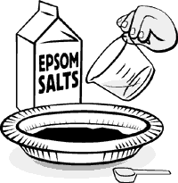

Pour the salty water onto the black paper in the dish.

Put the dish out into the sun (or on a radiator). When the water
evaporates, you'll see lots of crystal spikes on the
black paper!

These crystals look great under a microscope!

Why does Epsom salt make crystal spikes?
When you add Epsom salts (magnesium sulphate) to water, the salt dissolves. When you leave the pan in the sun, the water evaporates and the salt forms crystals shaped like long needles.
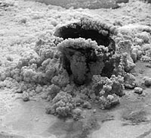
If you tried this experiment with table salt (sodium chloride) instead of Epsom salt, you wouldn't get crystal spikes. That's because table salt and Epsom salt are chemically different, so the crystals that they form are very different.
The picture on the right shows part of an artwork created by Swiss artist Jörg Lenzlinger. He mixed different kinds of salts with water. As the water evaporated, the salts crystallized, making beautiful shapes that kept growing and changing.
To learn more about this salt crystal artwork, visit the Complexity website.

© The Exploratorium, www.exploratorium.edu

