


Simple Chemical Experiments
Copper Caper
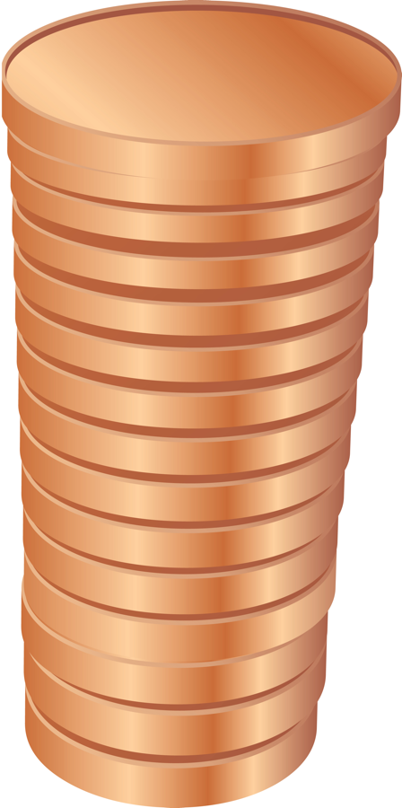
CfE
Through experimentation, I can identify indicators of chemical reactions having occurred. ...
SCN 3-19a
Having taken part in practical activities to compare the properties of acids and bases . . .
SCN 3-18a




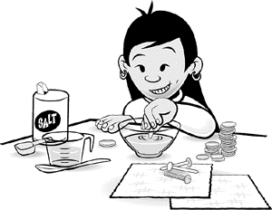
- 20 dull, dirty pennies
- 60 cm³ white vinegar
- 1 teaspoon salt

- A clear, shallow bowl (not metal)
- 2 clean steel nails
- A clean steel screw or bolt
- Paper towels

Put the salt and vinegar in the bowl.
Stir until the salt dissolves.

Dip one penny halfway into the liquid. Hold it there for about 10 seconds, then pull it out. What do you see?

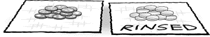

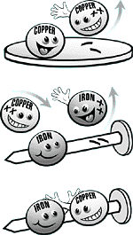
Why did the pennies look dirty before I put them in the vinegar?
Everything around you is made up of tiny particles called atoms. Some things are made up of just one kind of atom. The copper of a penny, for example, is made up of copper atoms. But sometimes atoms of different kinds join to make molecules. Copper atoms can combine with oxygen atoms from the air to make a molecule called copper oxide. The pennies looked dull and dirty because they were covered with copper oxide.

Why did the vinegar and salt clean the pennies?
Copper oxide dissolves in a mixture of weak acid
and table salt-and vinegar is an acid. You could also clean your pennies with salt and lemon juice or orange juice, because those juices are acids, too.
Why did the unrinsed pennies turn blue-green?
When the vinegar and salt dissolve the copper oxide layer, they make it easier for the copper atoms to join oxygen from the air and chlorine from the salt to make a blue-green compound.

How did the nail and the screw get coated with copper
To understand how the nail and screw got coated with copper, you need to understand a little bit more about atoms. Atoms are made up of even smaller particles called protons, neutrons, and electrons. Electrons and protons are both electrically charged particles. Electrons are negatively charged and protons are positively charged. Negative charges attract positive charges, so electrons attract protons.
When you put your dirty pennies in the vinegar and salt, the copper oxide and some of the copper dissolve in the water. That means some copper atoms leave the penny and start floating around in the liquid. But when these copper atoms leave the penny, they leave some of their electrons behind. Rather than having whole copper atoms in the liquid, you've got copper ions, copper atoms that are missing two electrons. These ions are positively charged.
Now add two steel nails and a screw to the mixture. Steel is a metal made by combining iron, other metals, and carbon. As you found out when you cleaned your pennies, your mixture of salt and vinegar is really good at dissolving metals and metal oxides. When you put the steel nail in the mixture, some of the iron dissolves. Like the copper atoms, each of the iron atoms that dissolves leaves two electrons behind. So you've got positively charged iron ions floating in your vinegar with the positively charged copper ions.

Originally, the steel nail was neutrally charged-but when the iron ions left their electrons behind, the nail then became negatively charged. And remember what we said way back at the beginning of this section: negative charges attract positive charges. The negative charges on the nail attract positive charges in the liquid. Both the iron ions and the copper ions are positively charged. The copper ions are more strongly attracted to the negative charge than the iron ions, so they stick to the negatively charged nail, pick up electrons and form a coating of copper on the steel.
Why did bubbles come off the steel screw?
Each water molecule is made up of two hydrogen atoms and an oxygen atom. In an acid (like vinegar or lemon juice), lots of hydrogen ions (hydrogen atoms that are missing an electron) are floating around. In the chemical reactions at the surface of the screw, some of these hydrogen ions join to electrons on the surface of the iron to make hydrogen atoms. Two of these then join to form hydrogen gas. The bubbles that you see coming off the screw are made of hydrogen gas.

© The Exploratorium, www.exploratorium.edu

