Chemical Demonstrations
Traffic Lights
This reaction can be applied to curriculum for excellence.
Through experimentation, I can identify indicators of chemical reactions having occurred ...
SCN 3-19a
CfE Higher – Chemistry in Society
- Oxidising or reducing agents
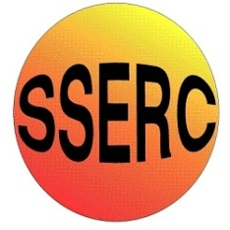


Background
This is a Redox reaction. The indicator can be oxidised many times by shaking.
Gently shaking the mixture produces one oxidised form with a different colour, while vigorous shaking will then turn this into a different oxidised form again, with yet another colour still.
As the mixture is allowed to stand, the dye reverts back to its reduced forms with the accompanying colours again becoming visible.

What you will need
- 250cm³ of 0.5M sodium hydroxide solution (corrosive)
- 7.5g of glucose powder
- 10cm³ of indigo carmine indicator made up as below.
- 1 x 500 cm³ conical flask or large bottle (A 500cm³ coke or a vinegar bottle is fine)

What you do

Before the demonstration
Prepare the indigo carmine dye by dissolving 0.1g of the powder in 100cm³ of distilled water.

The demonstration
- Place the sodium hydroxide, the glucose and the 10cm³ of the indigo carmine dye in a large conical flask or a bottle and stopper it tightly.

- Shake the mixture to dissolve the glucose. It will go green.

- Allow the mixture to stand until it turns yellow.

- Taking care not to dislodge the stopper, shake the mixture gently. It will turn red.

Now shake vigorously – it turns green. Allow the contents to stand and watch them turn back to red and then to yellow once more.
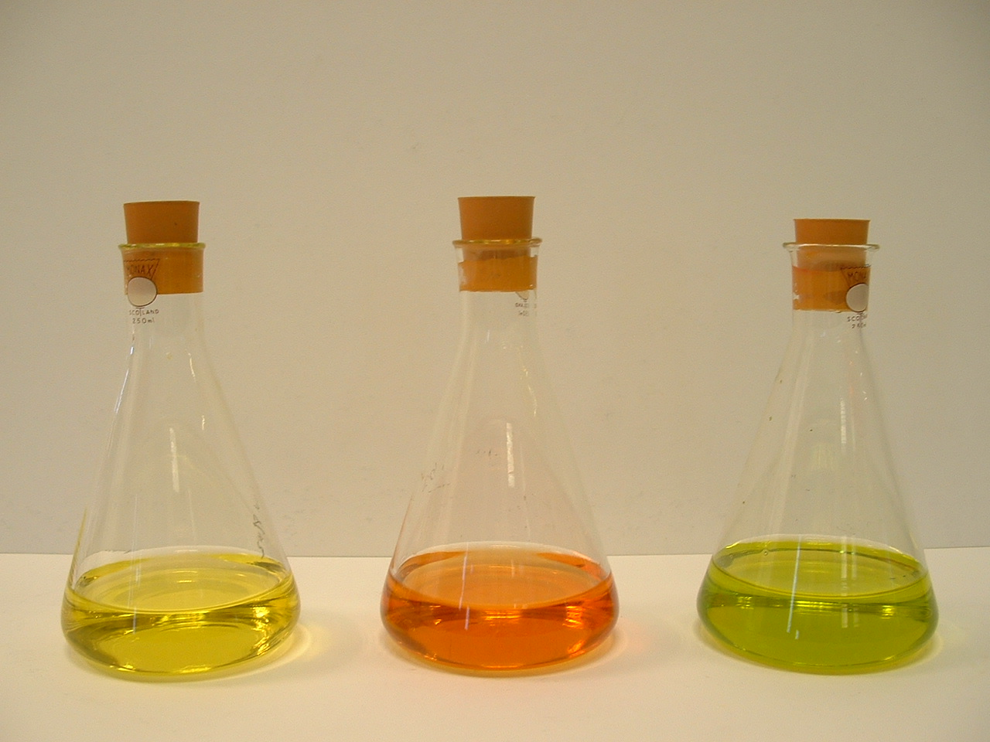

- Repeat again and again. The colour changes will tend to slow down as time goes on. The reaction can be refreshed by the addition of more glucose powder.

Safety
Wear eye protection. Wear gloves

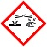
Care with alkali – Corrosive

It is the responsibility of teachers doing this demonstration to carry out an appropriate risk assessment.

