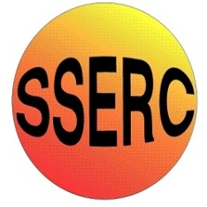

Chemical Demonstrations
Rhubarb! Rhubarb!
Rhubarb!
This reaction can be applied to curriculum for excellence.
Through experimentation, I can identify indicators of chemical reactions having occurred. ...
SCN 3-19a
N4 Chemical Changes and Structure
- Rates of Reaction

N5 Chemical Changes and Structure
- rates of reaction

CfE Higher – Chemical Changes and Structure
- Controlling the rate - Collision theory
Background
Rhubarb contains a chemical, oxalic acid, that reacts with the purple permanganate ions. Colourless manganese ions are formed.
This can be extended into an investigation (See Rhubarb! Rhubarb!)

What you will need
- A jar of potassium permanganate crystals (harmful, oxidising agent)
- A bottle of 2 mol l⁻¹ sulphuric acid (corrosive)
- Stalks of rhubarb
- 2 x 250 cm³ beakers
- Stirring rod

Background
Rhubarb contains a chemical, oxalic acid, that reacts with the purple permanganate ions. Colourless manganese ions are formed.

What you do
before the demonstration: Make up a batch of acidified potassium permanganate solution for a number of demonstrations.

- Take a very small crystal of potassium permanganate and dissolve in approximately 500 cm³ of water.
- Dilute this solution to give a clear pink colour but no more intense than that.
- Add equal volumes of this potassium permanganate solution and the sulphuric acid to the bottle that is being used to store the acidified solution.

The demonstration
- Add approximately 50 cm³ of the acidified potassium permanganate solution to a beaker. Use a stalk of rhubarb to slowly stir this solution. The solution will slowly decolourise (this is different from ‘going clear’ - it is clear at the start!).

- You may wish to first stir with a glass rod to show that stirring does not have any effect on the solution.

Safety
Wear indirect vent goggles

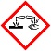
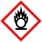


Care with acid-corrosive

Care with permanagate – oxidising agent/harmful

It is the responsibility of teachers doing this demonstration to carry out an appropriate risk assessment.

