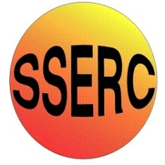


Chemical Demonstrations
Rainbow reaction
This reaction can be applied to curriculum for excellence.

Having taken part in practical activities to compare the properties of acids and bases, I have demonstrated ways of measuring and adjusting pH and can describe the significance of pH in everyday life.
SCN 3-18a
N4 Chemical Changes and Structure
- Acids & alkalis.

N5 Chemical Changes and Structure
- Acids & alkalis

CfE Advanced Higher – inorganic &Physical chemistry
- Indicators

To illustrate the pH scale for acids and alkalis.

What you will need
- 50cm³ burette with bung.
- Syringes to dispense up to 20cm³.
- Eye protection.
- 0.4M sodium hydroxide solution (irritant).
- 2M hydrochloric acid ( irritant).
- Sodium carbonate solution.
- Universal indicator solution (flammable).

What you do
- Make sure that the tap of your burette is closed.

- Add 10cm³ of sodium hydroxide to the burette followed by a few drops of universal indicator.

- Add 20cm³ of hydrochloric acid followed by 2cm³ of sodium carbonate solution.

- Insert the bung and turn the burette upside down carefully, while holding on to the bung. Be careful as gas will form and could spray over you.

- You should see rainbow colours ranging from deep purple through blue and green to orange and red. But if you don’t, turn the burette upside down again (carefully).

Safety

Wear eye protection

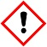
Care with acid and alkali – irritants

It is the responsibility of teachers doing this demonstration to carry out an appropriate risk assessment

