Simple Chemical Reactions
Piezo-Rocket Launchers

Construction of a Sparker from an Empty Piezoelectric Lighter | 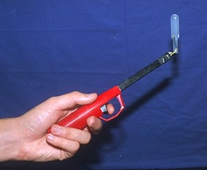  Figure A

An extremely useful sparker used for initiating reactions of gas mixtures can be constructed from an empty (out of fuel) piezoelectric igniter such as an Aim-&-Flame. The assembled device is shown in Figure A.

How to Build a Sparker.
Remove the end cap from the lighter. Use a screw driver to open the lighter. Locate the terminal in the centre of the barrel of the piezo lighter. Remove 5 mm of insulation from one end of each of the two pieces of wire. The wire lead to the piezo electrode is formed into a small loop to slide onto the piezo electrode prior to soldering. Solder one 8 cm lengths of 24-gauge wire to the centre terminal and another to the second terminal on the chassis which connects to the end cap as shown in Figure B. Replace the cap. The cavity around the piezo electrode is then filled with hot glue which adds stability and provides insulation from arcing. Wrap the cap in insulating tape. Place a band of insulating tape around the wire leads close to the arcing end of the wires (Figure C). Heat shrink plastic is also useful for insulating the wires. Simultaneously cut both wires 2 mm beyond the tape band. Do NOT remove insulation from the arcing leads; the spark will easily jump and the insulation prevents the leads from making contact. Place another band of electrician's tape around the chassis/wire lead solder joint to complete the project. Click the lighter to check for spark.
The sparker is less prone to arcing when wet if one lead is cut shorter than the other and the long lead bent over to form the gap.

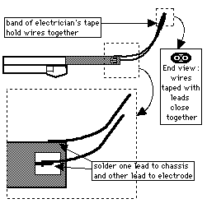  Figure B | Figure C
Images and diagrams from http://mattson.creighton.edu/AppendixC.html
Instructions from this source have been amended slightly in light of experience in constructing the sparker.
To make your piezo rockets
You will need:
- large pipette
- plastic cup or beaker filled with water
- syringe of gas or gas mixture
- scissors
- test tube, medium or small
- piezoelectric sparker (See separate sheet)
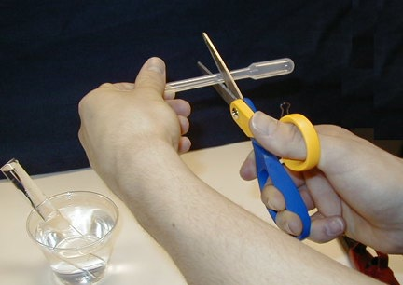
1. Prepare several pipette 'rockets' by removing all but 2-cm of the stem from several extra-large polyethylene (disposable) pipettes.

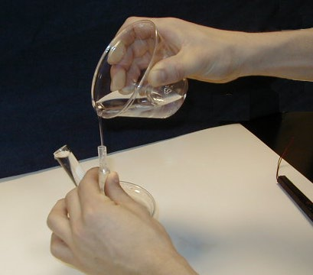
2. Fill the pipette rockets completely with water and store them in the cup filled with water.

3. Using the apparatus for ‘Dynamite soap’, bubble the gas mixture into the rocket until it is filled. Leave a little water in the stem (or draw some in) and store the rocket in a test tube filled with water. Multiple rockets can be prepared at this time.

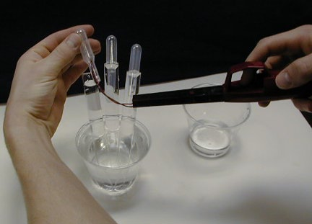
4. Position the rocket over the wire leads of the piezoelectric sparker. Water must remain in the stem because this serves as the propellant; however, the ends of the wire leads must be above the water in the gas-filled region of the rocket.

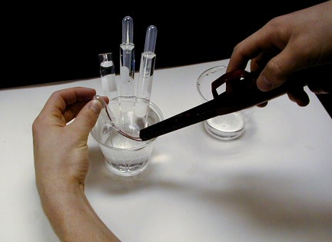
5. If the water leaks out of the stem while positioning the rocket over the wires, immediately fill the stem again by holding the wires plus rocket assembly in a cup of water and suctioning a very small amount of water into the stem.

6. Trigger the sparker and the rocket will fly 5 m or more.
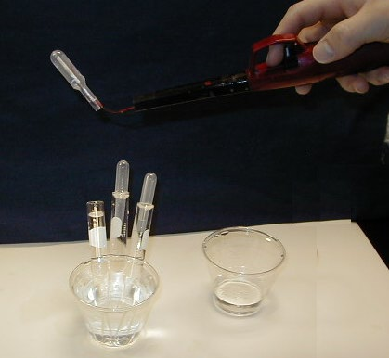
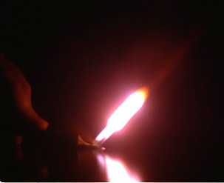

A fireball is noticed in a darkened room as the gas mixture ignites.
Technique and all instructions from http://mattson.creighton.edu/AppendixC.html

