


Chemical Demonstrations
Piezo-Rocket Launchers
This reaction can be applied to curriculum for excellence.
Through experimentation, I can identify indicators of chemical reactions having occurred ...
SCN 3-19a
N5 Nature's chemistry
- fuels
N5 Nature's chemistry
- energy from fuels

What to do

Fill your Piezo Rockets according to the information in the construction guide.

- Slip the pipette rocket over the wire leads of the piezoelectric sparker. Remember that hydrogen is lighter-than-air! Never tip the gas-filled rocket open-end up — the gas will escape.
- Draw some water into the stem — without this, the rocket will not fly far when “launched”. The ends of the wire leads of the piezoelectric lighter must be above the water in the gas-filled region of the rocket.
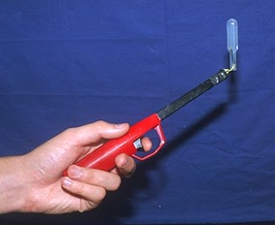
- Launch the rocket by triggering a spark. Do not aim the rocket at anyone! If the water leaks out of the stem while positioning the rocket over the wires, immediately fill the stem again by holding the wires and rocket in a cup of water and drawing a very small amount of water into the stem.
- The rocket should fly up to 10 m!
Picture from http://mattson.creighton.edu/O2/

Safety
Wear eye protection
It is the responsibility of teachers doing this demonstration to carry out an appropriate risk assessment.

