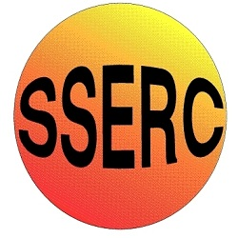

Chemical Demonstrations
Methane bags
This reaction can be applied to curriculum for excellence.
SCN 3-19a
Through experimentation, I can identify indicators of chemical reactions having occurred ...

National 4 – Chemical Change & Structure
Energy changes of chemical reactions
What you will need:
- Some polybags from loaves of bread (some plastic bags are not suitable. They burn easily giving rise to hazardous fumes)
- An oxygen cylinder
- A clamp stand and boss head
- A length of rubber tubing
- Ear defenders
- Safety screen
- A metre stick with a wax taper on the end

What you do:

Connect the rubber tube to a gas tap and fill one of the loaf bags full of methane.

- Tie off the mouth and clamp it in the boss head.
- Put the screen in place and light the taper on the metre stick.
- Now ignite the bag of methane. It will burn with a yellow flame.
- Take a second bag and fill it one third full of methane.
- Now fill the same bag two thirds full of oxygen.
- Tie it off as before and place it in the clamp stand.
- Put the screen in place.
- Ensure audience are at least 4 metres from the demonstration.

- Wearing ear defenders and with the audience holding their fingers
in their ears, ignite the methane/oxygen mixture as before.
- This time there will be a loud explosion!

Safety
Wear ear defenders Wear eye protection

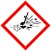
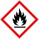
Care when igniting methane/oxygen mixture flammable/explosive mixture of gases.
Use a safety screen

Care when using oxygen cylinder

It is the responsibility of teachers doing this demonstration to carry out an appropriate risk assessment.

