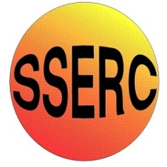

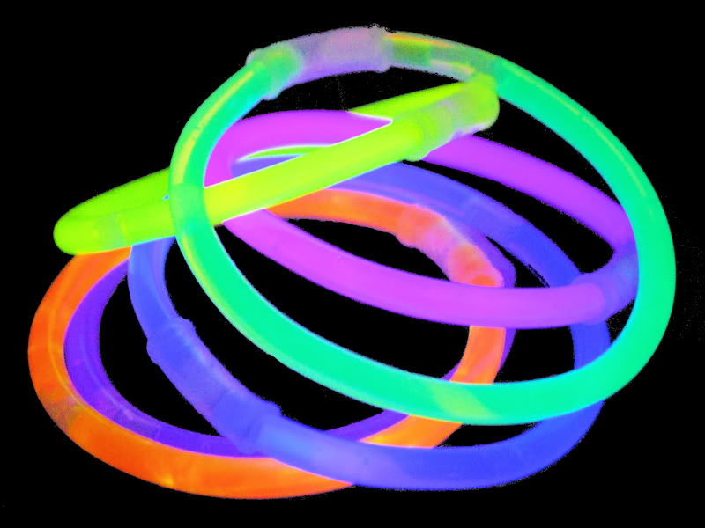
Chemical Demonstrations
Light Sticks
This reaction can be applied to curriculum for excellence.
Through experimentation, I can identify indicators of chemical reactions having occurred. ...
SCN 3-19a
N4 Chemical Changes and Structure
- Rates of Reaction

N5 Chemical Changes and Structure
- rates of reaction

CfE Higher – Chemical Change and Structure
Controlling the rate - Collision theory
Background

The glow stick contains a mixture of diphenyl oxalate and a suitable dye. The glass tube inside that you break to get the reaction going contains hydrogen peroxide. On breaking, the peroxide reacts with the oxalate, initiating a complex series of reactions that results in the dye molecule being excited and then releasing its energy as light.

This reaction shows how temperature affects a chemiluminescent reaction.

You will need

- 2 x 250cm³ beakers
- 2 light sticks
- Hot water
- Iced water

What to do: In a darkened room

- Half fill one of the 250 cm³ beakers with hot water

- Half fill another 250 cm³ beaker with iced water.

- Take two light sticks and bend them until they start to glow. They glow because you have mixed two chemicals and a reaction takes place that gives off light. Shake them to mix the chemicals so the reaction takes place along the length of the tube.

- Look at the brightness of the light from both sticks. (It may be easier to compare them if you hold them against a light coloured background).

- Now take one of the sticks and place it in the beaker of hot water,

- Take the second light stick and place it in the beaker of iced water.

- Leave both sticks in their separate beakers for 2-3 minutes.
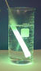

- Now remove the light sticks and compare the brightness of each stick.

Safety: Care with hot water. Do not let the chemicals escape from the light sticks.

It is the responsibility of the teachers doing this demonstration to carry out an approriate risk assessment

