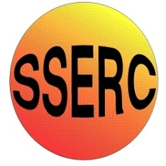

Chemical Demonstrations
Invisible writing
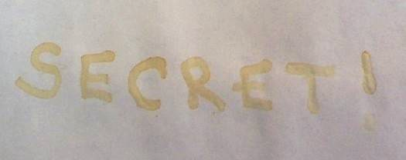
This reaction can be applied to curriculum for excellence.
Through experimentation, I can identify indicators of chemical reactions having occurred. ...
SCN 3-19a
Background
There have been many recipes for invisible writing over the years, but unlike others this one uses everyday household chemicals. The 300mg aspirin and 200mg ferrous sulphate tablets are easily available at a low cost
The washing soda and vinegar were purchased from a local supermarket.

What you will need
- Washing soda crystals (or sodium carbonate)
- Aspirin tablets
- Ferrous sulphate tablets
- White vinegar
- Deionised water
- Household bleach
- Beakers
- Measuring cylinders
- Mortar and pestle
- Filter paper
- Spray bottle
- Glass jar
- Stirring rods
- Small paintbrush

What you do
Aspirin ink solution:
- In a 100cm³ beaker add 7 aspirin capsules (approx 2g), 5g of washing soda and 30cm³ of de-ionised water.
- Dissolve with stirring and transfer to a glass jar. Shake occasionally and leave overnight.

Iron developing solution:
- To a 200cm³ beaker add 10 crushed iron capsules (approx 2g) and 125cm³ white vinegar.
- Dissolve the solution with stirring and then add 2.5cm³ household bleach.
- After adding the bleach the solution will turn dark orange. If needed, another 2.5cm³ of bleach can be added to ensure the colour of the solution is dark enough.
- Transfer to a spray bottle.

The Demonstration
- Using a paintbrush or cotton bud write a message onto a piece of filter paper and leave to dry. (A hairdryer can be used to speed up the drying process).
- Place a newspaper behind the filter paper to absorb any excess solution Spray the dried filter paper with the developer solution and watch the message appear.
(Do not over soak the filter paper as the message will blur)

Safety
Wear eye protection and gloves

Care with bleach–Irritant

It is the responsibility of teachers doing this demonstration to carry out an appropriate risk assessment.

