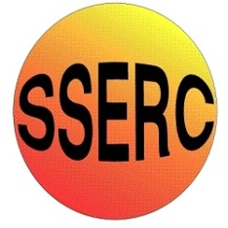
Chemical Demonstrations
Silver Xmas Trees
This reaction can be applied to curriculum for excellence.
Through experimentation, I can identify indicators of chemical reactions having occurred…
SCN 3-19a
Having carried out a range of experiments using different chemicals, I can place metals in order of reactivity…
SCN 4-19b
N4 Chemistry in society
- The properties of Metals and Alloys

CfE Higher – Chemistry in Society
Oxidising or reducing agents

Silver Xmas Trees

Apparatus you will need
2 microscope slides
Petri dish

Chemicals you will use
0.1M Silver (I) nitrate
Strip of copper
Copper wire (Xmas tree)

What you will do
- Lay the copper strip on top of one the microscope slides.
- Gently place the second slide on top of the copper strip.
- Place the 2 slides inside the Petri dish.
- Add enough silver nitrate solution to cover both slides.
- Observe what happens.
- Remove the slides, add the Xmas tree and observe what happens.

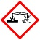
Health and Safety
Silver nitrate is corrosive.
Wear gloves and eye protection

