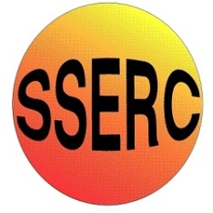

Chemical Demonstrations
Gloopy and Gooey
This reaction can be applied to curriculum for excellence.
Through experimentation, I can identify indicators of chemical reactions having occurred. ...
SCN 3-19a
N4 Chemistry in society
- materials
N5 Chemistry in society
- properties of plastics
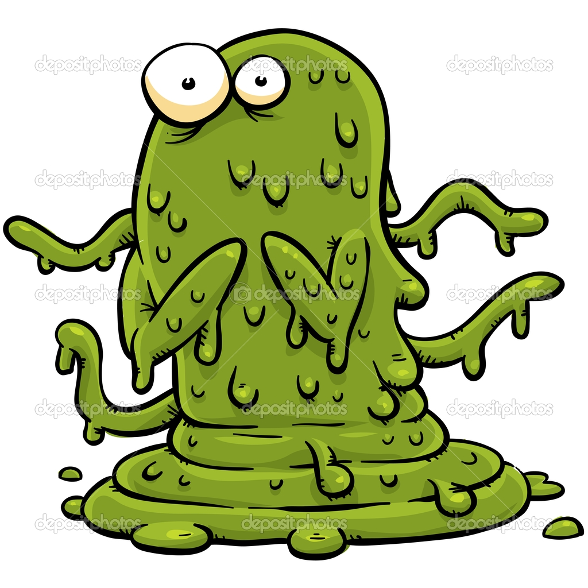
Background
Polymers are really long molecules which come in many different forms and colours.
Some are made from one chemical by
joining small molecules end to end
to made a much longer molecule.

In fact there can be millions of these
small molecules joined end to end to
make the long polymer strand.

Chemical 1
Other polymers can be made from
+
two chemicals. When they are
mixed, one of the chemicals links across the chains of the other one and this stops its chains flopping about.
Chemical 2

You can try two experiments to make these types over the page

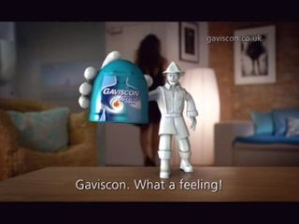
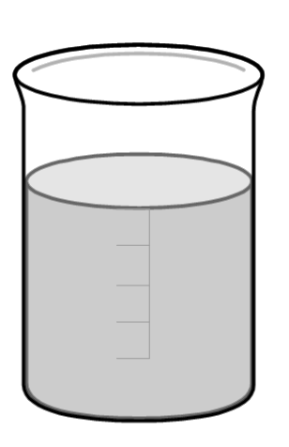
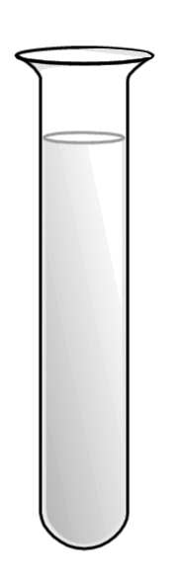
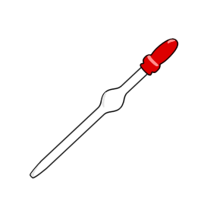
…………….
Gloopy
For the gloop, fill a test tube with the
blue solution.

Use a dropper to slowly add a continuous and gentle stream of Gaviscon to the boiling tube
of liquid.
Watch what happens!

gaviscon.co.uk

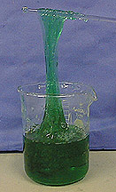
For the goo, measure out 25 cm³ of the PVA and put it in one of the plastic cups. Add two drops of food colouring to the PVA and stir to mix them.

Now measure out 5 cm³ of the Borax and add it to the PVA as well.
Mix them well with a stirring rod.

You can keep the gooey polymer in a sealed poly bag for ages and ages!

Gooey
green

What happened?
You prepared your gloopy polymer by adding the Gaviscon to copper sulphate solution. Gaviscon is gloopy because it contains long chains of a molecule called an alginate. The Cu²⁺ ions in the blue solution joined the ends of different alginate molecules together to make much longer ones.

You prepared your gooey polymer by mixing a PVA solution with a borax solution. The borax molecules linked across the PVA chains.

Safety
Solid borax is a reproductive toxin and copper sulphate is harmful handle with care.
It is the responsibility of the teachers doing this demonstration to carry out an approriate risk assessment

