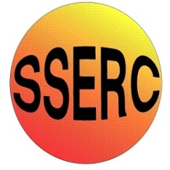


Chemical Demonstrations
Foam fire extinguisher
This reaction can be applied to curriculum for excellence.
Through experimentation, I can identify indicators of chemical reactions having occurred. ...
SCN 3-19a

This is a fun method for producing a foam fire extinguisher, showing a gas being made in a chemical reation. It can be messy!

What you will need
- 2 x 50cm³ beakers.
- 50cm³ measuring cylinders.
- 250cm³ conical flask. (you could even try a 100cm³ conical flask)
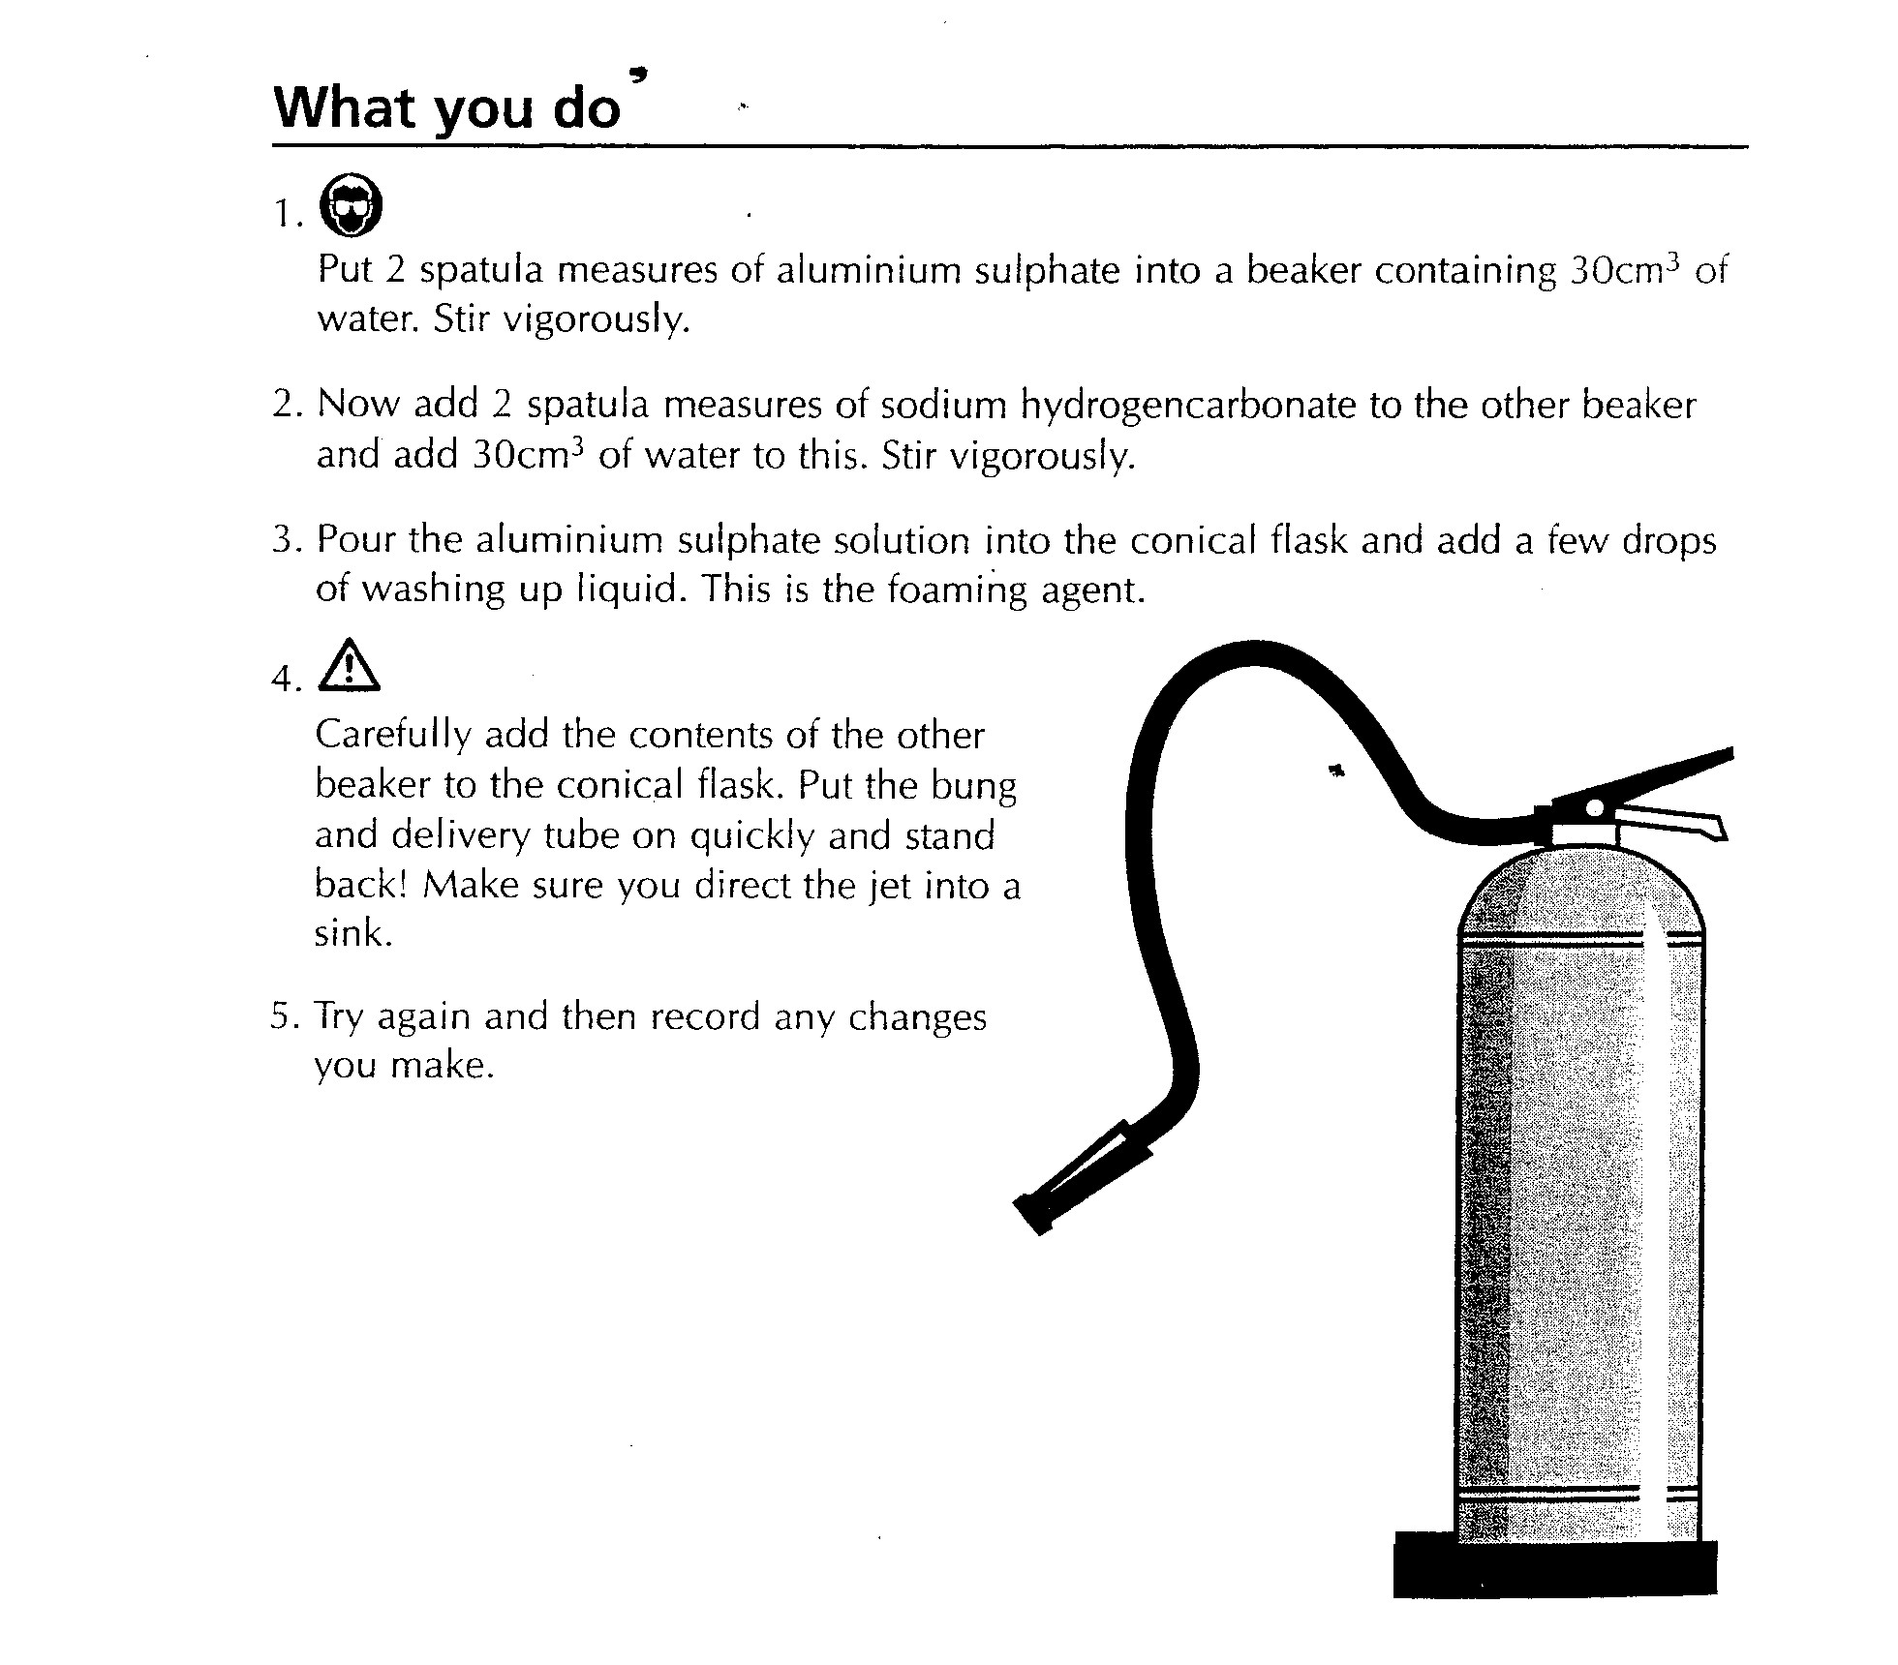
- Bung with delivery tube drawn out into a fine nozzle.
- Spatulas.
- Stirring rods.
- Dropping pipette.
- Aluminium sulphate powder.
- Sodium hydrogencarbonate.
- Washing up liquid or liquid detergent.
- Eye protection.
- Protective clothing (eg lab coats).

What you do
- Put 2 spatula measures of aluminium sulphate into a beaker containing 30cm3 of water. Stir vigorously.
- Now add 2 spatula measures of sodium hydrogencarbonate to the other beaker and add 30cm3 of water to this. Stir vigorously.
- Pour the aluminium sulphate solution into a conical flask and add a few drops of washing up liquid. This is the foaming agent.
- Carefully add the contents of the other beaker to the conical flask. Put the bung and delivery tube on quickly and stand back!
- Make sure you direct the jet into a sink.

Safety
Wear eye protection.
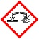
Aluminium sulphate can cause eye damage

It is the responsibility of teachers doing this demonstration to carry out an appropriate risk assessment.

