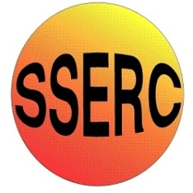


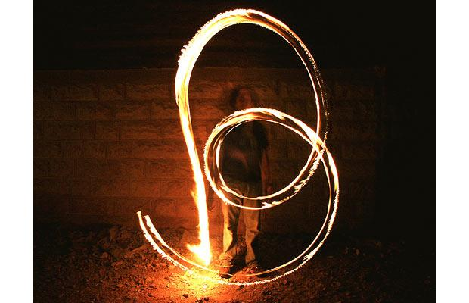
Chemical Demonstrations
Fire Writing
This reaction can be applied to curriculum for excellence.
Through experimentation, I can identify indicators of chemical reactions having occurred. ...
SCN 3-19a
CfE Higher – Chemistry in Society
Oxidising or reducing agents
This experiment involves setting fire to paper. The ‘ink’ contains an oxidising agent which when heated, provides more oxygen to keep the reaction going.

What you will need
- Bunsen burner.
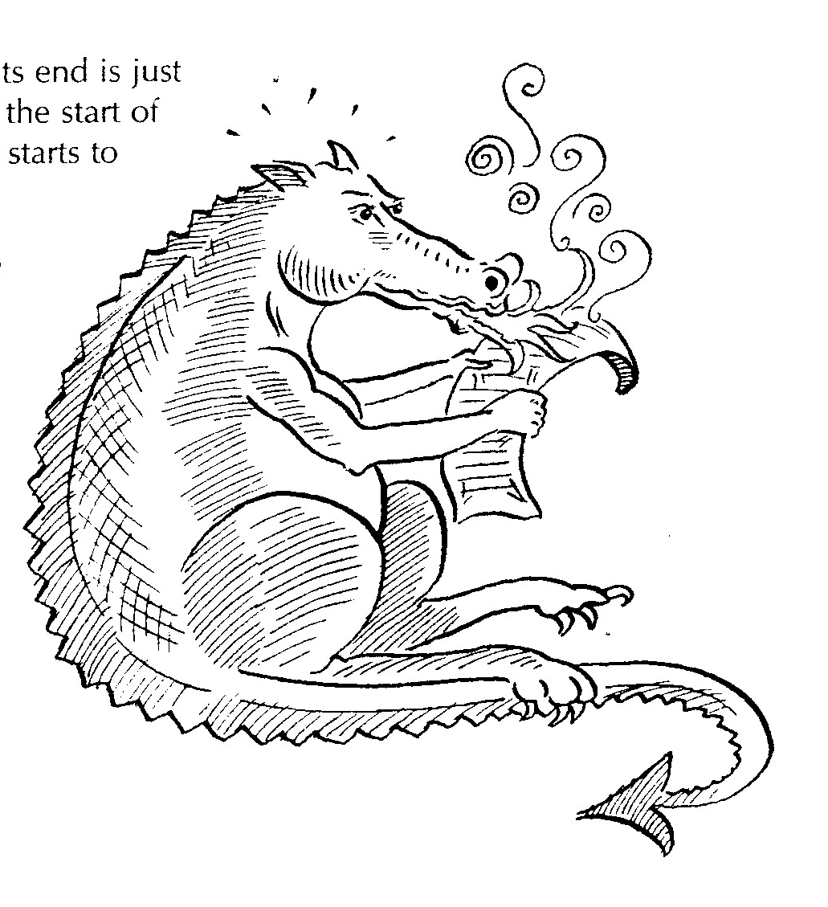
- 10cm³ measuring cylinder.
- 50cm³ beaker.
- Stirring rod.
- Filter paper.
- Wooden taper.
- Small paint brush.
- Pencil.
- Eye protection.
- Sodium nitrate.

What you do
- Pour 10cm³ of water into a beaker and add solid sodium nitrate gradually with stirring until no more will dissolve. This is a saturated solution.
- Using a small paintbrush write a message on the filter paper.
Use joined up writing but don’t complete the loops.
- Mark the start of the message with a pencil mark and leave the filter paper to dry in air or use a hairdryer to speed up the process.
- Light the taper from the Bunsen burner and then blow it out so its end is just glowing. Touch the glowing end to the start of the message until the treated paper starts to glow and char.
- Remove the taper and watch as the glow and charring works its way along the message, leaving the untreated paper untouched.

Safety
Wear eye protection
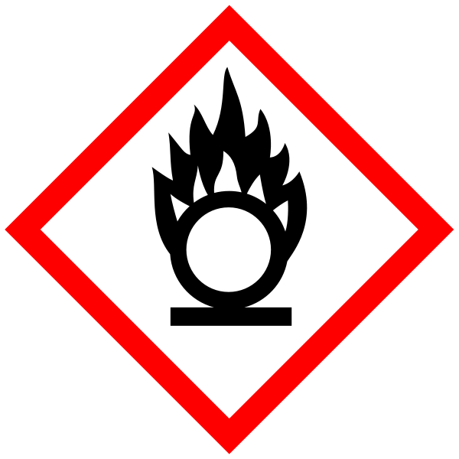
Care when using sodium nitrate - oxidising agent

It is the responsibility of teachers doing this demonstration to carry out an appropriate risk assessment.

