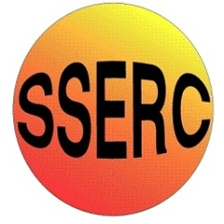

Chemical Demonstrations
Elephant’s toothpaste
This reaction can be applied to curriculum for excellence.
Through experimentation, I can identify indicators of chemical reactions having occurred ...
SCN 3-19a
…analyse experimental data on chemical reactions that result in an obvious change in energy.
SCN 4-19 a
CfE Higher: Chemistry in Society.
Equilibria

Apparatus you will need
Spatula
100 cm³ measuring cylinder
A large basin or a sink to stand the cylinder in (this gets messy!)

Chemicals you will use
60 cm³ x 100 volume hydrogen peroxide solution (corrosive,irritant)
A bottle of food colouring
A bottle of good quality washing-up liquid
Potassium iodide (pre weighed 1.4 g)

What you will do
- Take the cylinder, add a good squirt of washing-up liquid and a few drops of food colouring.
- Stand it in the basin or sink.
- Pour about 60 cm³ of the hydrogen peroxide into the measuring cylinder.
- Using a spatula, add the potassium iodide and stand back!

Safety
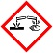

Wear eye protection
Care with peroxide - Corrosive and harmful
Wear gloves

It is the responsibility of teachers doing this demonstration to carry out an appropriate risk assessment.

