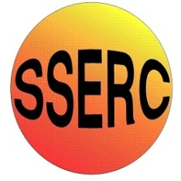


Chemical Demonstrations
Electroplating Faces
This reaction can be applied to curriculum for excellence.
Through experimentation, I can identify indicators of chemical reactions having occurred. ...
SCN 3-19a
N4 Chemistry in Society
- The properties of Metals and Alloys

Background

The silver you see in a jewellery shop is probably not pure solid silver but silver plate.
Electroplating is used to plate a thin layer of a valuable metal on top of a less valuable one. Have a go at plating the faces on foreign coins. (It is actually against the law to deface UK currency)

What you will need
- 100cm³ beaker.
- 2 – 4 V d.c. power supply, leads, crocodile clips.
- Eye protection.
- Disposable gloves.
- 1M Copper sulphate electrolyte solution (toxic, irritant)
- 1M nickel sulphate electrolyte solution (toxic, irritant)
- Nickel and copper foil.
- Foreign copper coin.
- Foreign nickel coin.

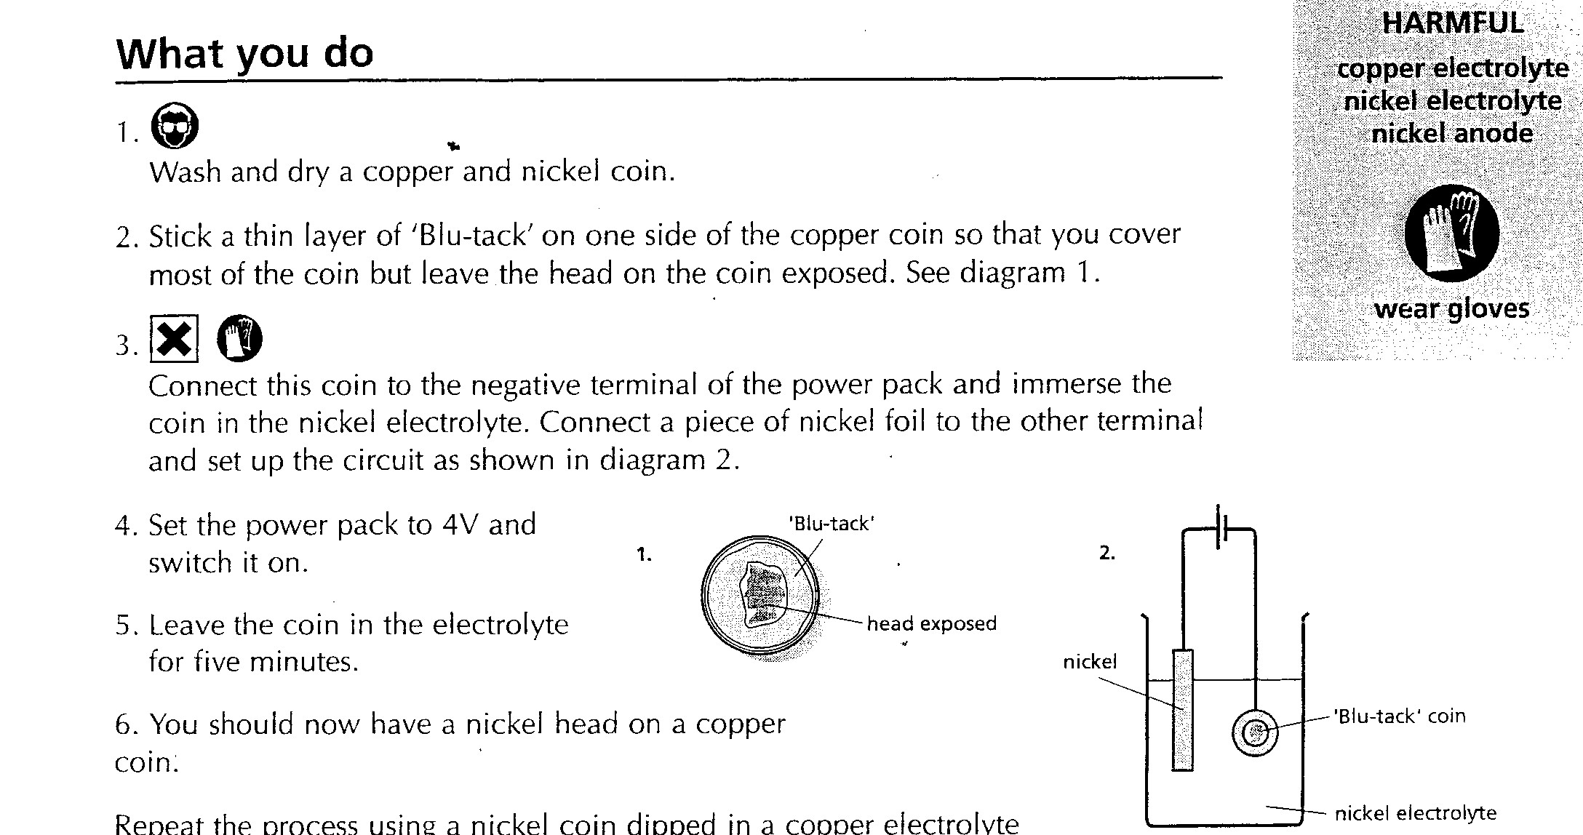
What you do
- Wash and dry a copper coin.
- Stick a thin layer of ‘Blu-tack’ on one side of the coin so that you cover most of the coin but leave the head of the coin exposed.
- Connect this coin to the negative terminal of the power pack and immerse the coin in the nickel electrolyte.
- Connect a piece of nickel foil to the other terminal and set up the circuit as shown opposite.
- Set the power pack to 4V D.C. and switch on.
- Leave the coin in the electrolyte for five minutes.
- You should now have a nickel head on a copper coin

Other things to try: Stripes on pieces of copper, nickel or other metal.
To make stripes:
immerse your foil electrode in the first electrolyte (eg copper).
Plate the entire surface with copper.
Place your metal foil electrode in the second electrolyte (e.g. nickel) but leave a small length (say 0.5cm) protruding above its surface.
You can then plate your metal foil with nickel, apart from the length above the surface which stays covered in copper.
Place your metal foil in the first electrolyte again, but leave 1cm protruding above the surface this time.
After plating, your metal foil should be covered with copper apart from two stripes of nickel and copper at the top end.
Continue the process to get more stripes.
Wear eye protection and gloves

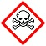
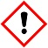
Care with solutions toxic, irritants

It is the responsibility of teachers doing this demonstration to carry out an appropriate risk assessment.

