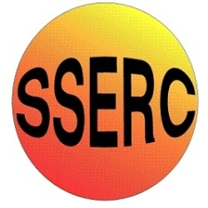

Chemical Demonstrations
Disappearing Water
This reaction can be applied to curriculum for excellence.
Through experimentation, I can identify indicators of chemical reactions having occurred. ...
SCN 3-19a
N4 Chemistry in Society
- Materials
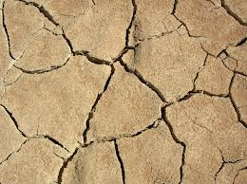

A nice little experiment to show a physical change

Background

There are granules of sodium polyacrylate (with a molecular weight of over 1 million) in the nappy lining. There are sodium carboxylate groups along the carbon chain. When water is added to the polymer, the sodium ions migrate leaving negatively charged carboxylate groups on the chain. The negative charges repel each other so the chains unwind and the polymer increases in volume. At the same time, there is an electrostatic attraction between the ions and the water molecules. Many water molecules are attracted to the carboxylate groups and are electrostatically held to them. The polymer absorbs water!

What you will need

3 polystyrene drinking cups

The lining from a disposable nappy. (Cheap ones will do – remove plastic backing but the inner layer nearest the baby can be left).

A measuring cylinder.

A beaker of water.

Food colouring (optional).

Before the demonstration

Cut circles, the diameter of the bottom of a cup (about 4.5 cm), out of the lining.

Place one in the bottom of one of the cups. It should be a snug fit.

Nappy liner in one of the cups

The demonstration

Measure out 10-15 cm3 of water (no more or the nappy will not absorb all of it) and place it in one of the cups. Colour if desired with a few drops of food colouring.

Make a great play of switching round the cups (but making it obvious which one has the water) and asking the audience to say which one has the water in it.

Each time they get it right, pour the water from the cup into the second empty cup.

On one occasion, pour the water into the ‘empty’ cup that contains the nappy liner.

Then when they predict the cup with the water, take the others in turn and show they do not contain water by attempting to pour from one empty cup to the other. (It also gives time for the nappy to absorb the water). This should convince the audience they are correct in their prediction. Now attempt to pour from this cup into one of the empty ones. Heh presto! The water has ‘disappeared’.

It is the responsibility of the teachers doing this demonstration to carry out an appropriate risk assessment.

