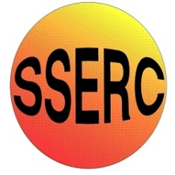
Chemical Demonstrations
Different Drinks from the Magic Bottle
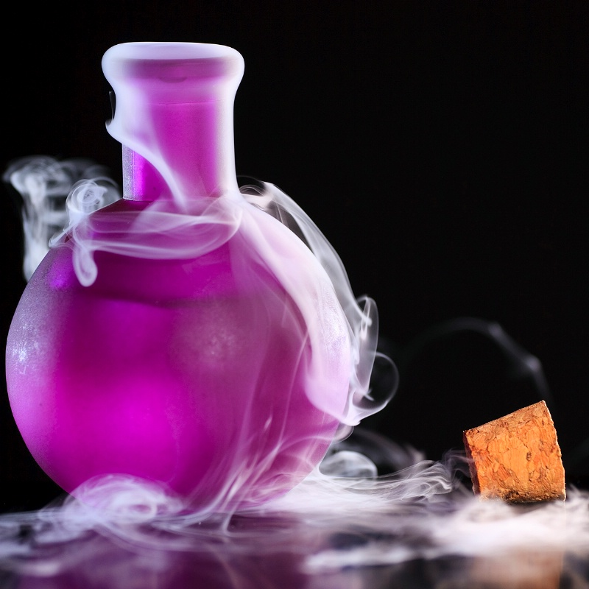
This reaction can be applied to curriculum for excellence.
Through experimentation, I can identify indicators of chemical reactions having occurred. ...
SCN 3-19a
Background
Sodium sulphate solution reacts with barium chloride solution to produce barium sulphate. This is insoluble in water and forms as a fine white solid (a precipitate in chemistry language).

What you will need
- Stock bottle of sodium sulphate solution (the magic bottle)
- Stock bottle of barium chloride solution, 30% (almost saturated) (harmful)
- 2 wine glasses

What you do
Before the demonstration
Add a few drops of water to one of the wine glasses to no more than wet the glass and a few drops of the barium chloride solution to the other.
The demonstration
The demonstration can be used to encourage students to ask “I wonder why?”, a very important question in the scientific method.
Carefully pour from the bottle into the ‘water’ glass to give a clear and colourless ‘drink’. On pouring from the bottle into the ‘barium chloride solution’ glass, a milky white ‘drink’ appears. Ask the students to suggest how the ‘trick’ is done. In this case, the magic of chemistry is a result of a simple chemical reaction (and a little deception).


Safety
Wear eye protection Care with chemicals - harmful

It is the responsibility of teachers doing this demonstration to carry out an appropriate risk assessment.

